ARARIO GALLERY SHANGHAI
After the Reaction

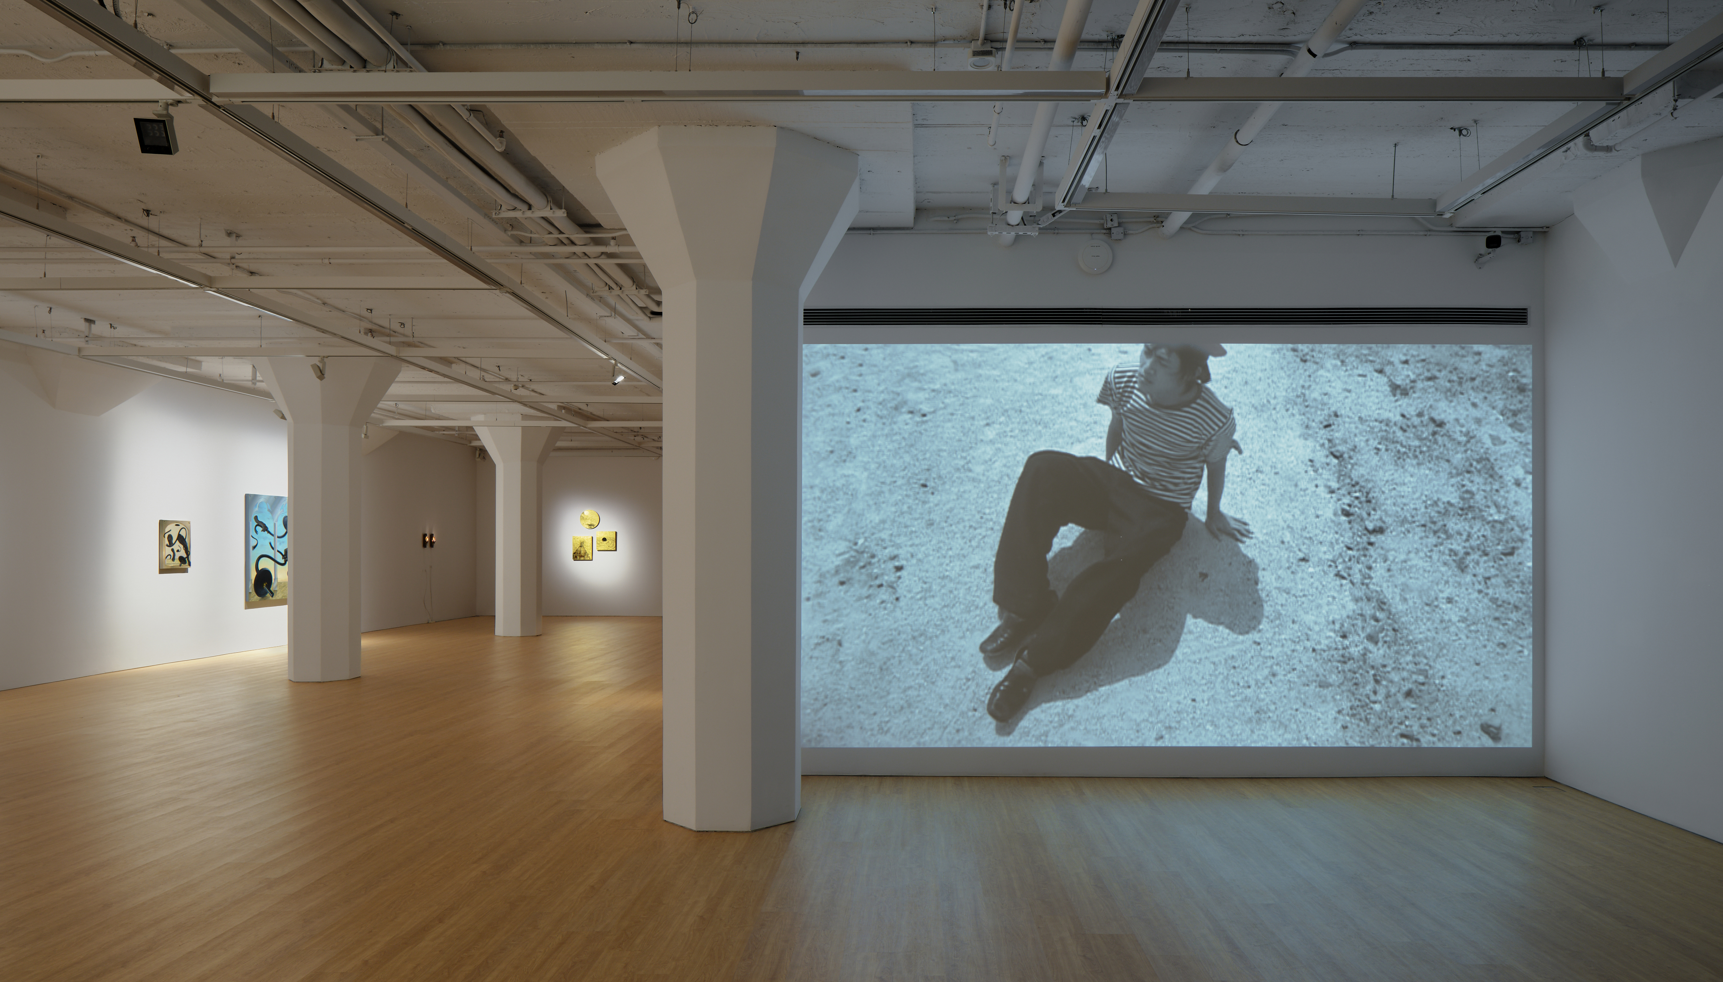
Installation view of After the Reaction at ARARIO GALLERY SHANGHAI, Shanghai, China, 2026.

Artists  Title  Dates  Venue  Artworks | :  :  :  :  : | CHEN Xiaozhi, LU Chunsheng, SUN Yiwen, YAN Heng  After the Reaction  16 Jan – 7 Mar 2026  ARARIO GALLERY SHANGHAI (2F-205, 30 Wen’an Road, Jing’an District)  16 pieces in total
[Artwork images and Installation view]
https://drive.google.com/drive/folders/1N703TLM18_usF3_weo-rfLjSMK60pqq_?usp=drive_link

[Inquiry]
ARARIO GALLERY SHANGHAI | E. info@arariogallery.com
Jiayi WANG, Sales & Exhibition | E. wangjiayi@ararioshanghai.com

Table of Content | 1. Exhibition Overview  2. Exhibition Theme  3. Artworks  4. Installation View  5. Artist Introduction  6. Artist CV | ---------------------------------------------------------------------------2  -------------------------------------------------------------------------2-3  -------------------------------------------------------------------------3-5  -------------------------------------------------------------------------5-7  -----------------------------------------------------------------------7-10  ----------------------------------------------------------------------10-15

1. Exhibition Overview

ARARIO GALLERY SHANGHAI presents After the Reaction, a group exhibition by CHEN Xiaozhi (b. 1980), LU Chunsheng (b. 1968), SUN Yiwen (b. 1991), and YAN Heng (b. 1982), which employs “chemistry” as a central metaphor to explore the ongoing effects of technological innovation, social structures, and historical narratives in contemporary life. Here, “chemistry” is not limited to a laboratory discipline but is understood as a mechanism of modernity concerned with transformation, refinement, acceleration, and control: technologies evolve, forms change, yet humanity’s impulse to convert the world into power and resources persists. In this sense, “chemistry” serves as a lens for understanding the structural contradictions of the contemporary world.

2. Exhibition Theme

CHEN Xiaozhi constructs a contemporary “cabinet of curiosities” through foil, glass, and ancient craftsmanship. Her work does not aim to reproduce history; rather, it activates time in the act of viewing through light, reflection, and accumulation. In CHEN’s practice, what remains invariant is not the historical forms or material traditions themselves, but the very modes through which time is perceived, observed, and refracted—a perceptual structure that continuously operates through light, reflection, and sedimentation.
LU Chunsheng’s History of Chemistry originates from a photograph of an offshore drilling platform: a massive structure almost entirely exposed above the water, emerging like a foreign object from the sea. In his perspective, the Asia-Pacific region resembles a continuously operating alchemical workshop. Through photography, LU interprets modernization as an ongoing process of alchemy: technologies are constantly updated, narratives are constantly reshaped, yet the desire to convert the world into resources and objects of control remains unaltered. In works such as Hey! Lana and I Want to Be a Gentleman, this logic is translated into arrangements of bodies, spaces, and power: identities are updated, narratives rewritten, yet the ways in which power organizes the body persist.
YAN Heng’s painting focuses on structural residues that continue to operate after moments of change have ostensibly concluded. Renewed Continuum draws on the image of the Arhat Rāhula from Manpuku-ji Temple in Kyoto: the chest is opened to reveal a Buddha head within, and the body no longer functions as a complete individual but as a vessel through which meaning is stored, transmitted, and renewed. Grounded in the logic of inheritance, this figure is placed within a system composed of measuring instruments, circuitry, and utilitarian objects. Here, renewal no longer signifies rupture or rebirth, but a managed and maintained process—meanings may be replaced, while the structure itself continues to operate.
Under this premise, YAN’s Poem Porn series, can be understood as the material articulation of the same logic. Oysters belong simultaneously to marine ecology and to global systems of extraction, transportation, and consumption; their natural qualities and industrial logics converge on the surface, forming a material state that is repeatedly processed yet never fully resolved. No longer merely objects of observation, they become nodes within contemporary systems of cleaning, processing, and interpretation.
SUN Yiwen’s paintings position the body in states of imbalance, fall, and torsion, creating a distant resonance with classical depictions of “the fall” in art history. Unlike religious or fate-driven narratives, the bodies in his works are not struck down by divine will but are shaped by institutions, capital, and social structures. While the meaning of the body constantly shifts, the structures that govern it remain unyielding, becoming one of the most direct yet imperceptible manifestations of contemporary social conditions.
This exhibition does not aim to reconstruct history. Rather, by juxtaposing practices across media and generations, it examines structural residues that continue to operate even after profound social, technological, and material transformations. These residues are not historical relics; they are embedded in the present through material forms, bodily orders, and spatial logic, continuously shaping the mechanisms by which reality functions. The exhibition foregrounds the disjunction between surface-level change and deep structural continuity in contemporary life, revealing how such disjunctions are perceived, maintained, and reproduced within everyday experience.

- Artworks
*The high-resolution images can be downloaded via the Google Drive link provided on the first page.
*When using artwork images, please include the following copyright credit: ©2026. Courtesy of the Artist and Arario Gallery.

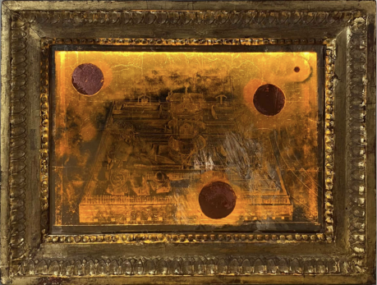  CHEN Xiaozhi  Labyrinthine Observatory (Lightbox), 2024  Palladium Leaf, Colored Silver Leaf, Natural Mineral Color, Glass, European Antique Solid Wood Frame, Lightbox  33 x 44 cm | 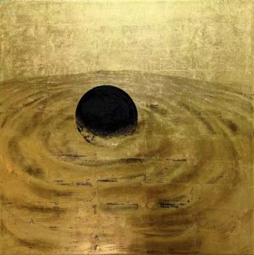  CHEN Xiaozhi  Image License – Occluded Center (Square), 2024  24k Gold Leaf, Natural mineral color, Rabbit skin glue, Birch Board  40 x 40 cm
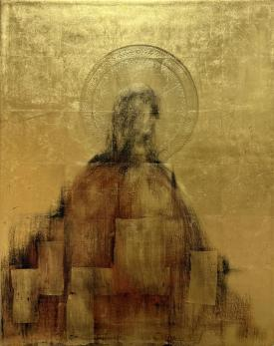  CHEN Xiaozhi  Image License – Visualization (Rectangular), 2025  24k Gold Leaf, Rabbit skin glue, Birch Board  40 x 50 cm | 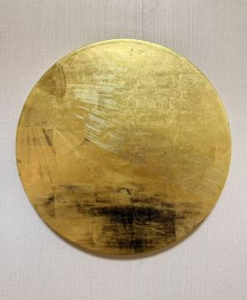  CHEN Xiaozhi  Light (Circular), 2024  24k Gold Leaf, Rabbit skin glue, Birch Board  Diameter 40 cm
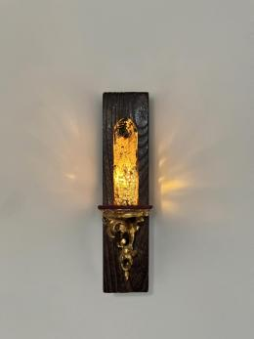  CHEN Xiaozhi  25ml of Energy A, 2024  24k Gold Leaf, Glass Solvent, Old Wooden Base, Antique Wood Carving Leaf Holder  9 x 26.5 x 1 cm | 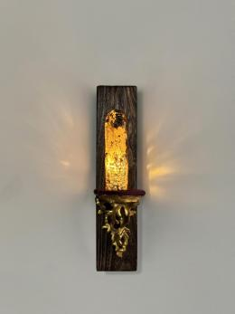  CHEN Xiaozhi  25ml of Energy B, 2024  24k Gold Leaf, Glass Solvent, Old Wooden Base, Antique Wood Carving Leaf Holder  9 x 26.5 x 1 cm
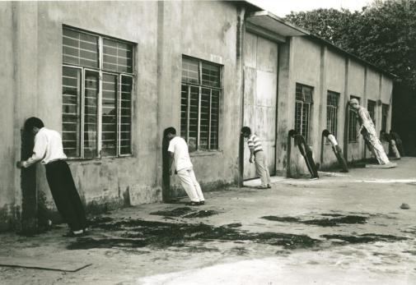  LU Chunsheng  Hey! Lana, 2000  B&W chromogenic print  30.6 x 44 cm  Edition of 4 (#2/4) | 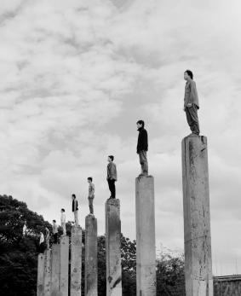  LU Chunsheng  I want to be a Gentleman (1), 2000  B&W chromogenic print  77.5 x 64 cm  Edition of 8 (#6/8)
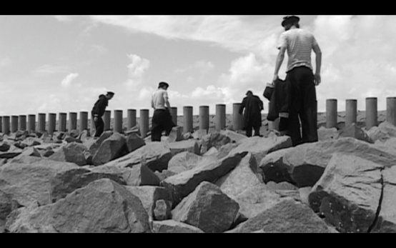  LU Chunsheng  History of Chemistry, 2004  Single-channel video  26 minutes 17 seconds | 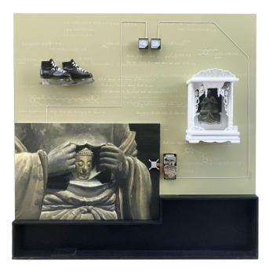  YAN Heng  Renewed Continuum, 2026  Oil on canvas, installation  200 x 200 x 20 cm
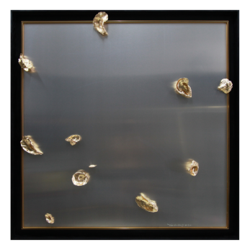  YAN Heng  Poem Porn - NO.5, 2022-2024  Mixed media  125 x 125 cm  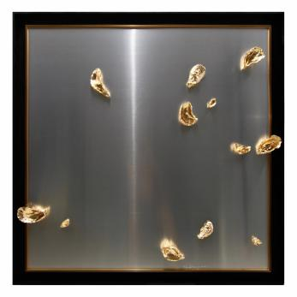  YAN Heng  Poem Porn - NO.7, 2022-2024  Mixed media  125 x 125 cm | 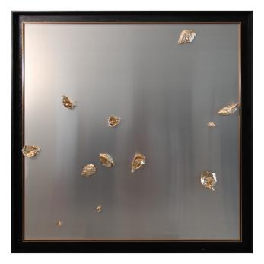  YAN Heng  Poem Porn - NO.6, 2022-2024  Mixed media  125 x 125 cm  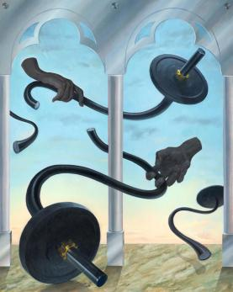  SUN Yiwen  Out of Control, 2024  Oil on Canvas  150 x 121 cm
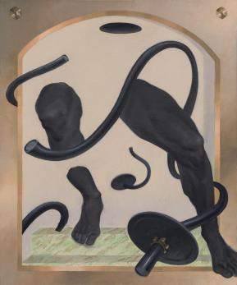  SUN Yiwen  Exhausted II, 2024  Oil on Canvas  60 x 50 cm | 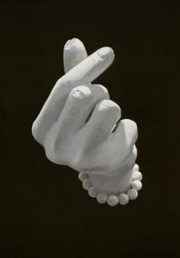  SUN Yiwen  Love at Your Fingertips, 2025  Oil on canvas  30 x 21 cm

4. Installation view
*The high-resolution images can be downloaded via the Google Drive link provided on the first page.

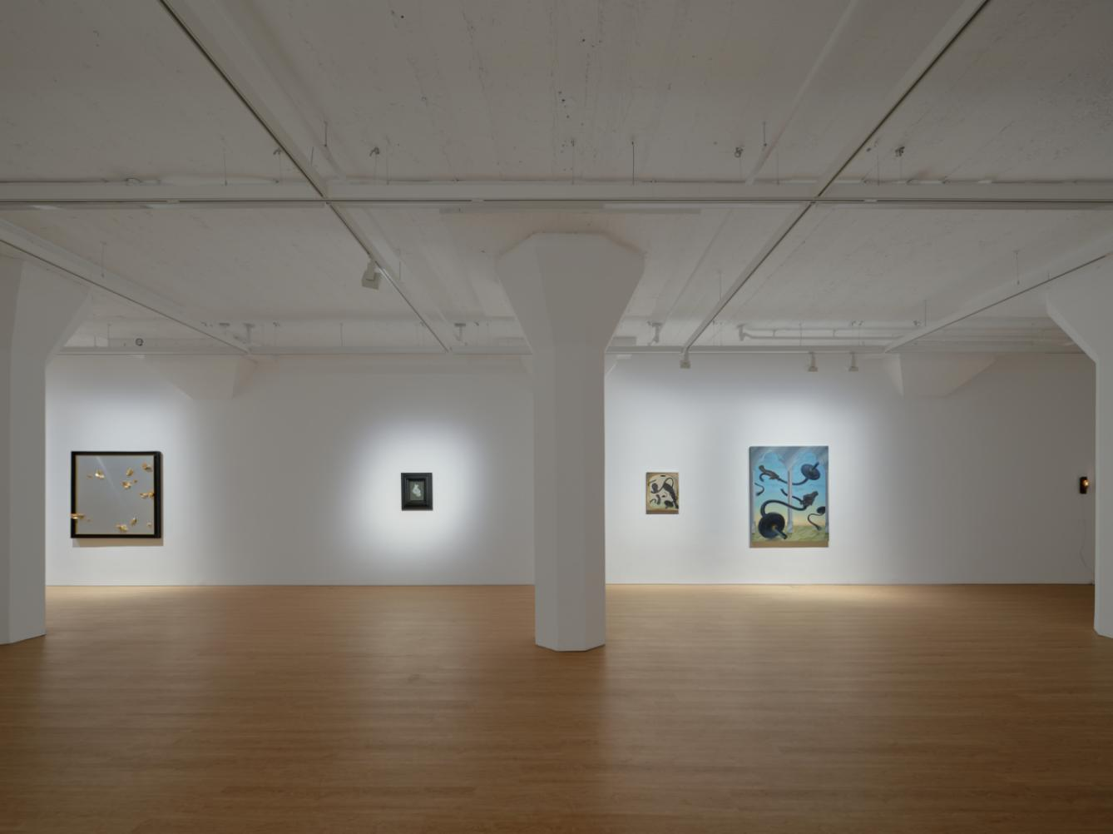 | 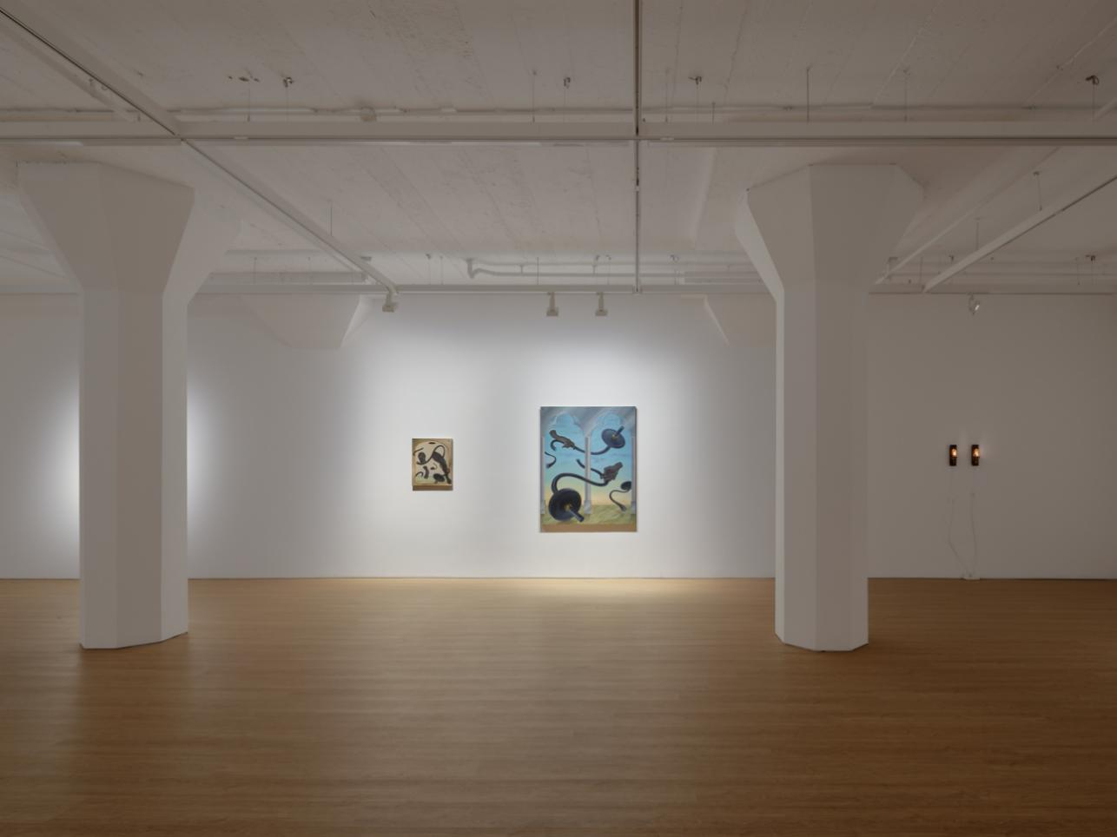
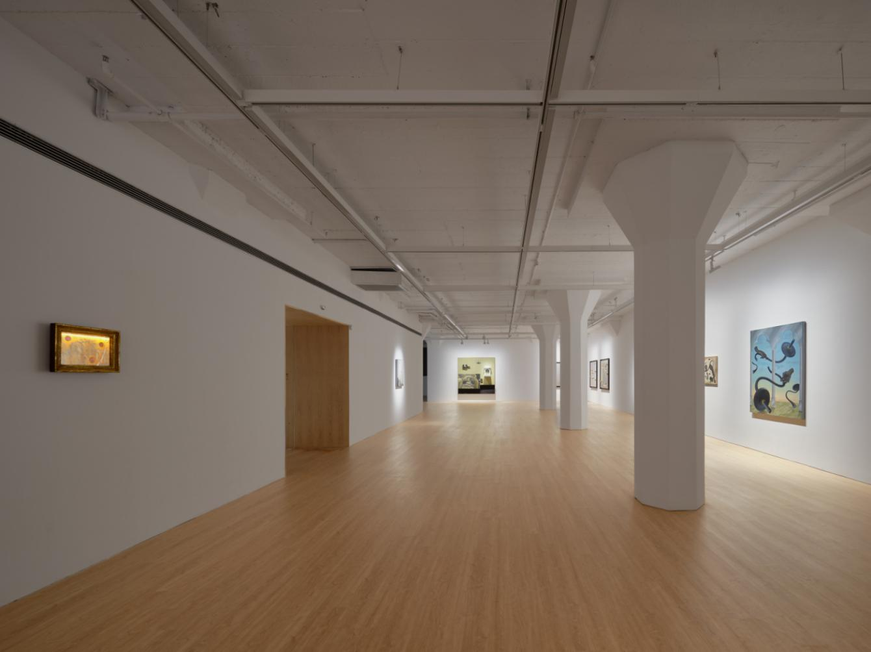 | 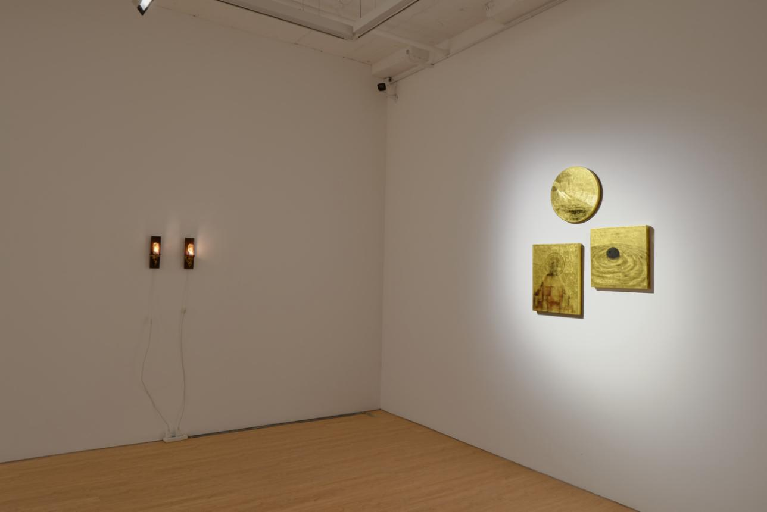
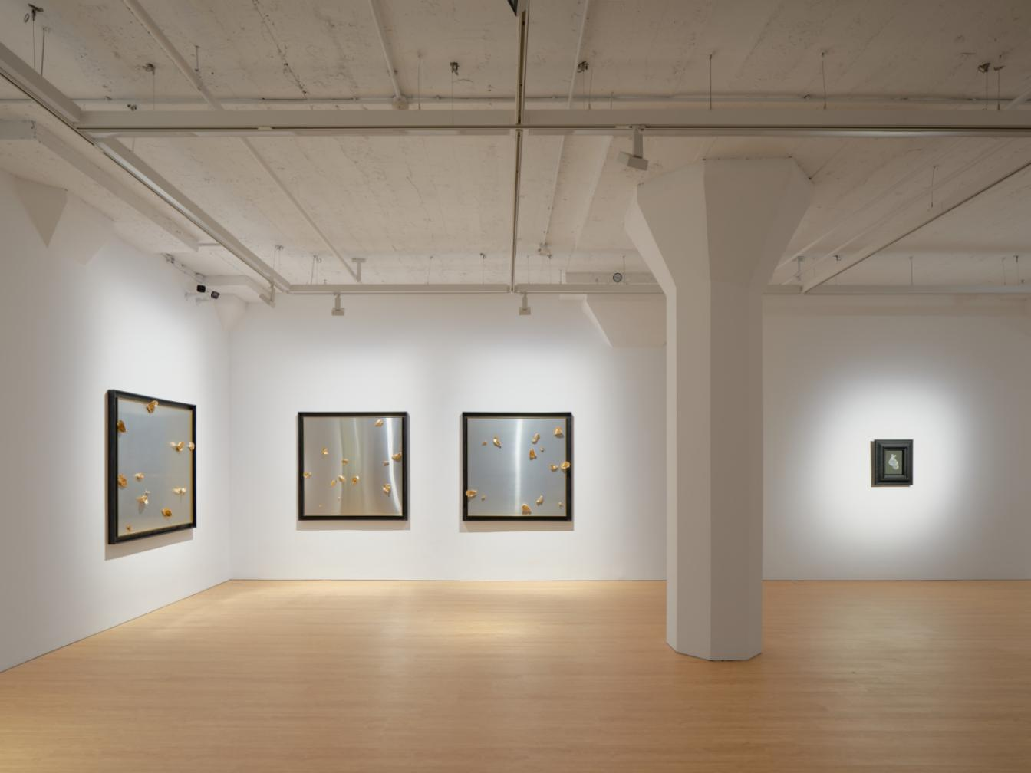 | 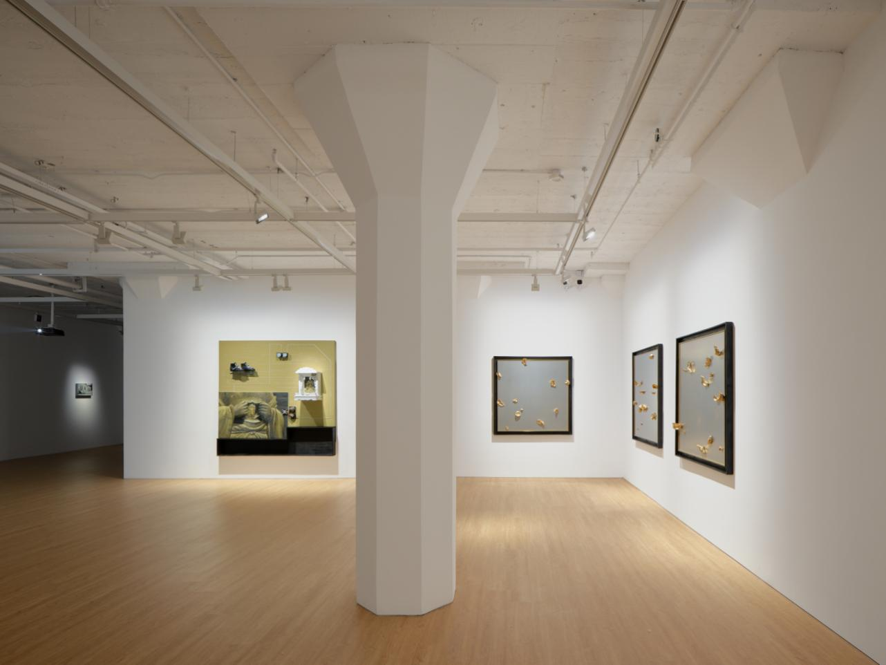
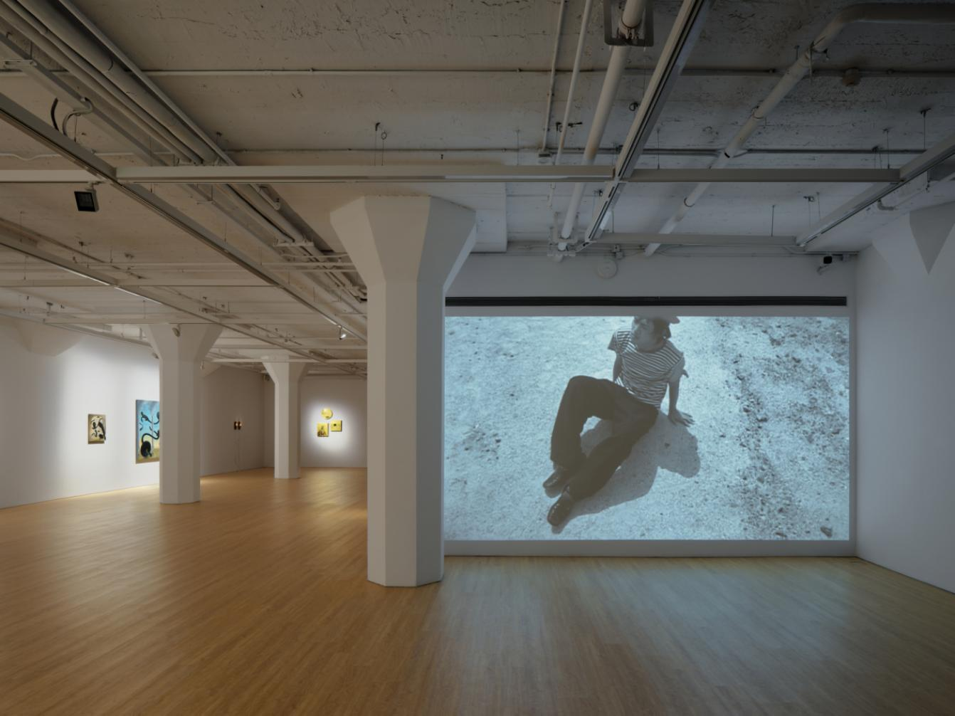 | 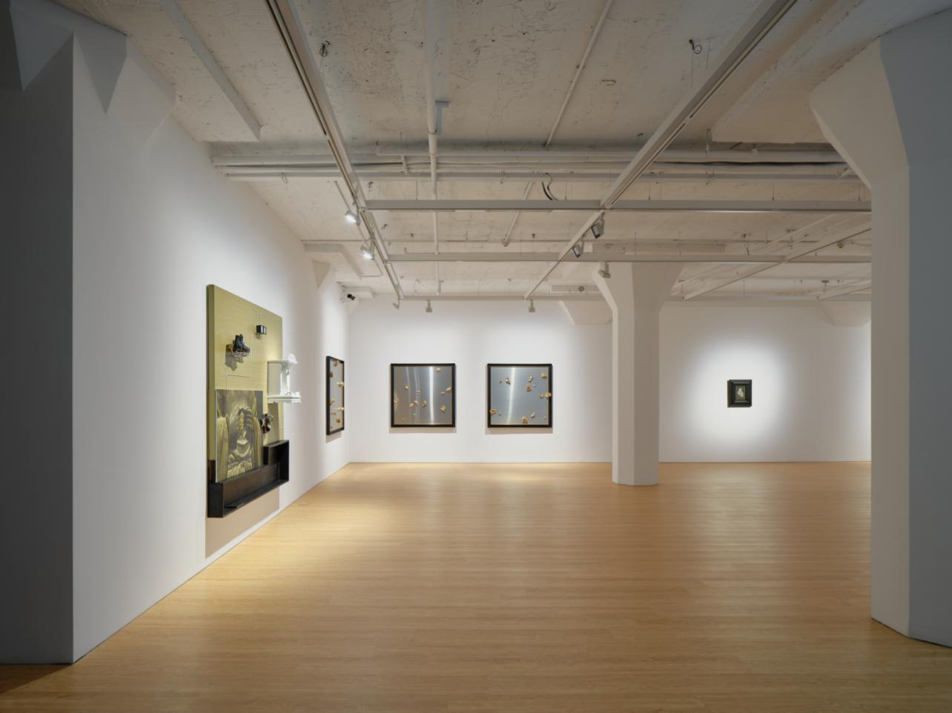
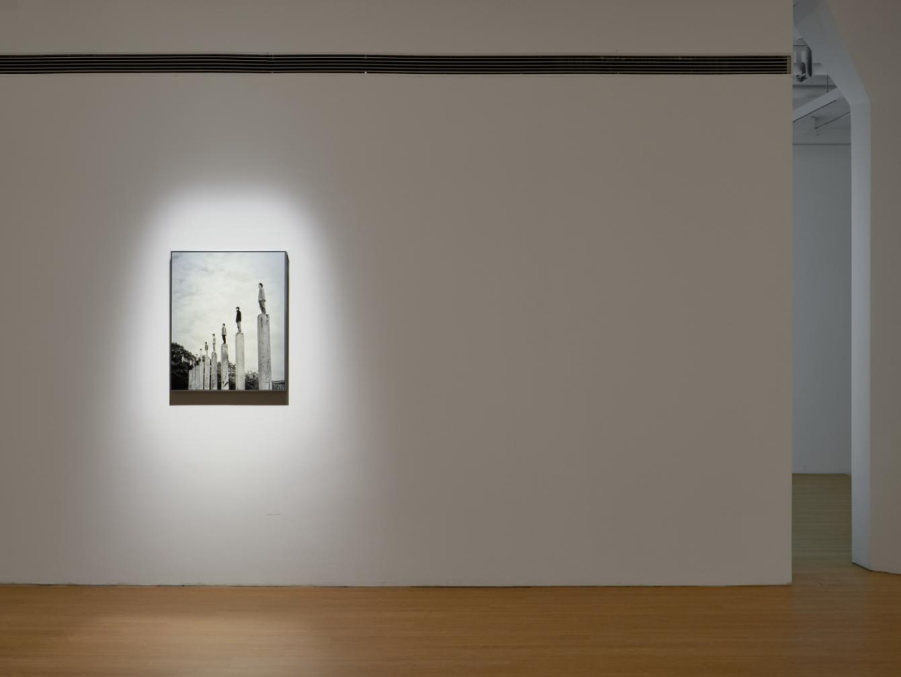 | 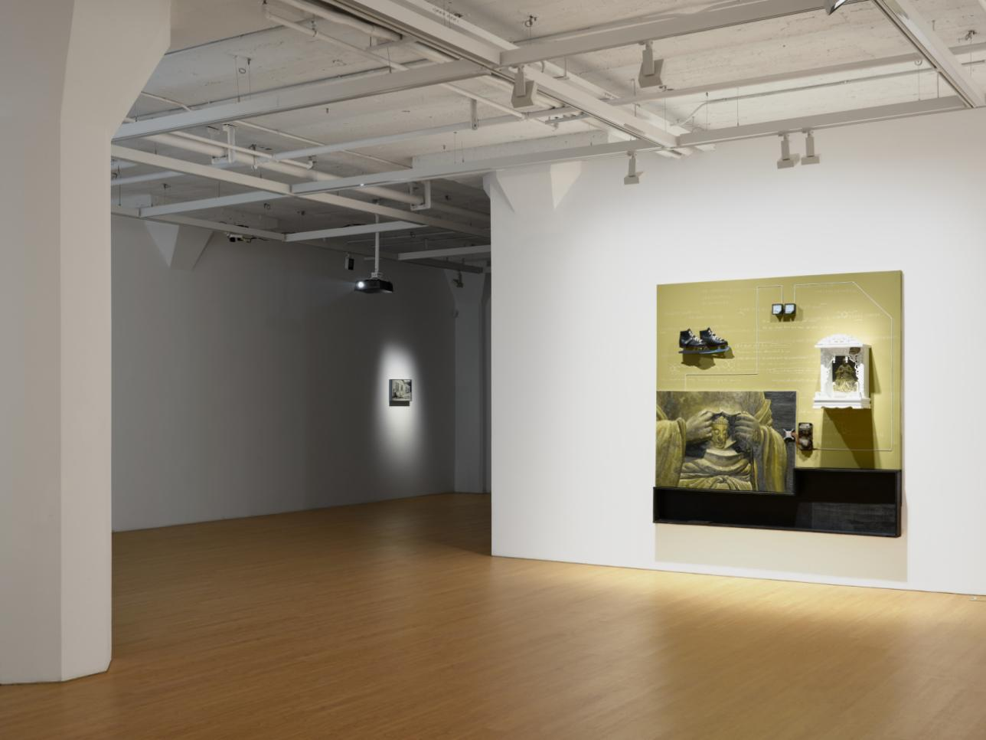
Installation view of After the Reaction at ARARIO GALLERY SHANGHAI, Shanghai, China, 2026.

5. Artists Introduction

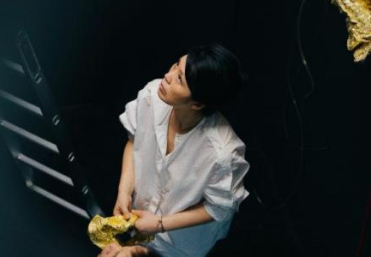 | CHEN Xiaozhi (b. 1980, Hunan) lives and works between Paris and Shanghai. Her practice moves fluidly between the “past” and the “future,” “creation” and “being created,” weaving together painting, sound installation, and sculpture to explore perception, memory, and the transformation of energy. Having worked extensively in art conservation, Chen regards restoration as a “science of seeing,” a method that shapes her temporal and sensory understanding of the world. Her works combine traditional materials such as gold leaf, ramie, and glass fragments with modern industrial residues—where gold leaf becomes both a sacred and eternal medium, a bridge between spirit and matter. Far from nostalgia, Chen’s engagement with ancient media seeks to rebuild emotional resonance within fragmented contemporary life, tracing how energy circulates across time. Through repetitive, meditative labor, she balances the mechanical and the transcendental, re-forging cultural remnants to open fissures in our accelerated era, where viewers may glimpse folds of time and the emergence of unseen possibilities.  CHEN Xiaozhi has held solo exhibitions including Carte Blanche – Réminiscence d’un futur antérieur at 743 ART Lab in Shanghai (2025) and The Time of Curiosity at Right Art Museum, Shanghai (2024). She presented double exhibitions in Paris, including Entre chien et loup: Chaotic Forest at OVISION Art Space (2022) and an artist jewelry collaboration with Vissi d’Arte at La Manufacture Art Space (2022). Her work has appeared in group exhibitions such as the 11th Art Shenzhen “Qianhe Art Space Group Exhibition” (2024), the Shenyang “Une voie perpétuelle –A Century of Franco-Chinese Art” exhibition (2024), PODADA group exhibition Verre églomisé Painting in Asnières-sur-Seine, France (2021), L’art s’invite in Asnières-sur-Seine (2021), and La Parade animale at Château d’Asnières, France (2019). Her works are held in public and private collections, including the public installation Harmony with the Light and Dust for the Beijing EP YAYING project by FRANCLIN AZZI ARCHITECTE, Dust Mirror Series – A Vacant Space in the former residence of Lu Xiaoman in Shanghai, and in international collections such as Vissi d’Arte Gallery in Paris and Atelier Yô Art Space in Avignon.

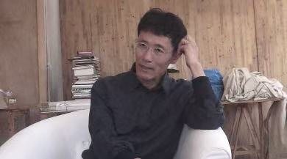 |  | LU Chunsheng (b. 1968, Jilin, China)'s work breaches the boundary between documentary and fiction. His conceptual and methodological coherence broadens and extends the inquiry into everyday life rather than merely illustrate it. LU is now focusing on photography and video art. In his work, he articulates a surrealistic and neutral attitude in his videos. Using fixed camera positions, endless drawn-out shots and unprofessional shooting techniques, he documents human behavior in bizarre situations. But unlike many of his fellow artists emerging from the same generation, he does not focus on the alienation following an accelerated urbanization (including its stream of rapidly moving images and perplexed inhabitants). Instead, he has developed an oeuvre that consists of characters in bizarre situations.  LU Chunsheng graduated from China National Academy of Fine Arts, Department of Sculpture. He has exhibited widely in China and abroad. He resides and works in Shanghai. Recent exhibitions include Vigorous shake and the after, the earth feature gets much clearer, prophecy comes into his mind, Vitamin Creative Space, Guangzhou, China (2014); Video Bureau Archive 6: Lu Chunsheng, Beijing/Guangzhou, China (2012); PERSPECTIVES: LU CHUNSHENG, Arthur M. Sackler Gallery, Washington D.C, U.S.A.(2011); Moving Image In China : 1988-2011, Minsheng Art Museum, Shanghai(2011); Lu Chunsheng, Part of Everybody Knows This Ss Nowhere: A Programme of International Moving Image, Stephensons Work, Newcastle, U.K.(2010); The Materialists are All Asleep, A Retrospective of Lu Chunsheng, The Red Mansion Foundation, London, U.K.(2008); 10th International Istanbul Biennial , Not only Possible, But also Necessary-Optimism in the Age of Global War, Istanbul, Turkey(2007); China Contemporary Art, Architecture and Visual Culture, Museum Boijmans van Beuningen, Rotterdam(2006), The Thirteen: Chinese Video Now, P.S.1 Contemporary Art Center, New York(2006), Out of Sight, De Appel Foundation, Amsterdam(2005), Double Vision, 1st Lianzhou International Foto Festival, Guangdong(2005) and Zooming Into Focus: Chinese Contemporary Photography and Video from Haudenschild Collection, National Art Museum, Beijing(2005) and subsequently in Mexico City and Shanghai.
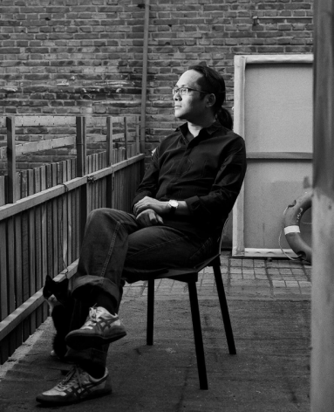 | YAN Heng (b. 1982, Liaoning, China) combines painting with installation to create an artistic form, by which to communicate with the audience and to convey the message he attempts to express. He has been holding a stubborn belief in figurative painting; has always been interested in the change of the society, development of scientific technology and the possibility they can bring to the humanity; as well as specializes in exploring unlimited possibilities in ordinary and simple daily life. Therefore YAN’s works are mostly re-expression of figurative characters, objects and external environment, and to reflect the artist's critical stance on man's excessive reliance on objects that invade the human cognitive domain by juxtaposing those old broken objects and paintings. YAN’s works are also persistent and well-balanced, sharing the characteristics of a wide amplitude of possibility and abundant amount of encoded stories and emotions.  YAN Heng has hold solo exhibitions and participated in group exhibitions in domestic and international art institutions. Selected solo exhibitions include From Dawn’s Breaking to the Gentle Dark, ARARIO MUSEUM TAPDONG CINEMA, Jeju, Korea (2025); Yan Heng: Spice, Lu Ban & Babylon, HOW Art Museum (2025); Absinthe, ARARIO GALLERY, Shanghai, China (2019); De la peinture, Galerie Sator, Paris, France (2016); Frequency Modulation (FM), ARARIO GALLERY, Shanghai, China (2016); Displacement, Wada Fine Arts, Tokyo, Japan (2015); Highway Inn, ARARIO GALLERY, Seoul, Korea (2014); LA BOTANIQUE DU RÊVE, Galerie Sator, Paris, France (2012) and many others. His works have been collected by ARARIO Collection, Yuz Museum, New Century Art Foundation and HOW Art Museum, as well as world famous private collectors.

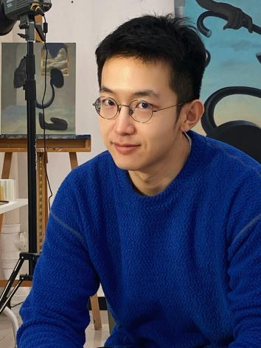 | SUN Yiwen (b. 1991, Liaoning, China)’s artistic practice investigates the relationship between industrial mass-produced objects and the alienated human body, while critically reflecting on issues of individual rights, social stratification, and consumerism. His easel paintings employ a diverse range of painterly languages, combining classical sensibilities with minimalist aesthetics. In parallel, he also works across multiple media, including installation and mixed media.  SUN Yiwen has held solo exhibitions at major institutions, including Rock Grows in Stillness at the China National Academy of Arts, Beijing, China (2022), and presented the art project On Detachment at Art Labor Gallery, Shanghai, China (2025). His selected exhibitions include The Cyclical Flow of the Four Seasons, Taimiao Art Museum, Beijing, China (2024); The Metaphysics Club, 20C Gallery, Beijing, China (2023); Linglong, PUPA Art Space, Shanghai China; Breath, Window Space, Shenyang, China; and the thematic section Botanical Life at West Bund Art & Design, Shanghai, China (2022). His art projects New Tiexi and Free Trade Time were supported by the National Arts Fund of China in 2022 and 2018 respectively. His works are in the permanent collections of the China National Academy of Arts, the CAFA Art Museum, and the Liaoning Provincial Art Museum.

- Artist CV

CHEN Xiaozhi
Born in 1980 Hunan, China
Lives and works in Paris and Shanghai

EDUCATION
2010 Master of Contemporary Art and Multimedia, Saint-Denis VIII University, Paris, France
2003 Bachelor of Mural Painting, Department of Central Academy of Fine Arts CAFA Pekin, Beijing, China

SELECTED SOLO EXHIBITIONS
2025 “Carte Blanche” Réminiscence d’un futur antérieur, 743 ART Lab, Shanghai, China
2024 The Time of Curiosity, Right Art Museum, Shanghai, China
2022 Entre chien et loup Chaotic Forest, OVISION Art Space, Paris, France
XIAOZHI CHEN et VISSI D’ARTE, La Manufacture Art Space, Paris, France

SELECTED GROUP EXHIBITIONS
2024 The 11th Art Shenzhen “Qianhe Art Space Group Exhibition”, Shenzhen, China
Une voie perpétuelle, Art week SHENYANG, Shenyang, China
2021 Verre églomisé Painting, PODADA, Asnières sur Seine, France
L'art s'invite, Asnières sur Seine, France
2019 La Parade animale, Asnières Castle, France

SELECTED COLLECTIONS
Franclin Azzi Architecte, Paris, France
Vissi d'Arte Gallery, Paris France
Atelier Yô Art Space, Avignon, France

LU Chunsheng
Born in 1968 China

EDUCATION
China Academy of Art, Major in Sculpture

SELECTED SOLO EXHIBITIONS
2014 “Vigorous shake and after, the earth's feature gets much clearer, prophecy comes into
his mind”, Vitamin Creative Space, Guangzhou, China
2012 “Video Bureau Archive 6: Lu Chunsheng”, Beijing/Guangzhou, China
2011 “Perspectives: Lu Chunsheng”, Arthur M. Sackler Gallery, Washington D.C, U.S.A.
2010 “Lu Chunsheng, Part of Everybody Knows This Is Nowhere: A Programme of International
Moving Image”, Stephensons Work, Newcastle, U.K
“Focus Shanghai - Lu Chunsheng and Birdhead”, Thomas Erben Gallery, New York, U.S.A.
2008 “The Materialists are All Asleep - A Retrospective of Lu Chunsheng”, The Red Mansion
Foundation, London, U.K.
2006 History of Chemistry 2 – Excessively Restrained Mountaineering Enthusiasts, Shanghart Gallery,
BizArt Art Center, at Paradise Theatre, Shanghai;Platform China, Beijing;Central Academy of
Fine Arts, Beijing, China
2005 “12+”, Shanghai Duolun MoMA, Shanghai, China
2004 “History of Chemistry”, Project Space Zip, Seoul, Korea

SELECTED GROUP EXHIBITIONS
2025 “The History of Chemistry”,Power Station of Art, Shanghai, China
2023 “Crossing the river by feeling the collectors”,C-PARK Haisu, Shanghai, China
2018 “Long March Project: Building Code Violations III – Special Economic Zone”,Guangdong Times Museum, Guangzhou, China
2015 “Slurping Soup and Peeing Quietly, and You Will Be Forbidden to Talk About Eternity”,Power Station of Art, Shanghai, China
2014 “V&P”, ShanghART Beijing, Beijing, China
2013 “Opening of SPA and the release of propaganda films”, Power Station of Art, Shanghai, China
“Move on Asia: Video Art in Asia 2002 to 2012”, ZKM, Karlsruhe, German
2012 “TransMedia Art & Fashion”, Shanghai Sculpture Space, Shanghai, China
2011 “Moving Image In China : 1988-2011”, Minsheng Art Museum, Shanghai, China
“Universo Video, MOVE ON ASIA, LABoral”, Centro de Arte y Creación Industrial, Asturias, Spain
“N Minutes Video Art Festival”, Shanghai, China
2010 “China Power Station: Part IV”, Pinacoteca Agnelli, Torino, Italy
“Reshaping History: Chinart from 2000-2009”, The Theme, China National Convention Center,
Beijing, China
“Jungle: A Close-Up Focus on Chinese Contemporary Art Trends”, Platform China, Beijing, China
“San Sheng Wan Wu, Opening Program of Zendai Contemporary Art Exhibition Hall”, Zendai
Contemporary Art Exhibition Hall, Shanghai, China
2009 “2009 German Week: Every Human Being Is an Artist”, Times Square, Shanghai, China
“Scene”, A Dialogue With Space & Time, River South Art Center, Shanghai, China
“Shanghai Kino”, KUNSTHALLE BERN, Switzerland
“Blackboard”, ShanghART H-Space, Shanghai, China
“Another Scene”, Artists' Projects, Concepts and Ideas, ShanghART H-Space, Shanghai, China
“Impossible, 8 Chinese Artists Engage Absurdity”, San Francisco Arts Commission Gallery & MISSION 17, San Francisco, U.S.A
"YEAR OF THE OX" : sound art, sculpture, film, and live performance from China and the UK”, V&A Museum, London,UK
“Our Future, The Guy & Myriam Ullens Foundation Collection”, Ullens Foundation, Beijing, China, 2008
“The World of Other's”, Museum of Contemporary Art, Shanghai, China
“Focus Shanghai”, New Video from China, Anthology Film Archives, New York, U.S.A.
“China!China!China!!! - Chinese Contemporary Art Beyond the Global Market., First Section of "40+4, Art Is Not Enough! Not Enough!"” Project, Fondazione Palazzo Strozzi, Firenze, Italy
“Fokus Kina, Riksutst, Llningar, Swedish Travelling Exhibitions”, Museum of Far Eastern Antiquities, Sweden
“Amateur World”, Platform China, Beijing, China
“China Power Station: Part III”，Mudam，Luxembourg
“IDA projects”，Creative Industries Block Space Gallery, Queensland University of Technology, Australia

YAN Heng
Born in 1982 in China.
Lives and works in Beijing, China.

EDUCATION
2007 Dept. of Oil Painting, the Lu Xun Academy of Fine Arts, Shenyang,

SOLO EXHIBITIONS
2025 From Dawn’s Breaking to the Gentle Dark, ARARIO MUSEUM , Seoul, Korea
2019 Absinthe, ARARIO GALLERY, Shanghai, China
2016 Frequency Modulation, ARARIO GALLERY, Shanghai, China
2014 Highway Inn, ARARIO GALLERY, Seoul, Korea
2012 La Botanique du Rêve, Galerie Sator, Paris, France
2011 Yan Heng, Gallery Yang, Beijing, China
Red Carpet, EGG Gallery, Beijing, China
2010 Fabled Landscape, Tang Contemporary Art, Hong Kong, China
2009 Freshness Preserved, Visual Space, Beijing, China

GROUP EXHIBITIONS
2013 B/D/RECT/ONAL PUNCTUM, Hive Center for Contemporary Art, Beijing, China
Artists with ARARIO 2012 Part 3, ARARIO GALLERY, Seoul, Korea
2012 Becoming Peninsula I: Symptoms, Iberia Center for Contemporary Art, Beijing, China
Attitude: Preview Exhibition to Schoeni's 20th Anniversary, Schoeni Art Gallery, Hong Kong, China
2011 Day Break, ARARIO GALLERY, Beijing, China
Image Mashup: Invitation Exhibition of Chinese Contemporary Oil Painting, HBMOA, Wuhan, China
The Pictures Meshed Up: Chinese Contemporary Invited Exhibition, Shenzhen Art Museum, Shenzhen, China
2010 One and One – Times Youth Artists 1st Exhibition, Times Art Museum, Beijing, China
In Times – Art Life Nights, Times Art Museum, Beijing, China
2009 Ten Years – The Art Gallery of Lu Xun Academy of Fine Arts, Shenyang, China
Unnamed – Recommendation Exhibition, Shanghai No.800 Art Museum, Shanghai / Beijing, China
Remix and Share – Creative Commons Art Exhibition, 798 Inter Art Center, Beijing, China
Integration · Digestion – 2007 Invitational Exhibition of Contemporary Chinese Oil Paintings, 798 SPACE, Beijing, China
2007 Today Art Student Annual Award Exhibition, Today Art Museum, Beijing, China
The Pictures Meshed Up: Chinese Contemporary Invited Exhibition，Shenzhen Art Museum, Shenzhen, China
Illusory · True – Lu Xun Academy of Fine Arts Exhibition of Young Artists，Beijing, China

SUN Yiwen
Born in 1991 in Liaoning, China.
Lives and works in Beijing, China.
Full-time artist at the China National Academy of Arts.

EDUCATION
2016 Master of Fine Arts, Oil Painting Department, Central Academy of Fine Arts (CAFA)
2013 Bachelor of Fine Arts, Oil Painting Department, Central Academy of Fine Arts (CAFA)

SOLO PROJECTS
2022 Solo Exhibition Rock Grows Freely ,Chinese National Academy of Arts, Beijing, China
New Tiexi receives funding from China National Arts Fund 2022 Annual Fine Arts Creation Project, Beijing, China
2018 Free Trade Time receives funding from China National Arts Fund 2018 Annual Project for Young Art Creators, Beijing, China

SELECTED GROUP EXHIBITIONS
2025 Escapology of Flesh”, Art Labor Gallery, Shanghai, China
2024 Four Seasons in Unison — Artworks Exhibition of Chinese National Academy of Arts, The Imperial Ancestral Temple Art Museum, Beijing, China
Metaphysical Club, 20C Gallery, Beijing, China
2023 Linglong, PUPA Art Space, Shanghai, China
Newcomers of the Times — Exhibition for the Recommendation Project of Young Artists by Chinese National Academy of Arts, Beijing, China
Breath & Sigh, Window Space, Shenyang, China
2022 Thematic Unit "Plant . Grow"of West Bund Art & Design Fair, West Bund Art Center,Shanghai, China
2021 Virtue Through Aesthetic Education - Plastic Arts of the Central Academy of FineArts, National Centre for the Performing Arts, Beijing, China
2018 The Second Youth Painter Exhibition by Beijing Jin Shangyi Art Foundation, ChineseAcademy of Oil Painting, Beijing, China
Observing- Young Artist Recommendation Exhibition, 798 Auction Center, Beijing, China
2016 The First Huajiadi Biennale, Huajiadi Community, Beijing, China
2015 Dynamics Revisited - Dynamic Images Exhibition, CAFA Art Museum, Beijing, China
2014 Works of New Artists in the Third Plastic Arts Exhibition, National Art Museum of China, Beijing, China
2011 Excavating . Discovering - The Second China Oil Painting Exhibition of Newcomers, Chinese Academy of Oil Painting, Beijing, China

SELECTED COLLECTIONS
2024 Bacon’s Flower permanently collected by Chinese National Academy of Arts
2016 Times permanently collected by CAFA Art Museum
2014 The High Heels Makes Her Nervous and Fat Girl Sleeping in Fatigue permanently collected by Central Academy of Fine Arts
2013 Madonna permanently collected by Liaoning Art Museum

