ARARIO GALLERY SHANGHAI
WANG Chen
Touching Red

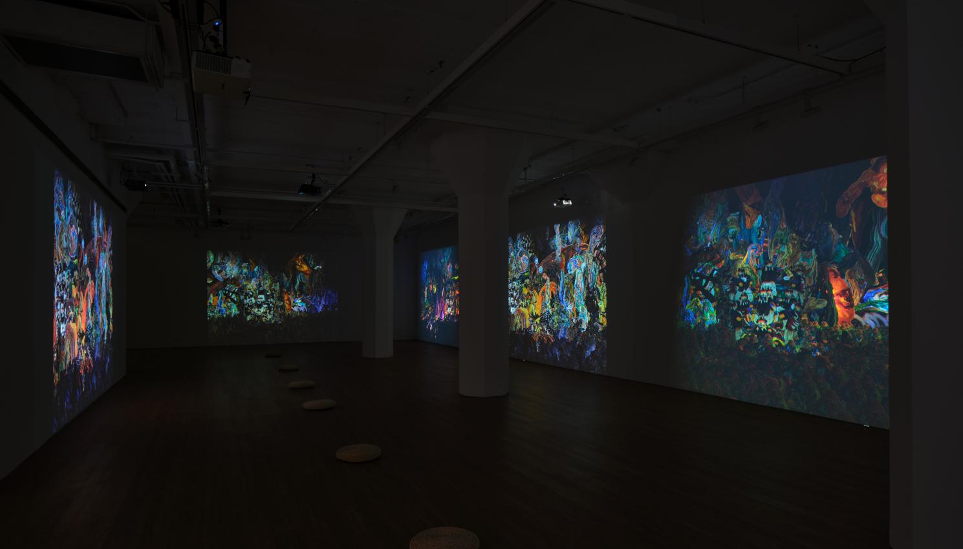
Installation view of WANG Chen: Touching Red at ARARIO GALLERY SHANGHAI, Shanghai, China, 2026.

Artist  Title  Dates  Venue  Artworks | :  :  :  :  : | WANG Chen (b.1991, China)  Touching Red  14 Mar – 9 May 2026  ARARIO GALLERY SHANGHAI (205, 30 Wen'an Road, Jing'an District, Shanghai, China)  1 video installation, 3 sculptures in total
[Artwork images and Installation view]
https://drive.google.com/drive/folders/1qD0Uoeu91W6pLSs7p3lljwwGt0YbZ0A2?usp=drive_link

[Inquiry]
ARARIO GALLERY | E. info@arariogallery.com
SUN Qidong, Director | E. sunqidong@ararioshanghai.com

Table of Content | 1. Exhibition Overview  2. Artworks  3. Installation view  4. Artist Introduction  5. Artist CV | -------------------------------------------------------------------------- 2  -------------------------------------------------------------------------3-5  -------------------------------------------------------------------------6-8  ---------------------------------------------------------------------------9  -----------------------------------------------------------------------9-11

1. Exhibition Overview

ARARIO GALLERY SHANGHAI is pleased to present Touching Red, a solo exhibition by WANG Chen (b.1991), on view from March 14 to May 9, 2026. The exhibition marks a significant stage in the artist’s recent practice. Through a three-channel video installation and newly created wooden sculptures, WANG constructs a “third space” situated between primal material textures and digital illusion. In this body of work, her focus expands toward a broader process of becoming, examining how life continues to manifest, transform, and exist amid the loosening and reconfiguration of order.
The central video work, Touching Red, seeks to demythologize the concept of “symbiosis.” Within the internal logic of the work, symbiosis is stripped of its idealistic veneer and restored to a state of inherent hybridity and entropy. The irreducible complexity between living entities reveals not only disorder and stagnation, but also a form of primordial violence. Structured as a precisely choreographed three-channel loop, each screen operates as an independent narrative fragment while simultaneously forming an interdependent whole within space. Moving from “complex symbiosis” to “conflictual extension,” and ultimately to “the subversion of order,” the work undergoes continual reconfiguration, presenting a mode of existence that resists assimilation into a single logic. This multi-screen spatial arrangement challenges the act of viewing: the audience cannot remain within a stable, singular perspective, nor arrive at a definitive interpretation. Through this displacement of viewpoint, established visual orders are diluted, allowing life to return to a dimension of irreducible complexity beyond containment.
Within WANG’s practice, the highly digital visual effects that characterize the final imagery stand in compelling tension with the intensive physical labor at their origin. From the hand-drawn design of textures to costume-making and embodied performance, tactile traces are preserved within each frame of the moving image. The artist investigates how the “density” and “weight” of labor might be restored to lightweight virtual imagery, ensuring that the body and its exertion remain central to image production. The mutable forms that appear onscreen are the result of sustained negotiation between physical effort and digital space, retaining within the virtual dimension the soreness of muscles and the warmth of fingertips—thereby establishing a tangible thickness distinct from purely algorithmic generation.
This exhibition also marks a significant shift in WANG’s sculptural medium. The introduction of wood does not replace previous material explorations; rather, it extends them. Wood preserves a more immediate and organic fibrous structure, allowing traces of growth and temporality to remain visible. Its inherent vitality and openness resonate with the thematic concerns of symbiosis. The sculptural series Touch embodies a “depersonalized” quality, with forms hovering at the threshold between animal, insect, and wooden structure, resisting fixed classification. Areas of blue pigment applied to the surfaces function like fragments of a “Blue Screen,” visually tearing open a passage into a virtual dimension. This blue is not merely chromatic intervention; it generates a speculative field, suggesting a future that remains indeterminate.
WANG likens the relationship between video and sculpture to that of mural and statue within an ancient temple. The moving image, like a mural, inhabits a fluid and continuously generated third space; sculpture, by contrast, occupies a material position between two-dimensional plane and three-dimensional volume. Together, they form a structure that is at once separate and interdependent. This configuration gestures toward a more primordial logic of exchange—one grounded in instinctual survival and the circulation of energies rather than modern systems of classification and order. Whether through the philosophical imagination of Becoming Animal or the intimate tactility of wooden grain, the works reactivate modes of perception not yet fully codified. Within the field of Touching Red, order is gradually loosened through entanglement, and life emerges from the fissures of tension and violence, seeking a new and more resilient mode of symbiosis.

2. Artworks
*The high-resolution images can be downloaded via the Google Drive link provided on the first page.
*When using artwork images, please include the following copyright credit: ©2026. WANG Chen. Courtesy of the Artist and Arario Gallery.

Featured Images
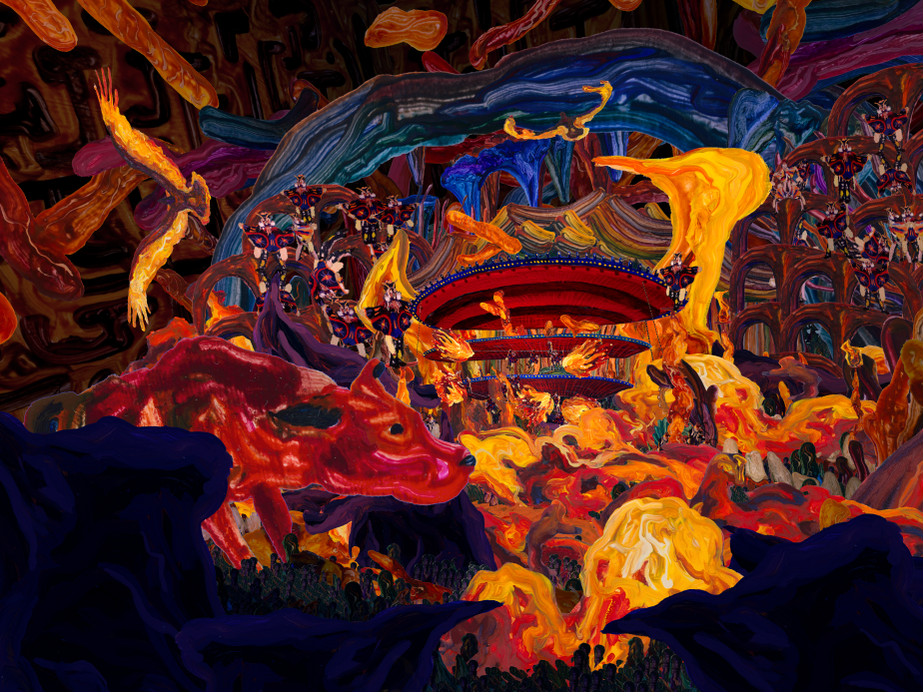
WANG Chen, Touching Red (still), 2026, Three-channel 4K video with sound, 15 min 43 sec
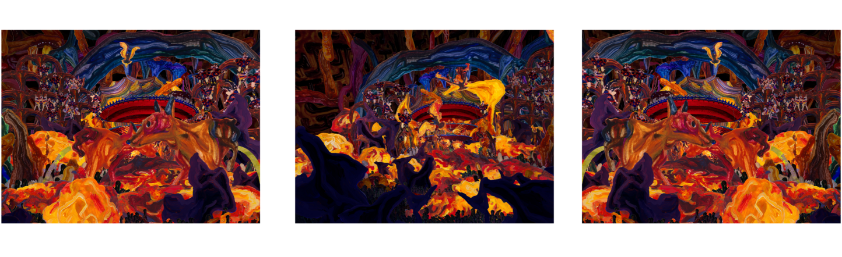
WANG Chen, Touching Red (still), 2026, Three-channel 4K video with sound, 15 min 43 sec
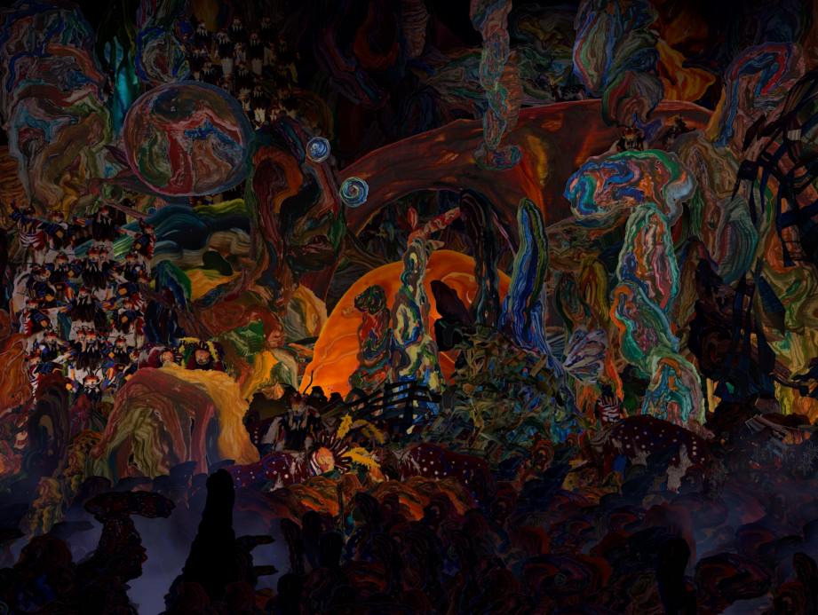
WANG Chen, Touching Red (still), 2026, Three-channel 4K video with sound, 15 min 43 sec
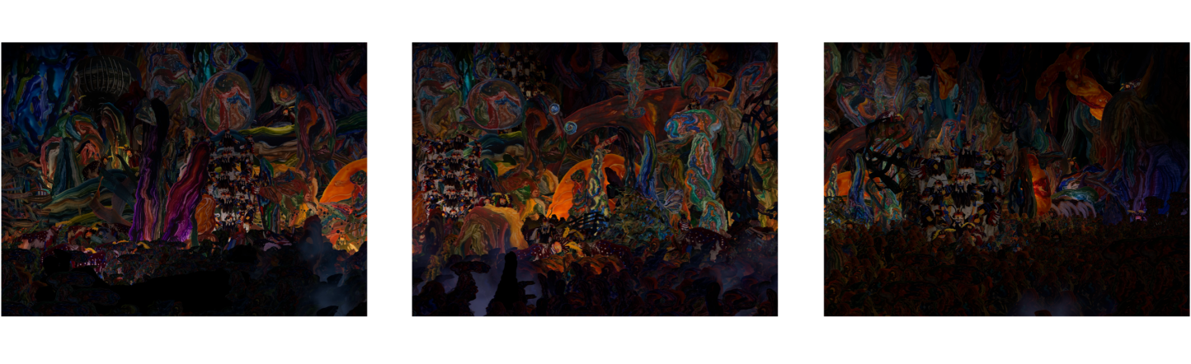
WANG Chen, Touching Red (still), 2026, Three-channel 4K video with sound, 15 min 43 sec
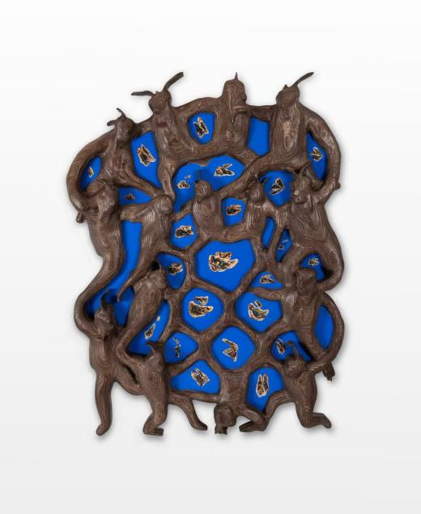  WANG Chen, Touch I (2026)  Wood and acrylic, 101.6 x 68.6 x 7.6 cm | 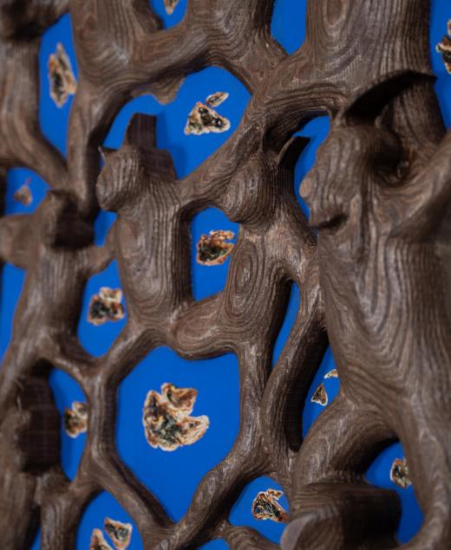  WANG Chen, Touch I (detail) (2026)  Wood and acrylic, 101.6 x 68.6 x 7.6 cm
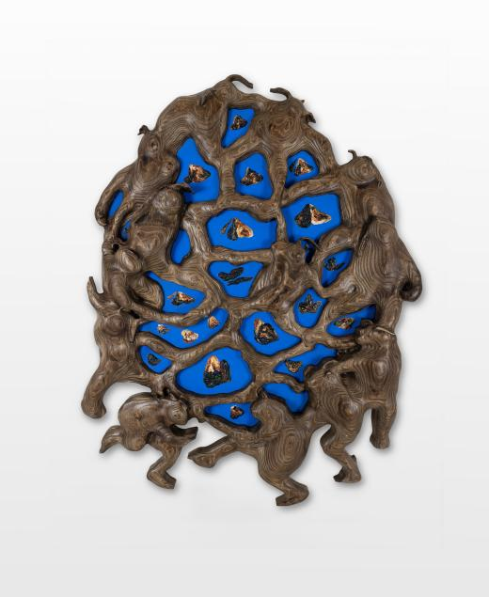  WANG Chen, Touch II (2026)  Wood and acrylic, 101.6 x 74.9 x 7.6 cm | 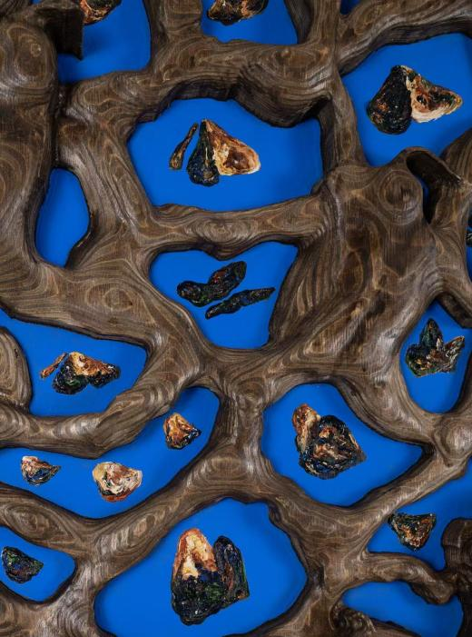  WANG Chen, Touch II (detail) (2026)  Wood and acrylic, 101.6 x 74.9 x 7.6 cm
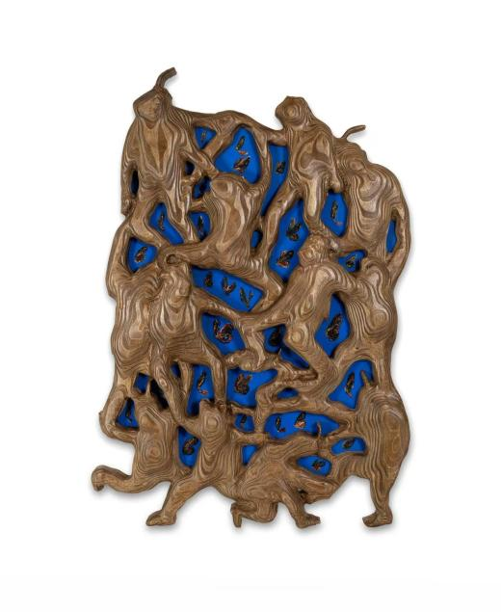  WANG Chen, Touch III (2026)  Wood and acrylic, 101.6 x 74.9 x 7.6 cm | 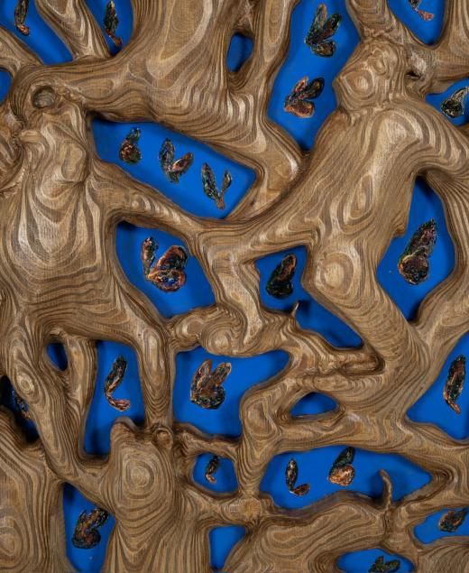  WANG Chen, Touch III (detail) (2026)  Wood and acrylic, 101.6 x 74.9 x 7.6 cm

3. Installation view
*The high-resolution images can be downloaded via the Google Drive link provided on the first page.

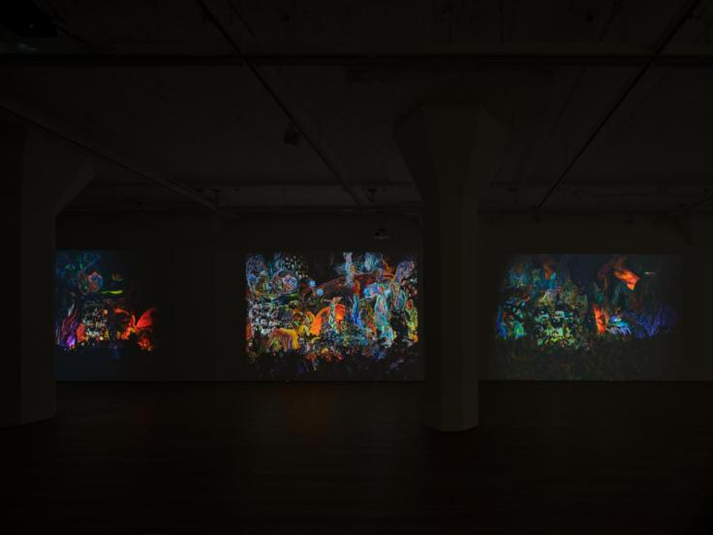 | 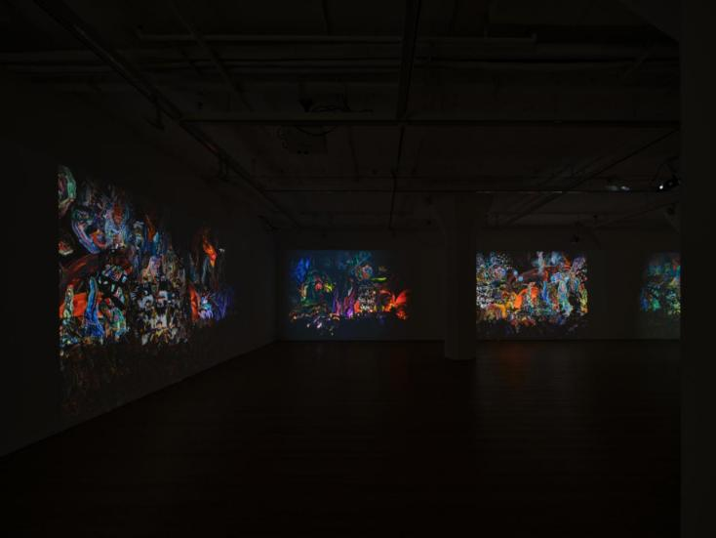
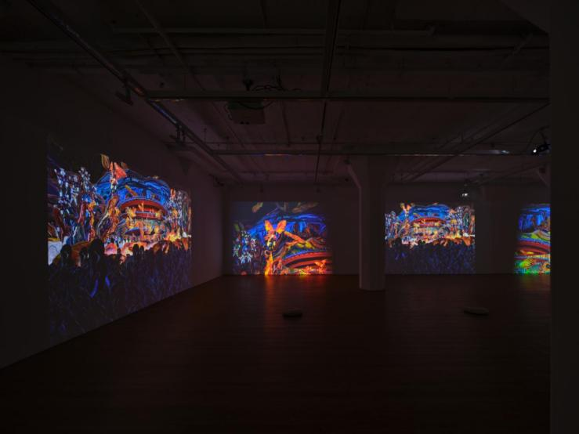 | 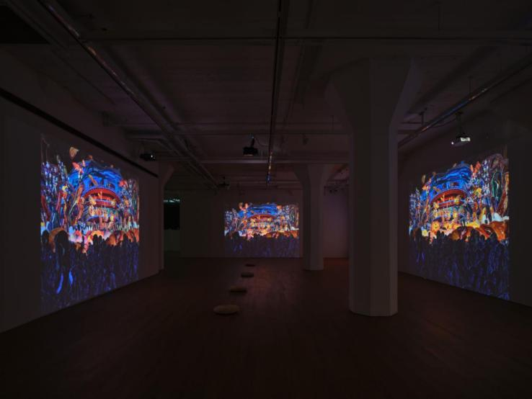
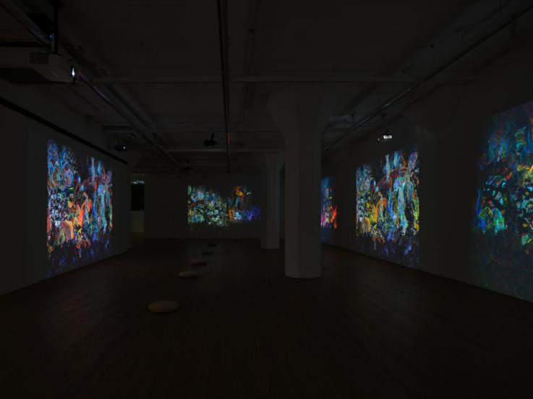 | 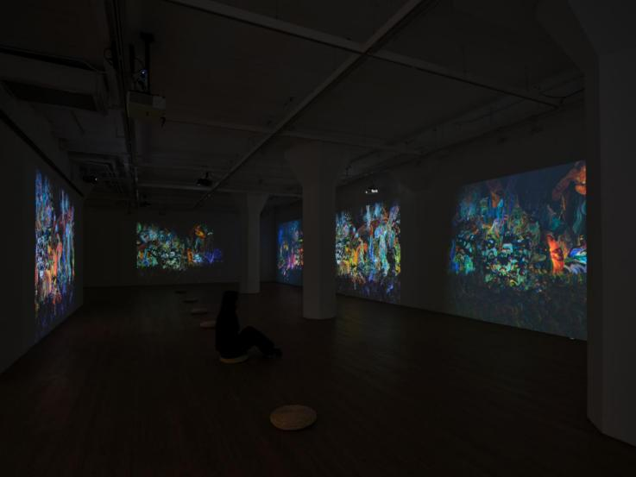
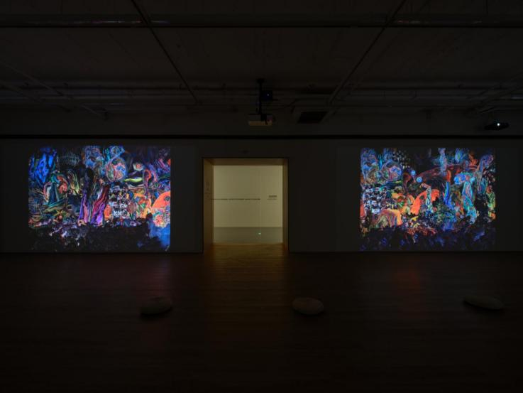 | 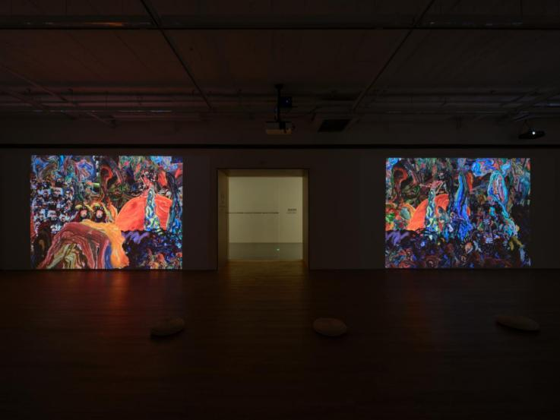
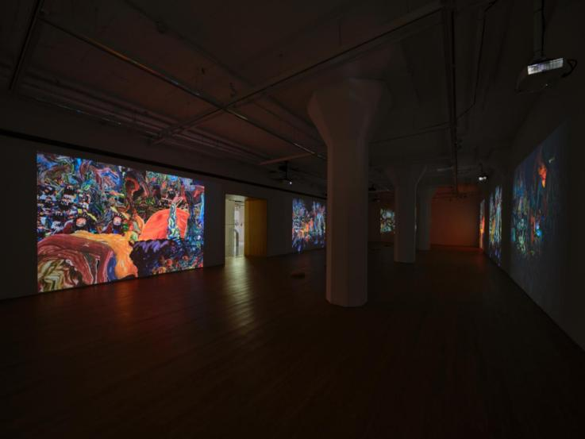 | 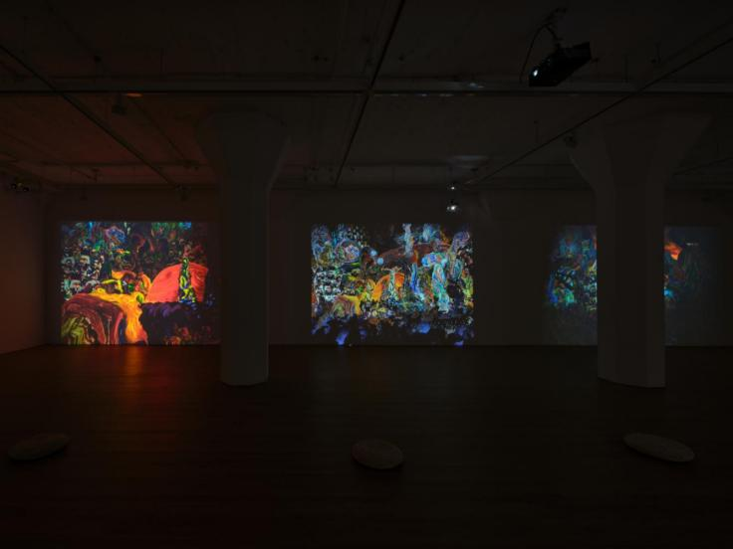
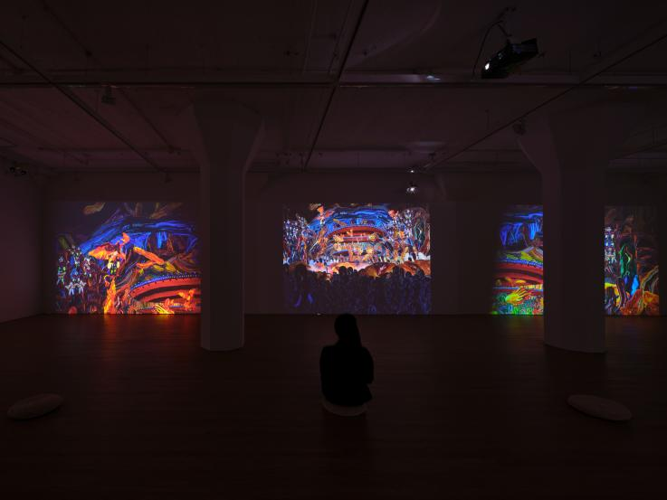 | 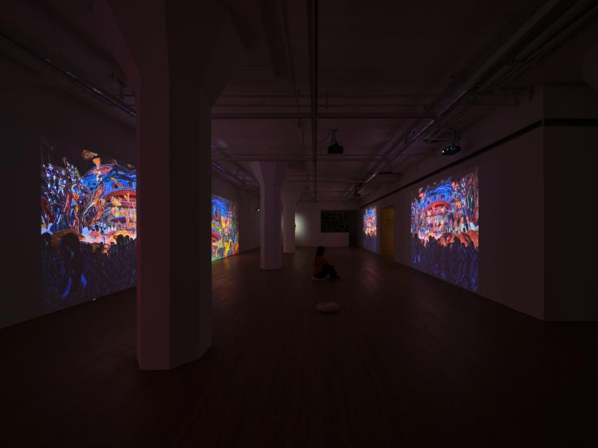
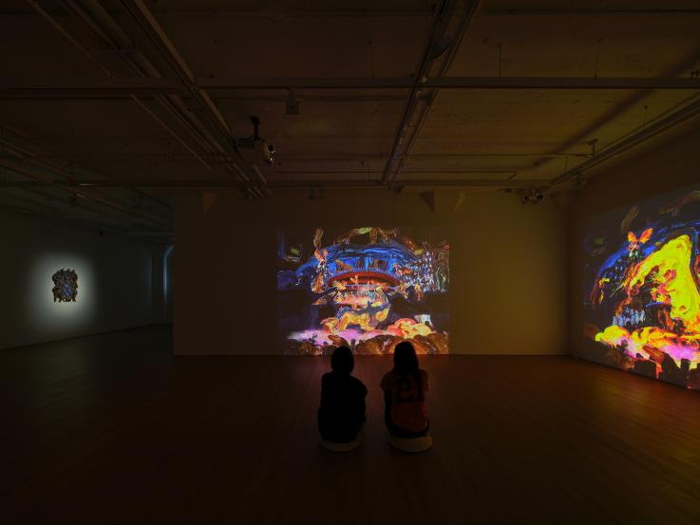 | 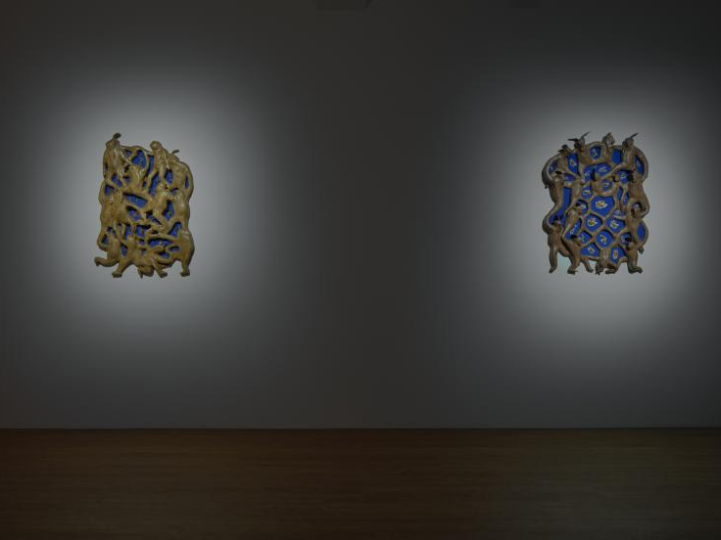
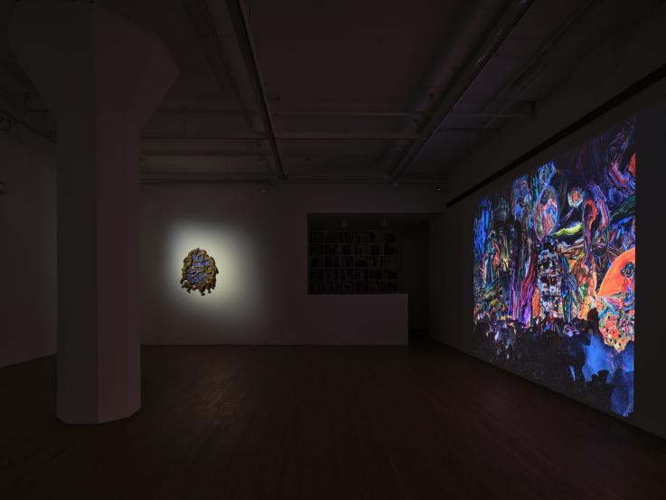 | 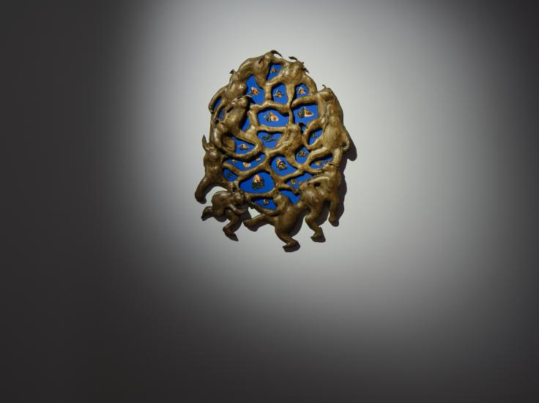
Installation view of WANG Chen: Touching Red at ARARIO GALLERY SHANGHAI, Shanghai, China, 2026.

4. Artist Introduction

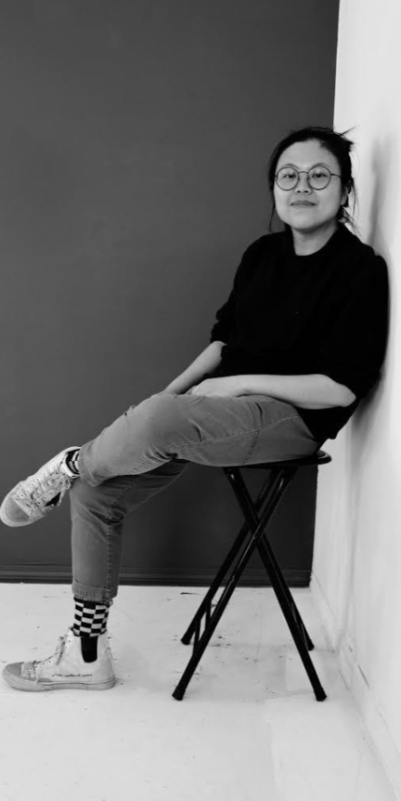  The artist WANG Chen. | Wang Chen (b. 1991, Hohhot, China) is a multidisciplinary artist based in the United States. Their practice spans video, drawing, performance, animation, and sculpture. By layering these mediums, Wang constructs immersive alternate realities to explore the complexity of coexistence between physical labor and virtual spaces.  Wang holds a BFA in Painting and Printmaking from Virginia Commonwealth University (2014) and an MFA in Photography from the Rochester Institute of Technology (2018). Solo exhibitions have been held nationally and internationally. Fellowships and residencies include the New York Foundation for the Arts (Interdisciplinary), MacDowell Fellowship, and Roswell Artist-in-Residence. They currently teach at Penn State University in State College, PA.

5. Artist CV

WANG Chen (b.1991)
Education
2018 MFA Photography and Related Media, Rochester Institute of Technology, Rochester, NY
2014 BFA Painting + Printmaking, Virginia Commonwealth University, Richmond, VA

Solo Exhibitions
2024 Synaptic Forest, 212 Photography Istanbul, Istanbul, Turkey
Fractured Delights, Fotografiska Museum, Tallinn, Estonia
Synaptic Forest, Fotografiska Museum, Shanghai, China
2023 Metamorphosis, Embodied, Handwerker Gallery, Ithaca College, Ithaca, NY
Fractured Delights, Gallery 51, Massachusetts College of Liberal Arts, North Adams, MA
2022 Tintinnabulations, Lauren Powell Project, Los Angeles, CA
2021 In the Woods, Roswell Museum, Roswell, NM
The Sin Park, Fotografiska Museum, Stockholm, Sweden
2019 The Sin Park, TSI / Harland Snodgrass Media Gallery, Alfred University, Alfred, NY
The Sin Park, Crosstown Arts, Memphis, TN
Group Exhibitions / Screening
2025 15 Fotografiska Years, Fotografiska Museum, Stockholm, Sweden
Overlapping Shadows, NAFI 2025 Nanjing International Art Season Main Exhibition (Presented by Arario Gallery), Sifang Art Museum, Nanjing, China
Ripple Effect, ArtPrize at Resonant Gallery, Grand Rapids, MI
2024 Arario Collection, Arario Museum, Jeju, South Korea
17 Days Video Series, Western Michigan University, Kalamazoo, MI
2023 Hello Animation Festival, Tulsa, OK
Alt-World, Rochester Contemporary Art Center, Rochester, NY
2022 Cute Gloom, Lauren Powell Project, Los Angeles, CA
2021 “Ren Zhi Chu,” ZAZ Corner Billboard, Times Square, NYC
Clock-Watching, Site-Specific Projection, Daniels & Fisher Tower, Black Cube Nomadic Museum, Denver, CO
2020 Homeland, The Immigrant Artist Biennial, NYC
E-motional Support Group, Curator: Lauren Powell
2019 Avatar Poetics, Rochester Contemporary Art Center, Rochester, NY
Satellite Art Show NYC, Paradice Palase, New York
Behind the Scene, NARS 2019 Season III Residency Exhibition, NYC
Wild, Wild Earth, New York Live Arts, New York
Pleasure in Precariousness, Thomas Erben Gallery, NYC
Multiversant, ChaShaMa, 340 E 64 St, NYC
EveryWomen Biennial, Film Category, NYC
Travels Through the Unreal, Outpost Artists Resources, NYC
Light Year 47: Tales of Diverted Reality, Manhattan Bridge, Light Year and Chanorth, NY
2018 Stockholm Fringe Festival, Stockholm, Sweden
Off the Wall 2018, Art + Literature Laboratory, Madison, WI
Midnight, Paradice Palase, Brooklyn, NY
Maracay International Film & Video Festival, Maracay, Venezuela
Scenes from an Unwritten Fairytale, Lefktron Castle Beaufort Festival, Mani, Greece
Video Art Miden, Archaeological Museum of Messenia, Kalamata, Greece
Just Experimenting: Playing the Sexual Edge of Film, Center for Sex and Culture, San Francisco
The Cube Art Project Biannual Competition, The Cube Art Project, Lincoln, NE
Future Artifact: Creative Tech Week Exhibition, Plexus Projects, Brooklyn, NY
CuratorSpace: Digital Art Exhibition, Leeds Digital Festival, Leeds, UK
BF Film Festival VI, The Bomb Factory Art Foundation, London, UK
Redefining, Jiye Art Museum, Suzhou, China
2017 Illuminate, ImageOut and NeighborWorks at the Point, Rochester, NY (Pop-up Event)

Awards / Residencies / Grants
2025 Golden Foundation Residency, New Berlin, NY
2022–23 Benedetti Fellowship, MCLA Arts & Culture, Massachusetts College of Liberal
Arts, North Adams, MA
2022 MacDowell Fellowship, Peterborough, NH
2021 New York Foundation for the Arts Fellowship (Interdisciplinary), New York
2020–21 Roswell Artist-in-Residence Program, Roswell, NM
2019 Institute for Electronic Arts Residency, Alfred University, NY
Fellowship Recipient, NARS Foundation Residency, NY
Crosstown Arts Residency, TN
2018 New York Foundation for the Arts Immigrant Artist Mentoring Program, NY
Vermont Studio Center Fellowship, VT
MASS MoCA Studio Residency, MA
RIT Juried Video Competition, Rochester Institute of Technology, Rochester, NY
ChaNorth / ChaShaMa Summer Residency, NY
Best in Show, Midnight, Paradice Palase, Brooklyn, NY
The Shell House Summer Artist Residency, NY
2nd Place Prize, Just Experimenting: Playing the Sexual Edge of Film, Center for Sex and Culture, San Francisco
1st Place Grand Winner, The Cube Art Project Biannual Competition, Lincoln, NE

