ARARIO GALLERY SHANGHAI
Huang Hankang: The Sky Remains as the Bird Departs

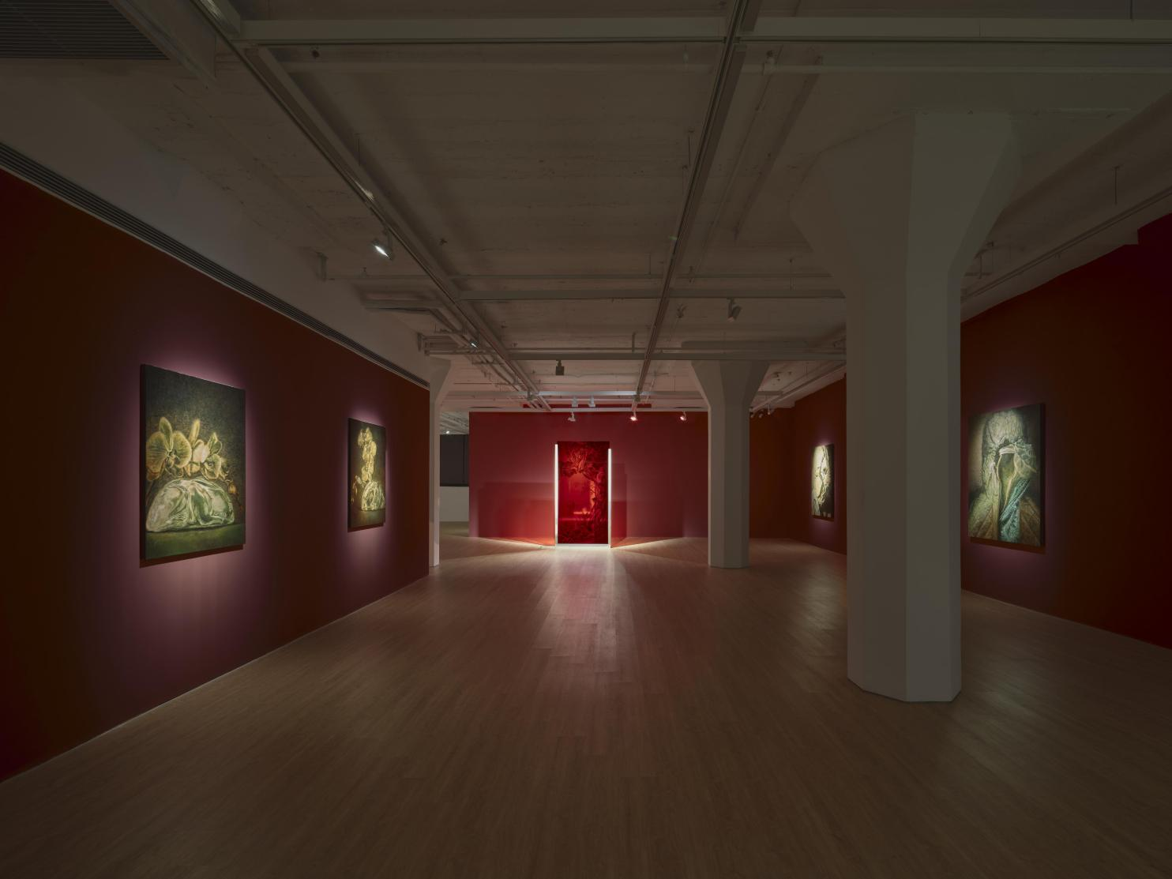
Installation view of Huang Hankang: The Sky Remains as the Bird Departs at ARARIO GALLERY SHANGHAI, Shanghai, China, 2026.

Artists  Title  Dates  Venue  Artworks | :  :  :  :  : | HUANG Hankang  The Sky Remains as the Bird Departs  15 May – 4 July 2026  ARARIO GALLERY SHANGHAI (2F-205, 30 Wen’an Road, Jing’an District)  16 pieces in total
[Artwork images and Installation view]
https://drive.google.com/drive/folders/1XlACHvaQuaUKjppD176pLQYhA3xUxfG3?usp=drive_link

[Inquiry]
ARARIO GALLERY SHANGHAI | E. info@arariogallery.com

Table of Content | 1. Exhibition Overview  2. Exhibition Theme  3. Artworks  4. Installation View  5. Artist Introduction  6. Artist CV | ---------------------------------------------------------------------------3  -------------------------------------------------------------------------3-4  -------------------------------------------------------------------------4-9  ----------------------------------------------------------------------10-11  ----------------------------------------------------------------------11-12  ----------------------------------------------------------------------12-13

1. Exhibition Overview

ARARIO GALLERY SHANGHAI is honored to present HUANG Hankang's solo exhibition “The Sky Remains as the Bird Departs” from May 15 to July 4. Taking Shanghai as its point of departure, this exhibition does not regard the city as a singular backdrop, but rather as a continuously operating "processing system"—a site where images, histories, and cultures from different sources are constantly received, translated, and reassembled. The exhibition is less concerned with the representation of "China" than with how this concept is continuously generated through processes of cross-cultural dislocation, juxtaposition, and re‑entry into reality. The viewer enters a space interwoven with multiple temporalities and scales: history no longer unfolds linearly but reveals its structure through continual rewriting.

2. Exhibition Theme

Through installations and paintings, the exhibition folds multiple visual and historical threads into a single structure. The core installation The Gate of Flesh and Soul juxtaposes Giuseppe Castiglione's hybrid visual language, the Cathay Theatre as a modern visual channel, and historical fragments surrounding George Washington's dentures, causing imperial imagery, urban experience, and bodily memory to collide and exert tension within the same space. Addressing the relationship between "nature" and "intervention," Overlaid Life and Wandering Shadow take as their respective points of departure a Yuan dynasty crystal rabbit and artificially cultivated phalaenopsis orchids, and a Liao dynasty hunting image. They present material properties, formal control, and cultural assimilation side by side, continually rewriting the boundary between generation and domestication.
This process of translation also operates on perception and the body. In paintings such as Void Resonance, figures are suspended between protection and isolation, their faces replaced by conch-like structures, shifting the relationship between person and world toward indirect experience mediated through an interface. Nameless Mark features cupping-glass marks, presenting the body as a medium in a state of continuous inscription and transmission. In the series Wind Orifice, forms drift through porous structures like the path of wind, manifesting a condition of ongoing mutation within existing constraints. Across the exhibition, different works intertwine to form an unstable perceptual system, in which experience is constantly being translated and reorganized.
The relationship between flow and constraint is further developed in the exhibition's spatial configuration. Festival Gliding Over Ritual juxtaposes a moving sphere with a silk-like, spreading form, creating a system that is at once fluid and obstructed. The sculptural installation The Sky Remains Not Necessarily True as the Bird Departs employs hanging birdcages together with architectural elements derived from the Jin Mao Tower, forming a spatial mechanism that simultaneously attracts and encloses, positioning the act of viewing perpetually between approach and limitation. Within this ceaselessly operating system, images, materials, and histories are continuously reordered. HUANG Hankang does not offer definitive conclusions about cultural identity but instead presents it as a process of ongoing generation between structure and flow—reality itself, in this sense, continually shifts its boundaries.

- Artworks
*The high-resolution images can be downloaded via the Google Drive link provided on the first page.
*When using artwork images, please include the following copyright credit: ©2026. Courtesy of the Artist and Arario Gallery.

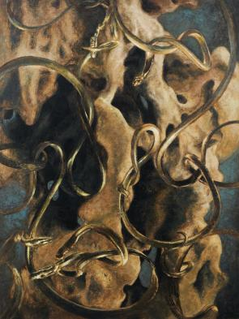  HUANG Hankang  Wind Orifice, 2025-2026  Acrylic and mixed media on canvas  160 x 120 cm  The core concept of the work derives from Zhuangzi’s philosophy: when wind blows through holes of varying depths and shapes, it produces distinct sounds—just as different individuals and life experiences lead to different outcomes.  The artist chooses the snake as the creative carrier, for the snake is the primordial prototype of the dragon. On pottery jars unearthed from the Xia Dynasty, the earliest depiction of the dragon takes the form of intertwined slender snakes. The snake moves along winding, meandering paths rather than straight lines, embodying the inherent Chinese character of being flexible and adaptable—a key reason why Chinese civilization has endured through the ages. Hailing from Suzhou, the artist incorporates rockery, an iconic cultural symbol ubiquitous in the Jiangnan region, which perfectly echoes the interplay between wind and hollow cavities in Zhuangzi’s allegory.  Placed within the context of Shanghai, the city has long bent and accommodated Eastern and Western civilizations alike, mirroring exactly the serpent’s fluid motion winding through crevices and hollows. | 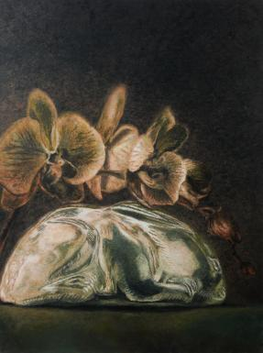  HUANG Hankang  Overlaid Life, 2026  Acrylic and mixed media on canvas  120 x 90 cm  Inspired by the crystal rabbit unearthed in Songjiang, Shanghai, dating back to the Yuan Dynasty. Ancient craftsmen carved crystal by following the natural form of the raw material—round pieces shaped into rabbits, curved ones into dragons, revering nature’s original gifts.  The artist places the crystal rabbit alongside an artificially cultivated orchid. The scene is serene and beautiful, yet the orchid quietly encroaches upon and overwhelms the rabbit. It mirrors humanity’s age-old attitude toward nature: from mining crystal to genetically modifying flowers and plants, we wear a veneer of civilization, while the domestication and plunder of nature have never ceased beneath the surface.
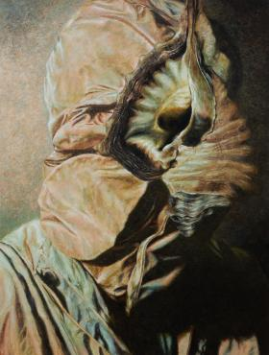  HUANG Hankang  Have You Witnessed, 2025-2026  Acrylic and mixed media on canvas  160 x 120 cm | 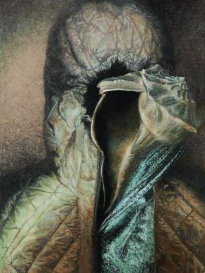  HUANG Hankang  Unseen Echo, 2025-2026  Acrylic and mixed media on canvas  160 x 120 cm
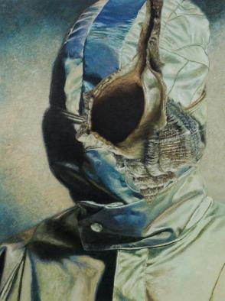  HUANG Hankang  Void Resonance, 2025-2026  Acrylic and mixed media on canvas  160 x 120 cm | 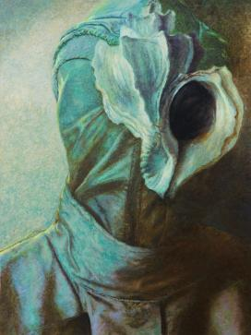  HUANG Hankang  Seeing and Hearing, 2026  Acrylic and mixed media on canvas  160 x 120 cm
A conch is a natural sound resonator. Its spiral form is shaped by the movements of the Earth and the cosmos, untouched by the shifts of human civilization, embodying an innate cosmic order.
Paired with the conch is a figure entirely enclosed and wrapped up. The artist intends to portray the human condition in the AI era: we are shrouded in layers of second-hand and third-hand experiences, and what we see and hear is not necessarily real. The conch covers the figure’s face and eyes, placing it in a state where information can no longer be perceived or interpreted. This perfectly captures our existential feeling amid the distortion of information in the present day.

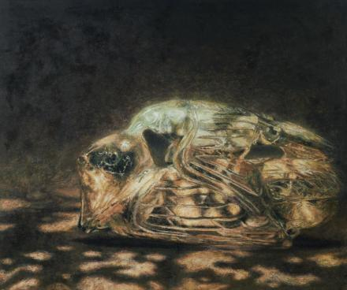  HUANG Hankang  Wandering Shadow, 2026  Acrylic and mixed media on canvas  100 x 120 cm  This work draws inspiration from an ancient Liao Dynasty jade carving of an eagle seizing a goose. Limited by the size of the jade material, the eagle’s neck was carved shorter than natural, making it look somewhat like a duck in the finished piece.  Top-tier ancient Chinese carving adheres to the principle of following the natural form of the raw stone, minimizing unnecessary carving strokes to keep the work as close to nature as possible. This ancient jade originally captures a violent moment of hunting, yet in its final form, the two creatures appear to coexist in harmony—violence is veiled by beauty.  It mirrors the world we live in today: outwardly amicable, yet riddled with underlying conflicts. With this tamed historical imagery, the artist reflects the relationship between different civilizations and nations in modern times—seemingly calm on the surface, yet quietly locked in rivalry beneath. The work offers no definitive interpretation, leaving audiences free to derive their own understanding. | 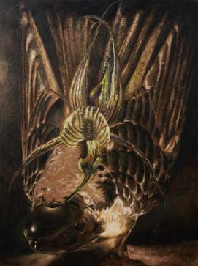  HUANG Hankang  Orchid Sparse, Birds Pass Not, 2025-2026  Acrylic and mixed media on canvas  120 x 90 cm  The work borrows the form of the spider orchid. The plant uses its rhizomes to mimic female genitalia, luring bees and butterflies to gather nectar and thereby spread its genes. The artist employs this trait as a metaphor for the way culture propagates itself.  The bird in the piece is a crystal bird crafted in the Western Art Deco style of the 1930s. Art Deco exerted a profound influence on Shanghai’s urban landscape, and numerous historic buildings of this style still stand across the city today. Western culture entered China through Shanghai, much like scattering cultural genes upon this land; now Shanghai’s culture is spreading outward in return. The two seduce, capture, and disseminate with one another in an intertwined cycle.
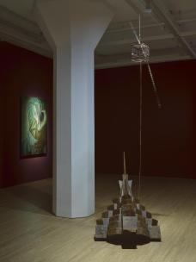  HUANG Hankang  The Sky Remains Not Necessarily True as the Bird Departs 2023-2026  Birdcage, feathers, iron, wood  Dimensions variable  This sculpture takes Shanghai’s Jinmao Tower as its prototype. As the first landmark built after the development of Pudong, it was designed by an American architect drawing reference to the architectural form of the ancient Yingxian Wooden Pagoda in China. All its facades are divided according to the number eight, blending ancient Chinese culture, modern economic aspirations and Art Deco style into one.  The artist cuts and reorganizes the form of Jinmao Tower into a structure resembling a bird trap and birdcage. The cage leaves seemingly escape routes, yet cannot contain a whole bird. The bird itself is absent; only a single feather pierces through the cage, conveying a tense, tugging sense of motion.This paradox of being seemingly able to break free yet ultimately unable to escape mirrors the very essence of Shanghai. From the opening of its port to the development of Pudong, Shanghai has long been a magnet drawing fortune seekers from all corners of the world. Some stay, while others leave, just like birds entering a cage to feed before flying away again. | 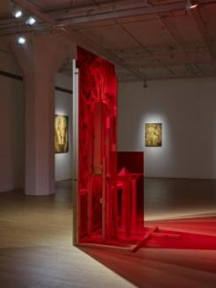  HUANG Hankang  Gate of Flesh and Soul, 2026  Wood, acrylic, sugar cubes, 3D printing, real paint  Dimensions variable  This core installation is adapted from a painting by Giuseppe Castiglione, a court painter of the Qing Dynasty. An Italian by birth, Castiglione adopted Western realistic painting techniques to depict a three-dimensional monkey, while the tree trunk in the work was rendered by Chinese court painters in freehand ink wash style. The three-dimensional monkey embedded within the flat trunk creates a striking visual dissonance, which perfectly mirrors the collision between Chinese and Western cultures. The artist splits the originally integrated painting into three sections, pulling and misaligning them in all directions to form a structure that appears stable on the surface yet inherently precarious. Enclosed in glass, the installation is viewable from both sides: the monkey is visible from front and back, while the Chinese painting presents a mirrored reversed effect.  Another subtle detail in the installation features Washington’s teeth and a cube of sugar. George Washington suffered from persistent toothache, and legend has it that his dentures were made from the teeth of enslaved Black people. The sugar cube, on the one hand, symbolizes the Western lifestyle integrated into Shanghai’s culture; on the other, it epitomizes the late era of slavery—slave owners ruined their teeth with refined sugar, while enslaved Black people could only grasp cheap sweetness from sugarcane. By juxtaposing the contradiction between the Declaration of Independence and the existence of slavery, the artist extends the reflection to the ambiguous divide between beneficiaries and victims ever since China embraced Western culture.
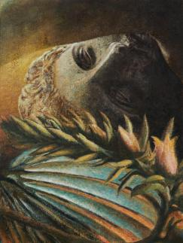  HUANG Hankang  State of Displacement, 2025  Acrylicand mixed media on canvas  80 x 60 cm  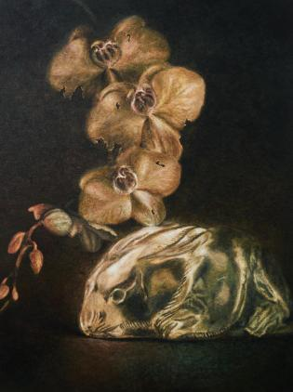  HUANG Hankang  Bud of Dawnless, 2026  Acrylic and mixed media on canvas  120 x 90 cm | 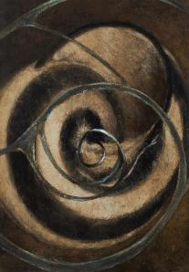  HUANG Hankang  Whence It Comes, 2025  Acrylicand mixed media on canvas  80 x 60 cm  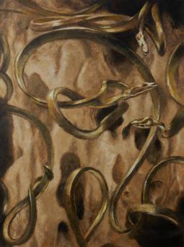  HUANG Hankang  Whence the Wind Comes, 2025  Acrylic and mixed media on canvas  80 x 60 cm
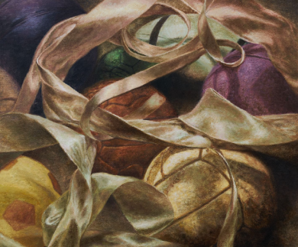  HUANG Hankang  Festival Gliding Over Ritual, 2026  Acrylic and mixed media on canvas  120 x 100 cm  The work is adorned with luxurious ribbons on the surface, creating a festive and celebratory atmosphere. Beneath them, however, multiple competitive spheres collide with one another, and both the ribbons and spheres are veiled in shadows.  It is a mirror of our present world: on the surface, driven by AI and new energy, life appears fashionable and joyous. Beneath the veneer, diverse interests clash constantly, and every trace of delight is shrouded in shadow. As for what these shadows signify, it is left for each viewer to perceive and interpret in their own way. | 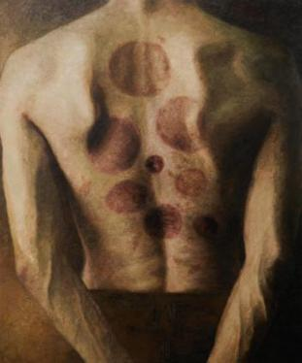  HUANG Hankang  Nameless Mark, 2025-2026  Acrylic and mixed media on canvas  120 x 100 cm  This work is inspired by news footage of foreign swimmers cupping together at an Olympic Games. Traditional Chinese culture is deeply engraved in the DNA of the Chinese people. Many are oblivious to it in their youth, yet in their thirties and forties, they suddenly begin to embrace practices like cupping therapy and wellness preservation.  The artist paints flat circular cupping marks onto a three-dimensional human figure. Cupping itself carries a unique duality: it serves as a form of healing while leaving mild physical blemishes. It is this ambiguous and contradictory relationship that the work seeks to convey.

4. Installation view
*The high-resolution images can be downloaded via the Google Drive link provided on the first page.

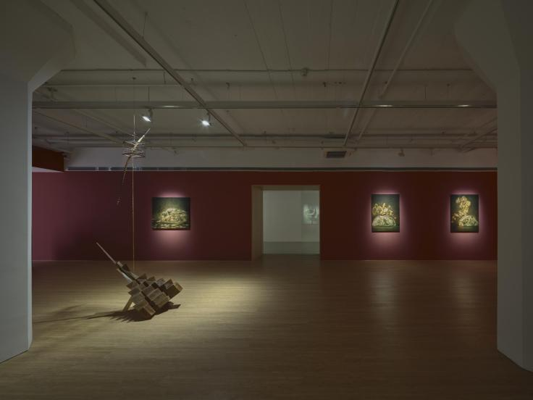 | 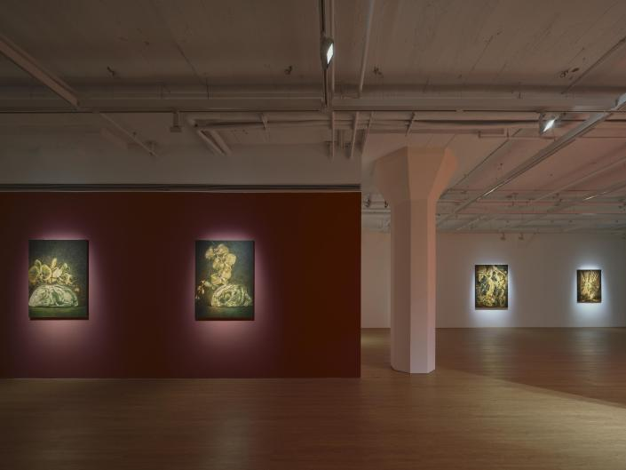
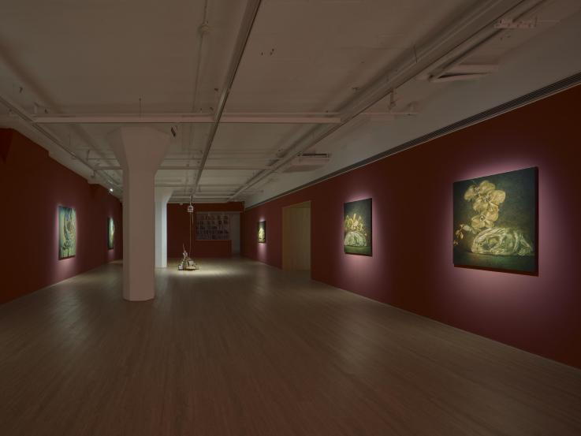 | 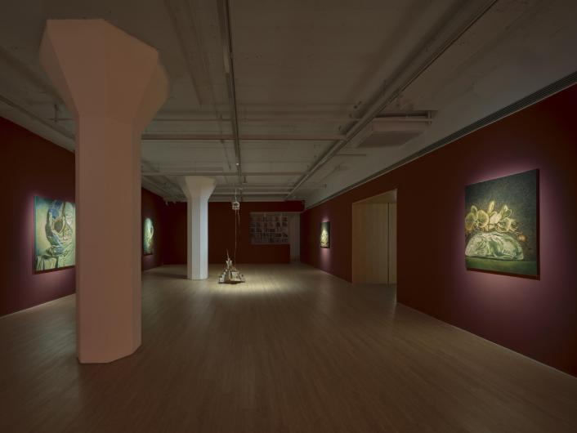
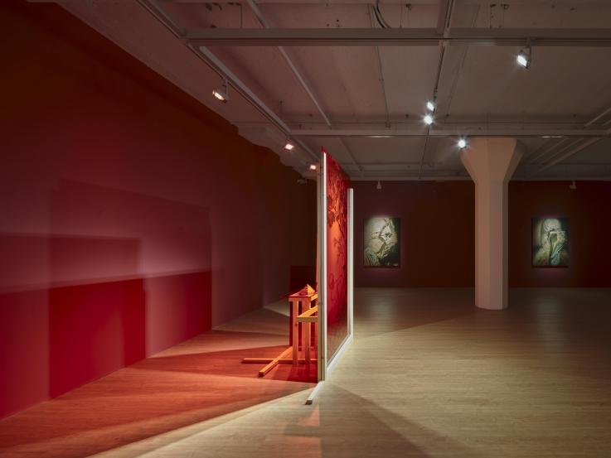 | 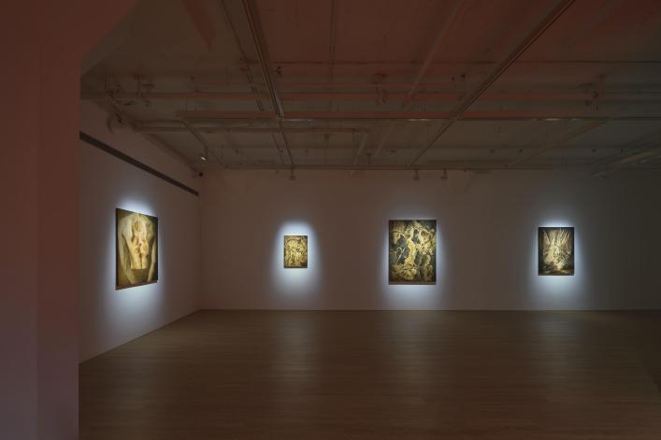
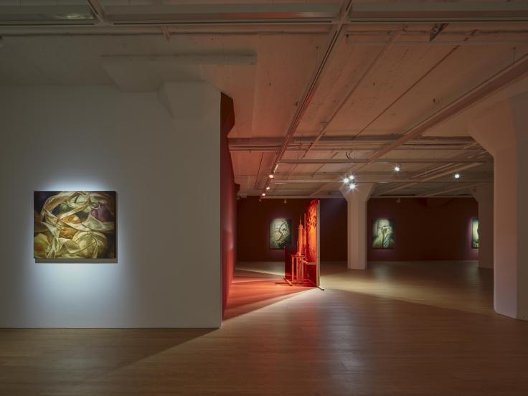 | 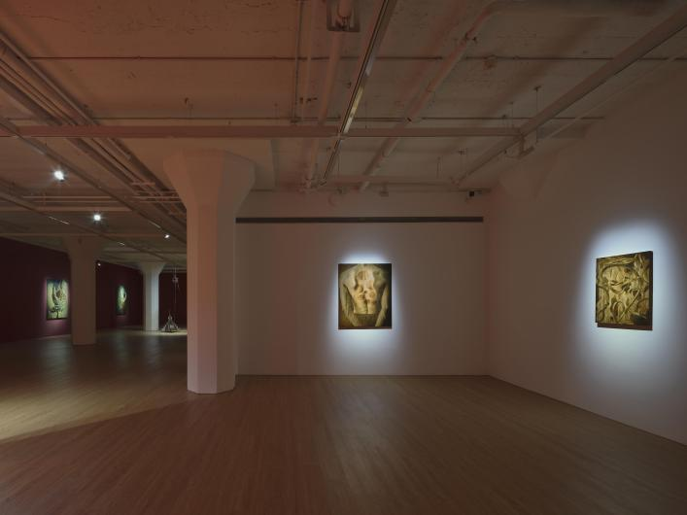
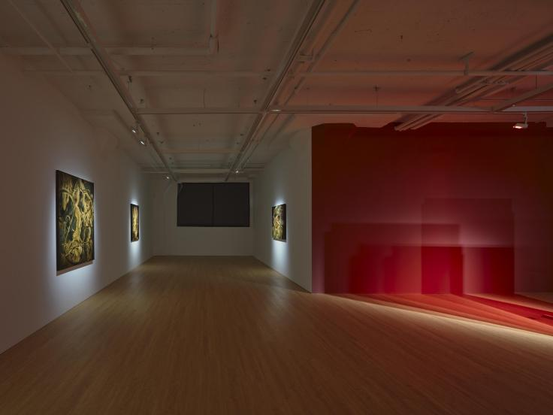 | 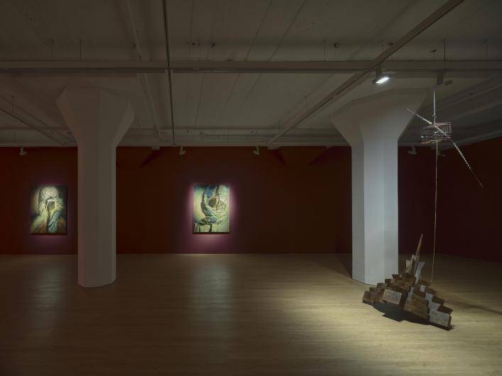
Installation view of HUANG Hankang: The Sky Remains as the Bird Departs at ARARIO GALLERY SHANGHAI, Shanghai, China, 2026.

5. Artists Introduction

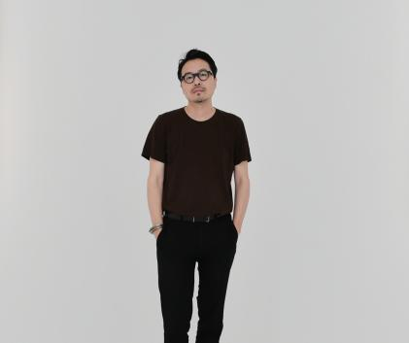 | HUANG Hankang (b. 1977, Suzhou, China) currently lives and works in Shanghai, China, and Paris, France. In 2006, he graduated from the École Nationale Supérieure d'Arts de Paris-Cergy, obtaining the National Diploma in Plastic Arts (DNSAP). Throughout his many years of living experience across Europe and China, HUANG frequently borrows and mobilizes figures that possess a "commonality" within the global context. Drawing on the interrelationships embedded in their different civilizational backgrounds and historical trajectories, he generates multi-layered dialogues through the transformation and connection of these figures' positions. The "coexistence" resulting from this fusion releases and points toward new, unknown relationships. Within these non-normative processes and threads of mutation, he "redevelops" the rapidly transforming society, civilization, and history of our time.  His works have been exhibited in major art institutions across the United States, France, Switzerland, and China. Recent major solo exhibitions include: “Traces and Echoes of All Time”, Hive Center for Contemporary Art, Beijing, China; “To Give Weight to the Wind”, Artlabor, Shanghai, China; “Turn On The Light”, Bertrand & Gruner Gallery, Geneva, Switzerland; “Fragment of Numerous Impacts”, Bertrand & Gruner Gallery, Geneva, Switzerland; “Unfunny Watercolors”, Danese Gallery, New York, USA. Group exhibitions include: “The Safari Journey”, Carte Blanche, Beijing, China; “Echoing Folds”, ORRO, Hangzhou, China; “Code: Normandy Operation”, 1690 Art Collection Space, Shanghai, China; “Voices from Elsewhere”, Hive Center for Contemporary Art, Beijing, China; “The Sequel of Light”, Yongfu 52, Shanghai, China; “The Unbearable Blue of Being”, TX Huaihai, Shanghai, China; “Beijing Contemporary Art Expo 2020 - Story Golden Flow”, CHAO Art Center, Beijing, China, among others.

- Artist CV

HUANG Hankang
Born in 1977 in Suzhou, China.
Lives and works in Shanghai, China and Paris, France.
Full-time artist.

Education
2006 National Diploma in Plastic Arts (DNSAP), École Nationale Supérieure d'Arts de Paris-Cergy

Selected Solo Exhibitions
2024 Traces and Echoes of All Time, Hive Center for Contemporary Art, Beijing, China
2023 To Give Weight to the Wind，Artlabor, Shanghai, China
2012 Turn On The Light，Bertrand & Gruner Gallery, Geneva, Switzerland
2009 Fragment of Numerous Impacts，Bertrand & Gruner Gallery, Geneva, Switzerland
2006 Unfunny Watercolors，Danese Gallery, New York, USA

Selected Group Exhibitions
2025-2026 The Safari Journey, Carte Blanche, Beijing, China
2025-2026 Echoing Folds, ORRO, Hangzhou, China
2025 Code: Normandy Operation, 1690 Art Collection Space, Shanghai, China
2025 Voices from Elsewhere, Hive Center for Contemporary Art, Beijing, China
2021 The Sequel of Light, Yongfu 52, Shanghai, China
2021 The Unbearable Blue of Being, TX Huaihai, Shanghai, China
2020 Beijing Contemporary Art Expo 2020 - Story Golden Flow, CHAO Art Center, Beijing, China
2018 2018 Group Show, Galerie Sébastien Bertrand, Geneva, Switzerland

