ARARIO GALLERY SHANGHAI
The Other Measure

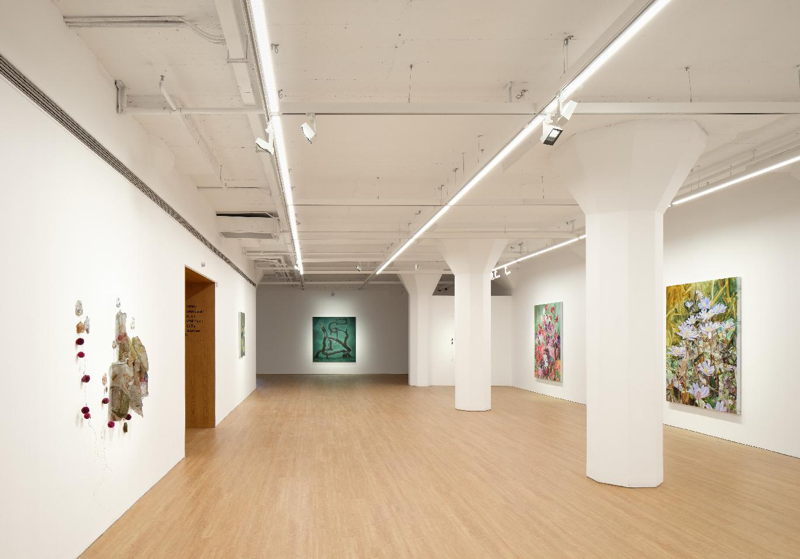

Installation view of The Other Measure at ARARIO GALLERY SHANGHAI, Shanghai, China, 2026.

Artists  Title  Dates  Venue  Artworks | :  :  :  :  : | CHEN Li, CHEN Xiaozhi, HE Xun, WANG Yiquan, XU Zhe, YUAN Yuan  The Other Measure  10 July – 5 September 2026  ARARIO GALLERY SHANGHAI (2F-205, 30 Wen’an Road, Jing’an District)  15 pieces in total
[Artwork images and Installation view]
https://drive.google.com/drive/folders/1YtQZRRxNnbgWhJTbx4wY0nuvuBTaWUOo?usp=drive_link

[Inquiry]
ARARIO GALLERY SHANGHAI | E. info@arariogallery.com

Table of Content | 1. Exhibition Overview  2. Exhibition Theme  3. Artworks  4. Installation View  5. Artist Introduction  6. Artist CV | ---------------------------------------------------------------------------3  -------------------------------------------------------------------------3-4  -------------------------------------------------------------------------5-7  -------------------------------------------------------------------------7-9  -----------------------------------------------------------------------9-12  ----------------------------------------------------------------------12-19

1. Exhibition Overview

ARARIO GALLERY SHANGHAI is pleased to present group exhibition “The Other Measure” from July 10 to September 5. This exhibition considers "measurement" not only as scientific calculation or quantification, but also as the acts of naming, classifying, recording, mapping, and displaying through which humans come to understand the world. Rather than offering a broad account of the Anthropocene, the exhibition approaches these questions through specific materials, images, sounds, and embodied experiences. In doing so, it asks how systems of knowledge shape our relationship with the earth, and whether other modes of perception and understanding might exist beyond them.

2. Exhibition Theme

We live in a world accustomed to measurement. Minerals are designated as reserves, plants are assigned to genera and species, subterranean spaces are mapped as energy grids, and the earth's surface is organized into transportation and logistics networks. The earth appears already measured, classified, and named. Yet when we trace the histories of these ways of knowing, we find that they are far from neutral forms of knowledge. Rather, they are processes through which reality is organized and order is produced.

Since the seventeenth century, alongside colonial expansion and the formation of global trade networks, European naturalists began systematically documenting and cataloguing plants, animals, minerals, and landscapes from around the world. Observers such as Georg Eberhard Rumphius spent years recording the natural world across the islands of Southeast Asia, producing notebooks that combined meticulous morphological descriptions with poetic imagination and personal experience. Later, Carl Linnaeus established a systematic taxonomy that brought nature into a clear, reproducible, and transmissible system of classification. At the same time, maps, images, specimens, archives, and commodity packaging gradually became essential tools for knowing and circulating the world. From poetic observation to standardized numbering, from lived experience to abstract systems, the earth ceased to be merely an environment inhabited by humans and became something that could be measured, recorded, displayed, and exchanged.

Yet measurement is never an endpoint, nor is it the only way of knowing. Before these epistemic systems emerged, encounters between humans and the earth unfolded more slowly and with greater uncertainty. Even after such systems took hold, the experiences and forms of perception they excluded never entirely disappeared. Our understanding of the world is not completed once and for all; it is continuously shaped through the interplay of history, power, technology, and circulation, while being repeatedly unsettled and rewritten through the echoes of ruins, new forms of growth, and the overflow of feeling.

Titled The Other Measure, this exhibition considers "measurement" not only as scientific calculation or quantification, but also as the acts of naming, classifying, recording, mapping, and displaying through which humans come to understand the world. Rather than offering a broad account of the Anthropocene, the exhibition approaches these questions through specific materials, images, sounds, and embodied experiences. In doing so, it asks how systems of knowledge shape our relationship with the earth, and whether other modes of perception and understanding might exist beyond them.

The six participating artists approach this theme from distinct perspectives. CHEN Xiaozhi takes spices such as clove, ginger, and nutmeg as points of departure, layering botanical illustrations, maritime maps, and trade routes onto mirrored glass surfaces. Her works trace how things once embedded within local ecologies and everyday life are continually redefined through surveying, classification, and global trade networks. CHEN Li's works revolve around moths, pond snails, and crab floss. The pond snail, a familiar species from her hometown, carries both local memory and personal experience; moths and crab floss evoke childhood imaginings of unfamiliar windows and the unknown lives concealed behind them. In her practice, living creatures become not only natural beings but also emotional vessels onto which meanings are continually projected and transformed. HE Xun explores the relationship between Buddhist seed syllables and sound, bringing together seeds, letters, and vocalization. Existing prior to linguistic meaning, these vowels and symbols function as a medium between bodily perception and spiritual experience, suggesting an alternative path of understanding that exceeds naming and classification. WANG Yiquan draws upon export commodity packaging, printed imagery, and trade archives to examine how nature is reshaped through circulation and representation. As plants, landscapes, and natural products are transformed into visual motifs on commercial packaging, they become embedded within systems of production, trade, and image-making. XU Zhe's sound installation begins with archival materials from residential architecture of the 1970s and 1980s. Through reconstructed architectural ornamentation, sound devices, and memory-based imagery, the work places personal experience alongside collective aspirations of its era. Within the traces left behind by architecture, fragments of memory, visions of the future, and the residues of everyday life are brought back into presence. YUAN Yuan constructs a female utopia composed of flowers. Figures appear in floral form, growing and proliferating within intensely saturated fields of colour. Exceeding fixed identities and categories, they form an open and expansive landscape of life.

The exhibition unfolds as a layered structure concerned not only with how knowledge is constructed, but also with how it loosens, transforms, and becomes available to sensation once again. When the measures through which we habitually understand the world are slowed down, questioned, and pushed to their limits, how might the earth, living beings, and material things appear differently? The exhibition invites visitors to pause among these works and attend to what remains unnamed, unmeasured, or perhaps no longer measurable at all.

- Artworks
*The high-resolution images can be downloaded via the Google Drive link provided on the first page.
*When using artwork images, please include the following copyright credit: ©2026. Courtesy of the Artist and Arario Gallery.

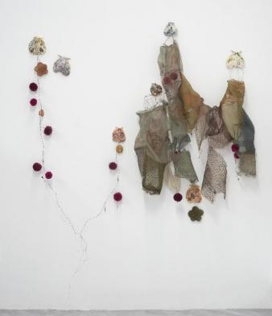  CHEN Li  Exhausting the Windows, 2026  Dyed silk, sewing thread, copper wire, fishing sinkers, yarn, copper plate, glazed ceramic, natural lacquer  140 × 175 × 20 cm | 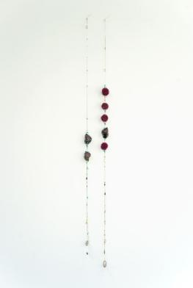  CHEN Li  The Snail’s Veil Ⅱ, 2026  Fishing line, pearls, beads, lacquered river snail shell, yarn, bobber stops, fishing sinkers, ceramic pieces  150 x 20 x 5 cm
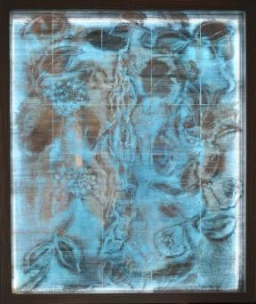  CHEN Xiaozhi  Aromatic Body I - Clove and the Sea, 2026  Verre églomisé on tempered glass and acrylic, silver leaf, colored foil, COB LED lighting system  53 × 63 × 14 cm | 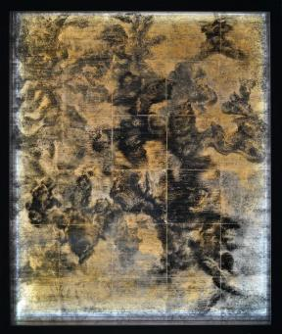  CHEN Xiaozhi  Aromatic Body II-The Spreading Body, 2026  Verre églomisé on tempered glass and acrylic, silver leaf, colored foil, COB LED lighting system  53 x 63 x 14 cm
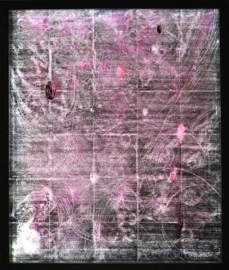  CHEN Xiaozhi  Aromatic Body III-Interior island, 2026  Verre églomisé on tempered glass and acrylic, silver leaf, colored foil, COB LED lighting system  53 x 63 x 14 cm | 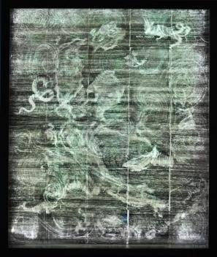  CHEN Xiaozhi  Aromatic Body IV-Kulilawan and Sea Monsters, 2026  Verre églomisé on tempered glass and acrylic, silver leaf, colored foil, COB LED lighting system  53 x 63 x 14 cm
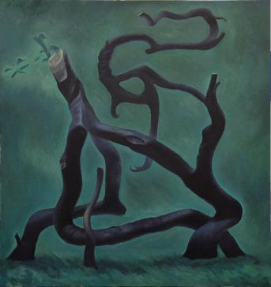  HE Xun  Seed-Iga (large), 2026  Oil on canvas  180 x 170 cm | 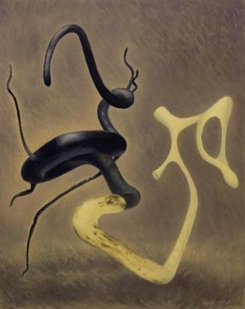  HE Xun  Seed-Ka, 2026  Oil on canvas  100 x 80 cm
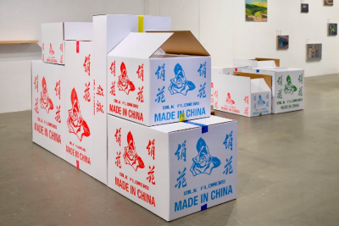  WANG Yiquan  Packaging Research-Shanghai Silk Flower, 2026  Installation, cardboard boxes, artist’s patterns, digital printing, adhesive tapes, each box specification varie  Dimensions variable  Edition 1-2 of 50 plus 5 AP | 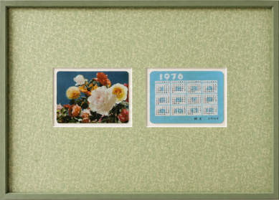  WANG Yiquan  Thriving with Prosperity, 2026  Mixed media, found calendar, vintage packaging paper, archival pigment print, artist-painted frame with acrylic paint  45 x 60 cm  Edition 1 of 2 plus 1 AP
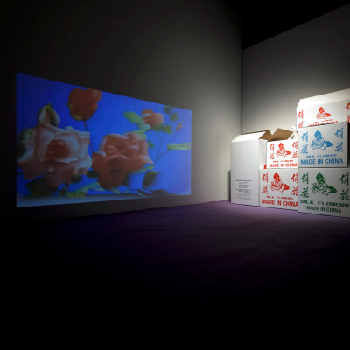  WANG Yiquan  Very Personal, 2022  HD digital video, colour, sound  10’12’’  Edition 2 of 8 plus 1 AP | 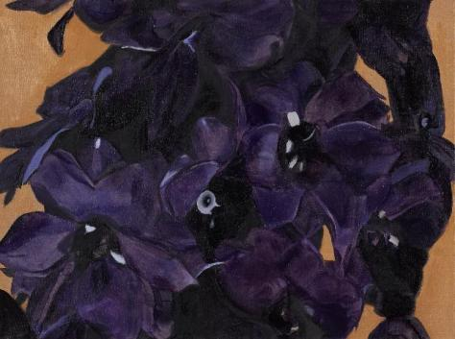  YUAN Yuan  Dark Purple, 2022  Oil on canvas  60 x 80 cm
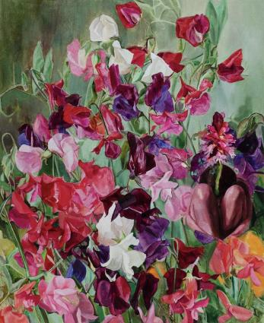  YUAN Yuan  The Last of Us-Pea Flower, 2023  Oil on canvas  195 x 160 cm | 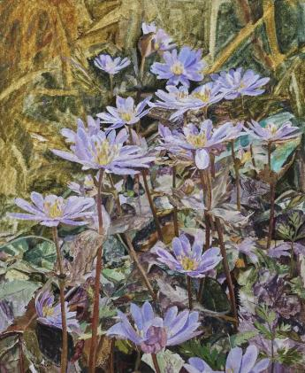  YUAN Yuan  The Last of Us-Spring Snowflake, 2026  Oil on canvas  195 x 160 cm
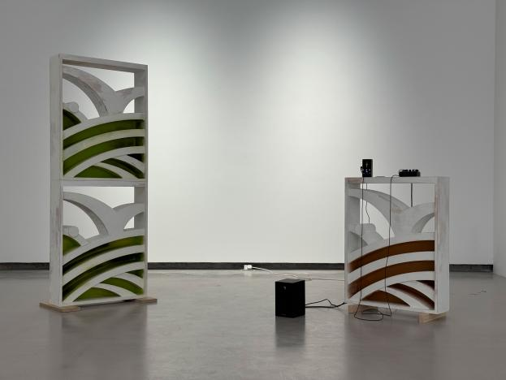
XU Zhe
Experiential Architecture #1, 2024
Mixed media installation
Dimensions variable

4. Installation view
*The high-resolution images can be downloaded via the Google Drive link provided on the first page.

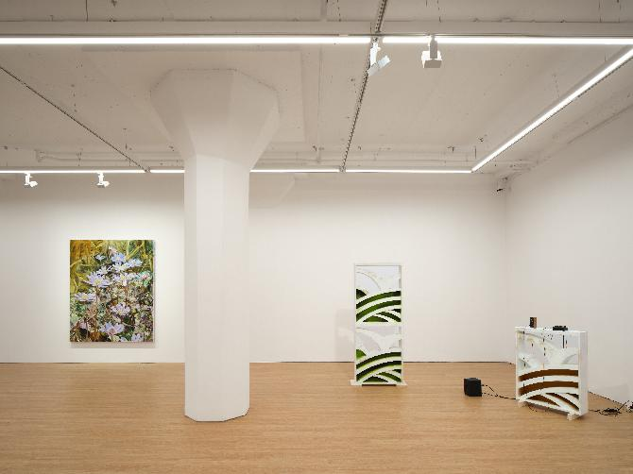 | 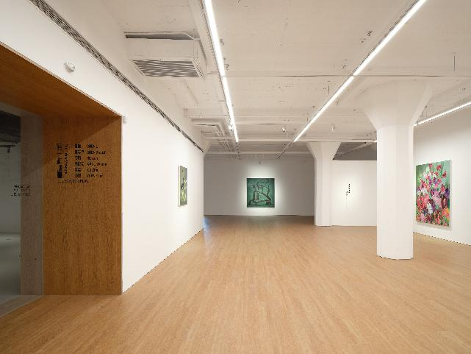
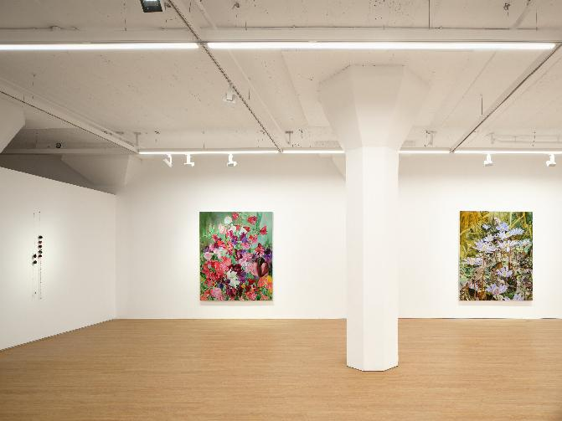 | 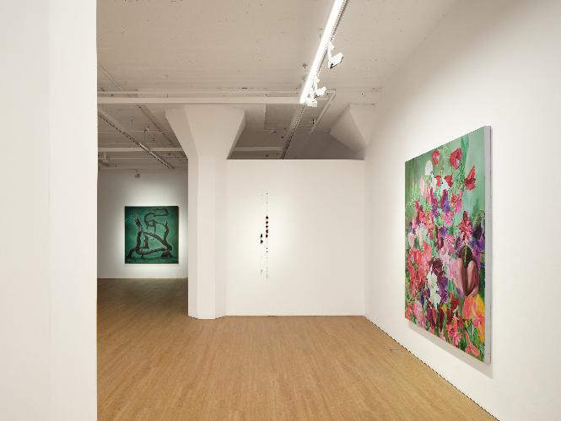
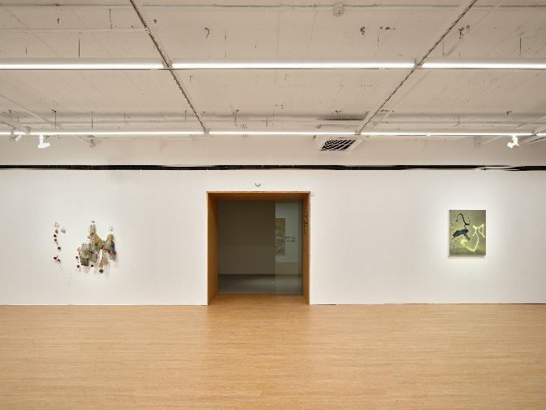 | 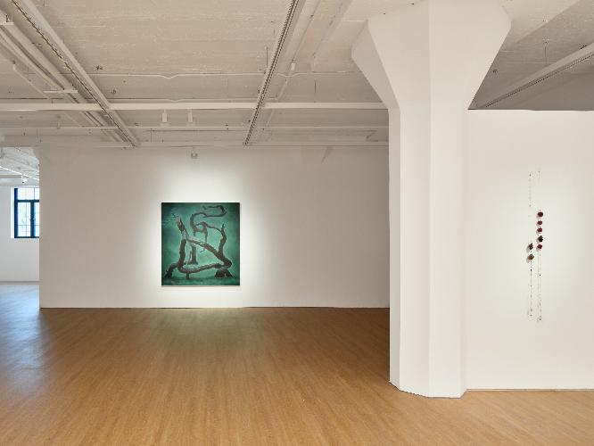
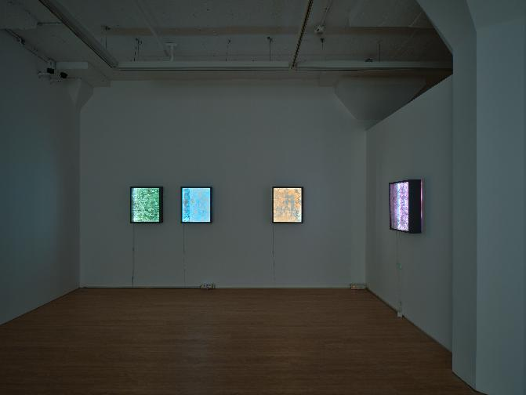 | 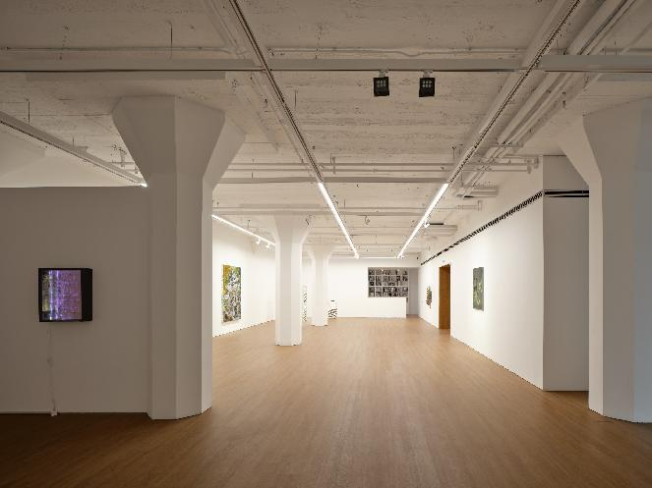
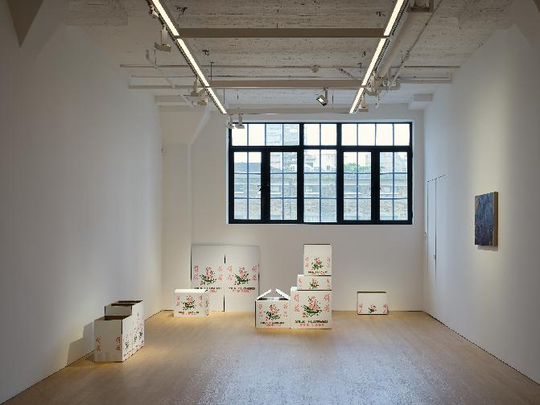 | 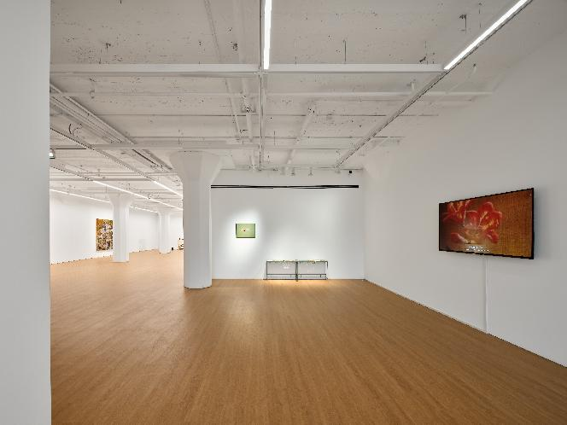
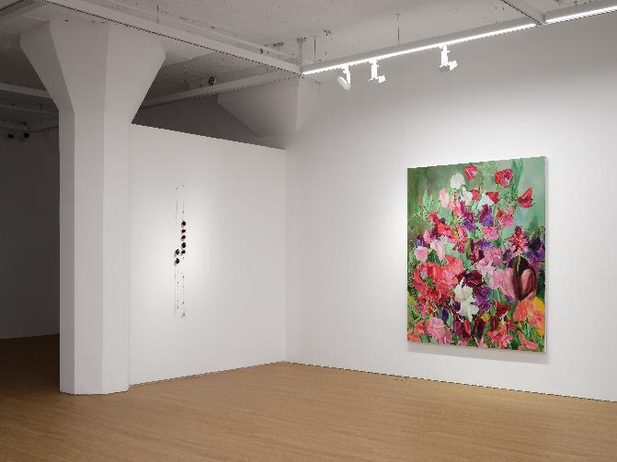 | 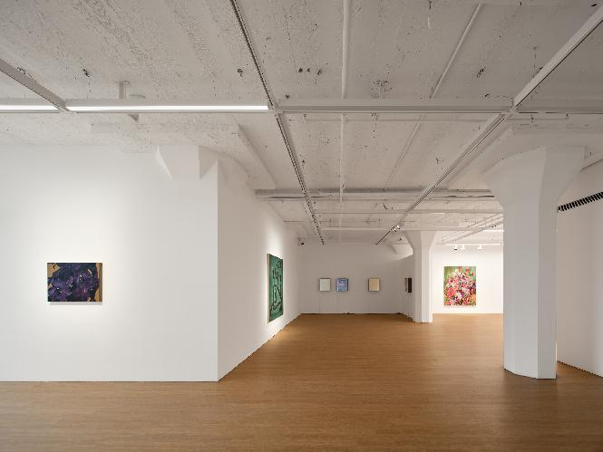
Installation view of The Other Measure at ARARIO GALLERY SHANGHAI, Shanghai, China, 2026.

5. Artists Introduction

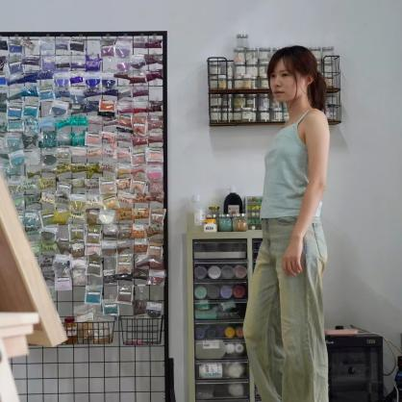 | CHEN Li (b. 1996, Zhejiang, China) received her BA in Fine Art, Painting & Printmaking from the Glasgow School of Art in 2018, and her MA in Fine Art from Central Saint Martins, University of the Arts London in 2020. She currently lives and works in Shanghai.  Chen Li’s works have been exhibited at numerous renowned museums and art institutions at home and abroad, including Saatchi Gallery (UK), 798CUBE (Beijing), HdM Gallery (Beijing), Guardian Art Centre (Beijing), Tree Art Museum (Beijing), Himalaya Museum (Shanghai), Arario Gallery (Shanghai), Blank Gallery (Shanghai), JW Projects (Singapore), ARTRO (Kyoto, Japan) and What Café (Tokyo, Japan).
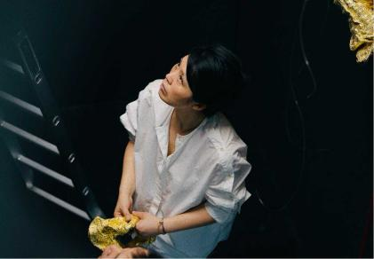 | CHEN Xiaozhi (b. 1980, Hunan, China)’s practice moves fluidly between the “past” and the “future,” “creation” and “being created,” weaving together painting, sound installation, and sculpture to explore perception, memory, and the transformation of energy. Having worked extensively in art conservation, Chen regards restoration as a “science of seeing,” a method that shapes her temporal and sensory understanding of the world. Her works combine traditional materials such as gold leaf, ramie, and glass fragments with modern industrial residues—where gold leaf becomes both a sacred and eternal medium, a bridge between spirit and matter. Far from nostalgia, Chen’s engagement with ancient media seeks to rebuild emotional resonance within fragmented contemporary life, tracing how energy circulates across time. Through repetitive, meditative labor, she balances the mechanical and the transcendental, re-forging cultural remnants to open fissures in our accelerated era, where viewers may glimpse folds of time and the emergence of unseen possibilities.  CHEN Xiaozhi has held solo exhibitions including Carte Blanche – Réminiscence d’un futur antérieur at 743 ART Lab in Shanghai (2025) and The Time of Curiosity at Right Art Museum, Shanghai (2024). She presented double exhibitions in Paris, including Entre chien et loup: Chaotic Forest at OVISION Art Space (2022) and an artist jewelry collaboration with Vissi d’Arte at La Manufacture Art Space (2022). Her work has appeared in group exhibitions such as the 11th Art Shenzhen “Qianhe Art Space Group Exhibition” (2024), the Shenyang “Une voie perpétuelle – A Century of Franco-Chinese Art” exhibition (2024), PODADA group exhibition Verre églomisé Painting in Asnières-sur-Seine, France (2021), L’art s’invite in Asnières-sur-Seine (2021), and La Parade animale at Château d’Asnières, France (2019). Her works are held in public and private collections, including the public installation Harmony with the Light and Dust for the Beijing EP YAYING project by FRANCLIN AZZI ARCHITECTE, Dust Mirror Series – A Vacant Space in the former residence of Lu Xiaoman in Shanghai, and in international collections such as Vissi d’Arte Gallery in Paris and Atelier Yô Art Space in Avignon.
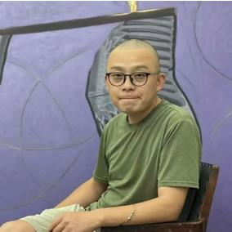 | HE Xun (b. 1984, Jiangxi, China) graduated from China Academy of Art in 2006. Currently works and lives in Hangzhou and Beijing. Member of JIEJUE COMMUNITY. HE Xun’s works include paintings, poetry and curating with attention to the symbolic role of agricultural culture, wizard belief and literal habits in daily life. He emphasizes on the impact on modern life caused by the ignored or suppressed languages, folk customs, totem worship, so as to seek for the common human emotional bonds, eternal memories and its deterioration.  His works have been showcased in Art Museum of Pond Loach, Imagokinetics (Hangzhou), Art Museum of Nanjing University of the Art, Times Museum Guangzhou, Guangdong Museum of Art, A4 ART MUSEUM, Sound Art Museum, Castello di Rivara Centro d‘Arte Contemporanea, Turin, Italy and Sovrapposizioni Di Immagini , Casa Dei Carraresi Museum, Italy; and collected by Start Museum, GeKA and etc. His poems and essays are published on journals as “West Lake”, “Enclave”, “Poem Jiangnan”, “The Best Poems of China 2006”, “Art World” and “Artshard”，Author of Portry A Bird and Another Bird (2024). Curation projects include “Go Live” with Art Museum of Nanjing University of the Art, “Suture: A Collection of Poetry by Contemporary Art Practitioners” with UCCA STORE, Beijing，“The Preparation of Art: Creative Origins of Contemporary Chinese Artists ” with Art Museum of Quzhou and etc.
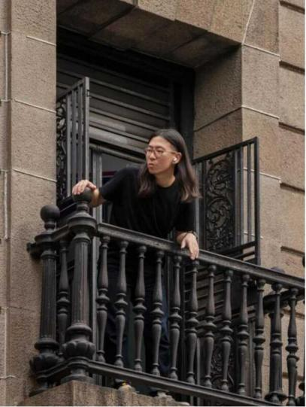 | WANG Yiquan (b. 1987, Beijing, China) currently lives and works in Shanghai. He is an active figure in China's contemporary art scene, working as an artist and curator, and is the founding partner of the spatial practice Acts and Pathways. His recent research interests include the practices and generational trends of artists from China's Post-1980s Generation, the transformation of factories and craftsmanship from a planned economy to a market economy, and China's radical urbanization.  His artworks have been exhibited in institutions such as the Centre for Heritage, Arts and Textile, Hong Kong (2022); Ming Contemporary Art Museum, Shanghai (2020); Contemporary Art Museum Kumamoto, Japan (2018); Beijing Design Week, Beijing (2016, 2017); Power Station of Art, Shanghai (2016); chi K11 art museum, Shanghai (2016); CAFA Art Museum, Beijing (2015); Museum of Contemporary Art, Shanghai (2015); and am art space, Shanghai (2013), among others. Recent curatorial projects include The Hyperlink of Food, Hushiguang Art Eco Site, Longyou County, Zhejiang Province (2024); Untitled, China Shanghai International Arts Festival, Shanghai (2023); Tan Chui Mui: Just Because You Pressed the Shutter?, Rencontres d'Arles, France (2023); FELLOWS, SNAP, Shanghai, (2022), and Meditations on the Urban Spectacle, Shanghai Minsheng Art Museum, Sun Ke Villa, Shanghai (2021).
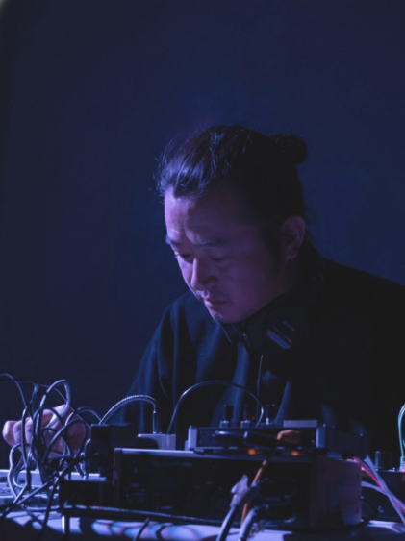 | XU Zhe (b. 1976, Shanghai, China) graduated from École Supérieure d’Art d’Aix-en-Provence, France in 2006. He currently lives and works in Shanghai.His practice spans multiple mediums including image, text, sound and archival materials, centering on the interplay between personal experience, historical narrative and artistic medium. Rather than reconstructing history or asserting fixed viewpoints, his works lay bare fractures within experience, examining how memories stratify and accumulate, how technology reshapes human perception, and how individuals navigate layered contextual realities.  His artworks have been exhibited at prominent museums and art institutions worldwide, such as J7 ART, Goethe-Institut China, SNAP Art Center, Jimei Art Center, Duolun Museum of Modern Art, Tianmuli Art Museum, Tabula Rasa Gallery, UCCA Center for Contemporary Art, Macalline Art Center, Spur Gallery, Ulsan Art Museum, Rockbund Art Museum, Nanjing University of the Arts Art Museum, Long Museum, 55 Gallery, UNArt Center, Leo Gallery, Power Station of Art, Antenna Space, MOMENTUM Art Center and Times Museum.
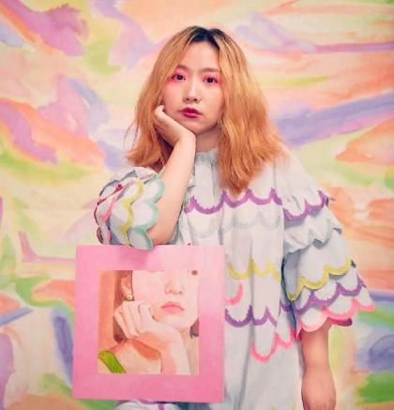 | YUAN Yuan (b. 1984, Beijing, China) received her Bachelor’s degree from the Oil Painting Department of the Central Academy of Fine Arts (CAFA) in 2008, followed by a Master’s degree from the same department in 2015. She currently lives and works in Beijing. Yuan Yuan’s practice bears a distinct surreal sensibility. Through dreamlike, fluid colour palettes paired with precise, solid figurative techniques, she conveys subtle emotions and profound artistic concepts. Her core creative themes revolve around the construction of personal utopias, interpretations of contemporary female identity, and the generation of feminine imagery.  Her works have been exhibited at major art museums and institutions across China and internationally, including Shekou Gallery (Shenzhen), M Art Museum (Suzhou), X Museum (Beijing), Yinchuan Museum of Contemporary Art, Song Art Center (Beijing), art spaces in Stockholm, Sweden, Tabula Rasa Gallery (Beijing; Singapore), No.9 Cork Street (London), MoCA Shanghai, Dietz Space (Cologne, Germany), Osthaus Museum (Germany), and UCCA Center for Contemporary Art (Beijing).

- Artist CV

CHEN Li
B. 1996 Zhejiang, China
Currently lives and works in Shanghai

Education
2018 BA (Hons) Fine Art, Painting&Printmaking, Glasgow School of Art
2020 MA Fine Art, Central Saint Martins, University of the Arts London

Selected Exhibitions
2026 Dance of the Seven(Solo), ARTRO, Kyoto, Japan
2025 Almost Molting, Arario Gallery, Shanghai, China
2025 OOO, Brownie Project , Shanghai, China
2024 Emerging Directors & Curators U40, What Café, Tokyo, Japan
2024 Seeing the Balsam Flower as a Farewell to Precepts (Solo), JW Projects, Singapore
2024 Spring, Sprang, Sprung, Hunsand Space, Beijing, China
2023 De wereld Wat Met Handvat getemni Ik?, 798CUBE, Beijing, China
2023 Motive and Narratiive Group, HdM Gallery, Beijing, China
2023 Eight Precepts, Entrance Space, Zhengzhou,China
2023 Escape of Light, Object Momento Gallery, Shanghai, China
2022 Metamorphosis of Rhythm, Himalaya Museum, Shanghai, China
2022 The Human World, Blank Gallery, M50 Art Zone, Shanghai, China
2021 Art Nova 100, Guardian Art Centre, Beijing, China
2021 Manifestation, Pearlona, M50 Art Zone, Shanghai,China
2021 Redirecting, Tree Art Museum, Beijing, China
2020 Moving Past, Moving Closer, Saatchi Gallery, London, UK
2020 Becomings, A.P.T Gallery, London, UK
2019 Humming Out of Time, Lux Gallery, London, UK
2019 We Are Here We Are, Apiary Studio, London, UK

CHEN Xiaozhi
Born in 1980 Hunan, China
Lives and works in Paris and Shanghai

EDUCATION
2010 Master of Contemporary Art and Multimedia, Saint-Denis VIII University, Paris, France
2003 Bachelor of Mural Painting, Department of Central Academy of Fine Arts CAFA Pekin, Beijing, China

SELECTED SOLO EXHIBITIONS
2025 Carte Blanche Reminiscence d’un futur anterieur, 743 ART Lab, Shanghai, China
2024 The Time of Curiosity, Right Art Museum, Shanghai, China
2022 Entre chien et loup Chaotic Forest, OVISION Art Space, Paris, France
XIAOZHI CHEN et VISSI D’ARTE, La Manufacture Art Space, Paris, France

SELECTED GROUP EXHIBITIONS
2025 After The Reaction, ARARIO Gallery, Shanghai, China
2024 The 11th Art Shenzhen “Qianhe Art Space Group Exhibition”, Shenzhen, China
Une voie perpetuelle, Art week SHENYANG, Shenyang, China
2021 Verre eglomise Painting, PODADA, Asnieres sur Seine, France
L'art s'invite, Asnieres sur Seine, France
2019 La Parade animale, Asnieres Castle, France

HE Xun
B. 1984, Jiangxi, China
Currently lives and works in Hangzhou and Beijing

Education
2006 B.A., China Academy of Arts, Hangzhou, China

Solo Exhibitions
2025 Keys, Hunsand Space, Beijing, China
2024 Dear all, Art Museum of Pond Loach, Qingyuan, China
2023 Flying Birds Temple, Reith Culture Arts Center, Shenzhen, China
Sow a Sun, Hunsand Space, Beijing, China.
2022 No Words, Round House, Shinshu, Japan
2021 Fibo nacci, Hunsand Space, Beijing, China
Wang Jing, Imaginary Mechanics Laboratory+ POP UP Gallery , Hangzhou, China
2019 KALAVIKA, Tong Gallery+Projects , Beijing, China
2018 The Second Oracle, A+ Contemporary, Shanghai, China
2017 Pearls of Citta, Enclave Contemporary, Shenzhen, China
2016 Rural Rhapsody, A+ Contemporary, Shanghai, China
2013 Empty Baggage, Hive Center for Contemporary Art, Beijing, China

Selected Group Exhibitions
2025 A Path to Enlightenment, HUSHEN ART MUSEUM, Shanghai, China
EMPATHY, EMPATHY MUSEUM, Hangzhou, China
The Reliable the Painting Manual, Positive Art Research Centre (PARC), Hangzhou,China
2024 Poetry, Moving images come after, Art Museum of Nanjing University of the Art, Nanjing, China
Meme to Jam, X sign Space, Hangzhou, China
Section, Enpoint, Connection Line, Mirror space, Shaoxing, China
100 new ideas for the city, A4 ART MUSEUM, Chengdu, China
Shakespeare’s Name is the Sword Drawn by Li Bai, THE DELTA INST GODOWN, Hangzhou, China
Cradle, ARR GALLERY, Hangzhou, China
Everything and Nothing, Central Art Museum, Hangzhou, China
The Narrow Gate, Gallery MC, Shenzhen, China
Time Suspension, East Gallery, Nanjing, China
2023 The 9th Beijing Poetry Festival, Sound Art Museum, Beijing, China
Prof.Challenger, THE DELTA INST GODOWN, Hangzhou, China
Weltanschauung, Guandong Contempory Art Center, Guangzhou, China
Blinding of Lights (Parallel Exhibition of Chengdu Biennale), Allab Art Center, Chengdu, China
Attend On Time, ARR GALLERY, Hangzhou, China
Pale Fire, AIKE GALLERY, Shanghai, China
Our Homeland, Ourselves, Shixiang Space, Beijing, China
Beautiful Garden, Hunsand Space, Hangzhou, China
The Essence of painting--Beyond the Concept, Sailing space, Shanghai, China
2022 Floating across the Shallow Clouds——about the seven states of painting,
JinChenYFM ArtGallery, Shanghai, China
Nocturnes-—Five Stories about Us, Space & Gallery Association(SGA), Shanghai, China
K, MartinGoyBusiness, Hangzhou, China
Fellows, SNAP, Shanghai, China
I AM OK, Block gallery, Hangzhou, China
Witness, Universe gallery, Hangzhou, China
2021 The timing of drifters, MartinGoyaBusiness, Hangzhou, China
Another Night, YiGuan Art Center, Nanjing, China
Chengdu Biennale Special Exhibition: Beyond interface, Southwest Jiaotong University
Museum,Chengdu, China
Chengdu Biennale Special Exhibition: Amalgmata, Winshare gallery, Chengdu, China
Love at the end of Tomorrow's World, The Galaxy Museum of Contemporary Art, Chongqing, China
Cover, Enclave Contemporary Art, Hangzhou, China

WANG Yiquan
B. 1987 Beijing, China
Currently lives and works in Shanghai

Education
2010 B.A., Beijing International Studies University, Beijing, China
2012 M.A., Central Saint Martins College of Arts and Design, London, UK

Selected Exhibitions
2024 The Theater of Mimicry, Hanart TZ Gallery, Hong Kong
2022 Children of the Motherland, CHAT (Centre for Heritage, Arts and Textile), Hong Kong
2020 Revisit Zhabei Park, Ming Contemporary Art Museum, Shanghai
2018 Temptation of Magic Metropolis: Shanghai Contemporary Art Exhibition,
Kumamoto City Museum of Modern Art, Kumamoto, Japan
2017 Beijing International Design Week, Beijing
2016 Beijing International Design Week, Beijing
Snacks, Power Station of Art, Shanghai
Us: Power of Chinese Contemporary Artists, chi K11 Art Museum, Shanghai
2015 2nd CAFAM Future Exhibition – Makers & Makers: Realistic Representations of Young Chinese Art,
CAFA Art Museum, Beijing
Sincerity, Bravery, and a Mess, MoCA Shanghai
2013 Drama Night: Grass Stage, AM Art Space, Shanghai

Curatorial Projects
2024 The Hyperlink of Food, Hushiguang Art Eco Site, Longyou County, Zhejiang Province
2023 Untitled, China Shanghai International Arts Festival, Shanghai
Tan Chui Mui: Just Because You Pressed the Shutter?, Rencontres d'Arles, France
2022 FELLOWS, SNAP Art Center, Shanghai
2021 Meditations on the Urban Spectacle, Shanghai Minsheng Art Museum, Sun Ke Villa, Shanghai
XU Zhe
B. 1976 Shanghai, China
Currently lives and works in Shanghai

Education
2006 M.A., École Supérieure d’Art d’Aix-en-Provence, France

Solo Exhibitions
2021 A Fiery Particle, SNAP Center, Shanghai
2014 Between Calmness and Seduction, Antenna Space, Shanghai
Extended Play, AM Space, Shanghai
2011 Lost Horizon, Fei Art Gallery, Guangzhou
Lost Horizon, Ofoto Gallery, Shanghai

Group Exhibitions
2025 Meme to Jam 2.0, J7 ART, Shanghai
Under the Stars, Goethe-Institut (German Cultural Centre), Beijing
Interwoven Voiceprints, Trigger, Shanghai
A Book of an Artist, SNAP Art Center, Shanghai
2024 Meme to Jam, X Sign Space，Hangzhou
In Search of The Gold-2024 Jimei-Arles Discovery Award, Jimei Art Centre, Xiamen
The First Annual Exhibition of Chinese Contemporary Photography and Video Arts,
Duolun Museum of Modern Art, Shanghai
Moment are Monument, Art Matters Museum, Hangzhou
Righteous Market, Tabula Rasa Gallery, Beijing
Pathway of Life, Outside Art Space, Beijing
2023 Synthesized Recall，Ullens center for contemporary art, Beijing
All Silence is a Hidden Space, The Cloisters Project , Maclline Art Center
Up in the Air, Spurs Gallery,Beijing
Semi Art Community Project: Boogie Woogie Museum-Two Steps After Golden Tea Room,
Ulsan Art Museum, Ulsan，Korea
2022 RAM Highlights 2022: The Good Life, Rockbund Museum, Shanghai
2021 Language is Everything, Residence of the French Consul General in Shanghai
Art Documents/Drawing Project1-4, AMNUA, Nanjing
2020 18th Sea Horizon - painting and sculpture exhibition, China Art Museum, Shanghai
For the Children, Long Museum, Shanghai
2019 The Kind Stranger, UN Art center, shanghai
Audiovisual Obstructions，PPPP Space，Beijing
2018 The 12th Shanghai Biennale, Power-station of Art , Shanghai
2017 Raw Notes·September, AM Space, Shanghai
2015 Essential Matters-Moving Images from China, Borusan Contemporary Perili Kosk, Istanbul, Turkey
2014 Photo Shanghai, Shanghai Exhibition Center，Shanghai
Aviff Cannes Art Film Festival Guest Program Basement6 Shanghaï, Cannes
PANDAMONIUM - Micro Exhibition, MOMENTUM，Berlin
2013 Drawing, Expression and Limit, AMNUA, Nanjing
ON | OFF: China’s young artistes in concept and practice, Ullens center for contemporary art, Beijing
2012 SEE/SAW: Collective Practice in China Now, Ullens center for contemporary art, Beijing
Fun Art—Open Studio Project, The Times Museum, Guangzhou
Wood works, V art center, shanghai
Chinese Experimental Music Jamboree: Sally Can't Dance, D22 Bar ,Beijing
2011 First issue-2011 SH Contemporary Art Exhibition Shanghai Exhibition Center, Shanghai

YUAN Yuan
B. 1984 Beijing, China
Currently lives and works in Beijing

Education
2008 B.A., Department of Oil Painting, Central Academy of Fine Arts, Beijing, China
2015 M.A., Department of Oil Painting, Central Academy of Fine Arts, Beijing, China

Solo Exhibitions
2026 A Garden, Shekou Gallery, Shenzhen China
2024 Someone Was Just Here, N3 Contemporary Art, Beijing, China
2023 Atum’s Gardener Tapping on Your Window, BAIwork x Tabula Rasa Gallery, Shanghai, China
2023 Art SG, dual solo booth, Tabula Rasa Gallery, Singapore
2021 La Possibilité d’une Fleur, Tabula Rasa Gallery, Beijing, China
2019 Glasswort, Tabula Rasa Gallery, Beijing, China
2015 Half-way into the Garden, Tabula Rasa Gallery, Beijing, China
2014 Die Brücke, Berlin, Germany
2011 Yuan Yuan: New Works, Beijing Commune, Beijing, China
2010 Yuan Yuan: A World of Yesterday and Tomorrow, Chambers Fine Art, Beijing,
China (travelled to Chambers Fine Art New York location)
2010 Curated by Yu Hong - Pan Li & Yuan Yuan: True False Objects, UCCA, Beijing, China

Selected Group Exhibitions
2025 Whispers of Frames - Time, Space, and the Imagery Within, M Museum, Suzhou, China
2025 Inherit with Love: Continuity of Time and Media Innovation, X Museum, Beijing, China
2025 Silent Fire: Breathing through the Void, SIMPLE ONE, Beijing, China
2024 Absence/Encore: The Flow of Art and Value, MOCA Yinchuan, Yinchuan, China
2024 Plato’s Ladder, Soul Art, Beijing, China
2023 Contemporary Myths and Artefacts, Stockholm, Sweden
2023 Tabula Rasa: Unveiled, No.9 Cork Street, London, UK
2022 The Female Gaze, VOGUE film Art Show, Shanghai, China
2022 Flowers, Vases and Artists, CP Treasury, Beijing, China
2021 The Logic of Painting, Xinjiang Art Musuem, Urumqi, China
2020 Animamix Biennial Snoopy 70th Anniversary, MoCA Shanghai, Shanghai, China
2020 Thing Self: New Art in the Integration of Civilizations,
The 5th Suzhou Jinji Lake Biennale, Suzhou, China
2019 Utopia / Dystopia, Dietz, Cologne, Germany
2018 XIE - SHENG, Bonacon Gallery, Guangzhou, China
2016 Aurora, Soka Art Beijing, Beijing, China
2016 Shan Shui Within, Museum of Contemporary Art, Shanghai, China
2015 International Artists Christmas Exhibition 2015 / 2016 - Global Impression,
Lion Palais Koenigsallee, Berlin, Germany
China 8, Osthaus Museum Hagen, Hagen, German
2015 CAFA Postgraduates Graduate Exhibition, Central Academy of Fine Arts, Beijing, China
2014 New Identity, VDA, Berlin, Germany
2013 @What - New Contemporary ART From China, ARKO Art Center, Seoul, Korea
2012 4 Blind Spots, Gallery Yang, Beijing, China
2012 Becoming Peninsula I: Symptoms, Iberia Center for Contemporary Art, Beijing, China
2010 Beijing Voice: Together or Isolated, Pace Gallery, Beijing, China
2009 Spectacle to Each, Museum of Contemporary Art, MoMA Taipei, Taipei, Taiwan
2008 CO 2008, Chambers Fine Art, Beijing China (travelled to Chambers Fine Art New York location)

