ARARIO GALLERY SHANGHAI
Where Does the Water Go

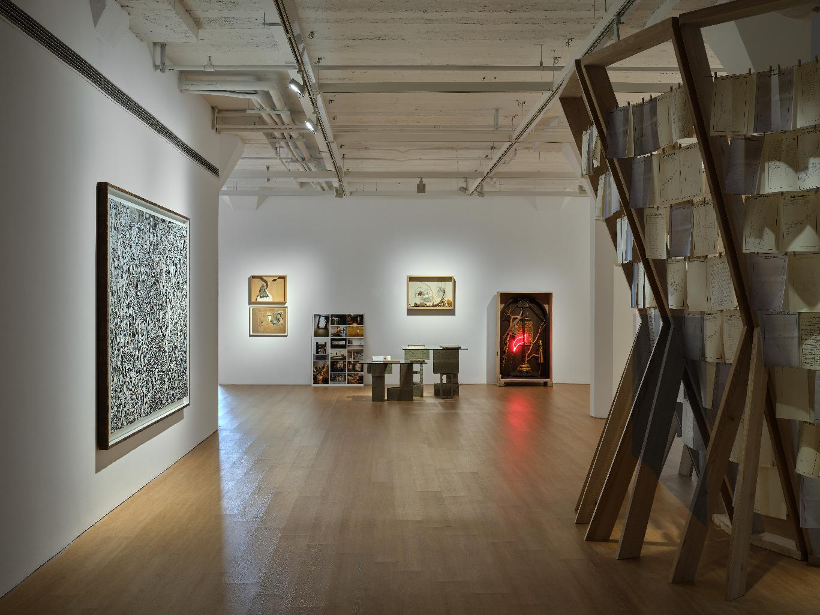

Installation view of Where Does the Water Go at ARARIO GALLERY SHANGHAI, Shanghai, China, 2026.

Artists  Title  Dates  Venue  Artworks | :  :  :  :  : | CHEN Shiyang, CHEN Yufan, CHEN Yujun, Gu Wenjing, LI Xiaoliang, LOONG Pan, QIU Sheng  Where Does the Water Go  11 September – 31 October, 2026  ARARIO GALLERY SHANGHAI (2F-205, 30 Wen’an Road, Jing’an District)  32 pieces in total
[Artwork images and Installation view]
https://drive.google.com/drive/folders/1S2wc6kI4at0v7l-TuwTt5uZwl_ykOdVF?usp=drive_link

[Inquiry]
ARARIO GALLERY SHANGHAI | E. info@arariogallery.com

Table of Content | 1. Exhibition Overview  2. Exhibition Theme  3. Artworks  4. Installation View  5. Artist Introduction  6. Artist CV | -------------------------------------------------------------------------3  -------------------------------------------------------------------------3-4  -------------------------------------------------------------------------4-5  -------------------------------------------------------------------------6-7  -----------------------------------------------------------------------8-11  ----------------------------------------------------------------------11-15

1. Exhibition Overview

ARARIO GALLERY SHANGHAI is pleased to present group exhibition “Where Does the Water Go” from September 11 to October 31. A river is never just a line on a map. Where does the water come from, what places does it pass through, and where does it join another river? This seemingly simple path is tied to the forms of the land, to vegetation and climate, and also to human migration, production, trade, belief, and everyday life. Dams, bridges, docks, irrigation systems, and urban construction continually reshape rivers, while rivers in turn transform the lands and lives along their banks. A place, therefore, can hardly be understood in isolation; it is always caught in relations with other places, other lives, and other times. The exhibition is not concerned with “the river” as a natural landscape, but rather with the watersheds that rivers form, and with how the people living within them relate to the land, water, infrastructure, and history.

2. Exhibition Theme

A river is never just a line on a map.

Where does the water come from, what places does it pass through, and where does it join another river? This seemingly simple path is tied to the forms of the land, to vegetation and climate, and also to human migration, production, trade, belief, and everyday life. Dams, bridges, docks, irrigation systems, and urban construction continually reshape rivers, while rivers in turn transform the lands and lives along their banks. A place, therefore, can hardly be understood in isolation; it is always caught in relations with other places, other lives, and other times.

The exhibition “Where Does the Water Go” is not concerned with "the river" as a natural landscape, but rather with the watersheds that rivers form, and with how the people living within them relate to the land, water, infrastructure, and history.

For the artists, entering a watershed also means entering a reality that cannot be quickly summarized. It takes time. Through walking, measuring, observing, conversing, and working, the artists come to know a place gradually, and in this process they continually revise their initial judgments. Materials may shift, the scale of their work may be re-determined, and habitual ways of seeing may become unreliable. The works are not illustrations of a predetermined theme, but the results left behind by these prolonged engagements.

For this reason, the exhibition seeks to present the works while preserving the unfinished state of the research. Sketches, notes, maps, photographs, experimental materials, archives, and artworks are placed side by side. They are not supplementary materials outside the works, but rather different ways through which the artists come to know a place. They allow us to see how a work gradually takes shape—from a single observation, an accidental discovery, or a shift in judgment.

The exhibition also attempts to pose a question that is not easy to answer: If we temporarily set aside administrative boundaries, singular historical events, and the borders defined by established disciplines, and instead start from the connections within a watershed, can we arrive at a way of seeing that differs from conventional local narratives?

In this sense, "watershed" is not a geographical concept, but a scale. It compels us to rethink the relationships between city and countryside, nature and society, data and memory. It does not unify these relationships into a single whole, but rather allows them to remain distinct while recognizing that they cannot truly be separated from one another.

- Selected Artworks
*The high-resolution images can be downloaded via the Google Drive link provided on the first page.
*When using artwork images, please include the following copyright credit: ©2026. Courtesy of the Artist and Arario Gallery.

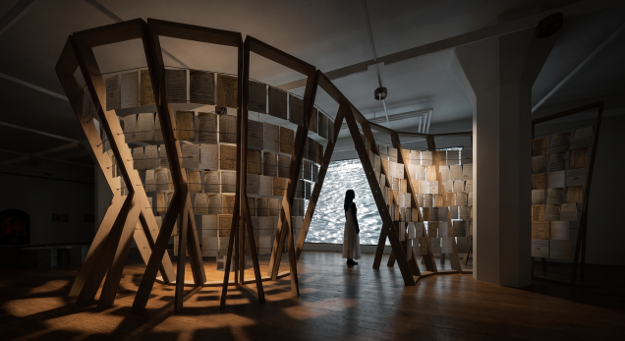  CHEN Shiyang  D.A.M., 2026  Beech wood, hemp rope, paper  820 x 490 x 300 cm | 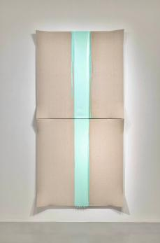  CHEN Yufan  Derivative-Folded Landscape No.6, 2024-2025  Acrylic and mixed media on canvas  270 x 135 cm (2 pcs)
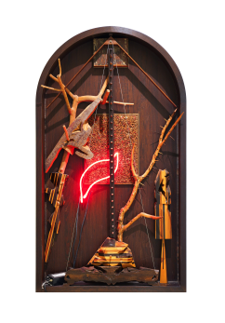  CHEN Yufan  Morgue, 2017-2018  Solid wood, industrial neon lights, longan tree branches, steel wire, wooden boards, mixed media on wood  150.3 x 85 x 17.4 cm | 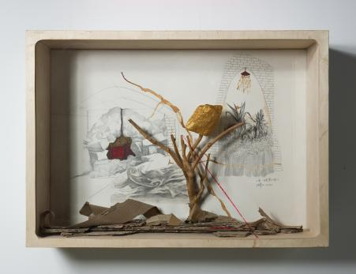  CHEN Yufan  Morgue-The Ideal Place, 2010  Multi-layered board, handmade paper, dragon fruit branches, stones, mixed media on paper  78.4 x 54.8 cm
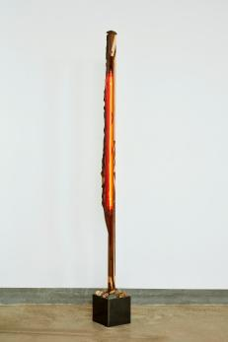  CHEN Yufan  Potted Plant No. 1, 2018  Logs, pebbles, steel plates, industrial neon lights  194 x 18.5 x 18.5 cm | 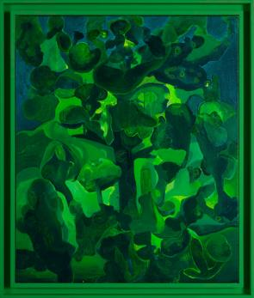  CHEN Yujun  A Midsummer Dream No.260609, 2026  Acrylic on canvas  120 x 100 cm
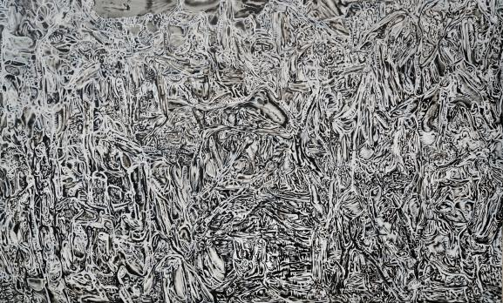  CHEN Yujun  Time Forest No.251215, 2026  Acrylic on canvas  160 x 265 cm | 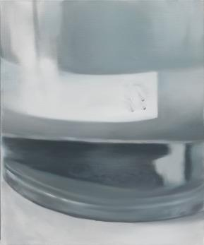  GU Wenjing  Dual Channel, 2026  Oil on canvas  60 x 50 cm
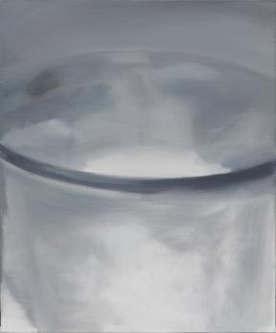  GU Wenjing  Dual Channel, 2026  Oil on canvas  60 x 50 cm | 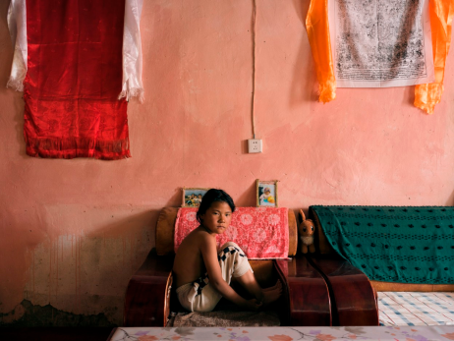  LI Xiaoliang  New Houses, 2022-2026  Archival inkjet print  75 x 100 cm  Edition of 3
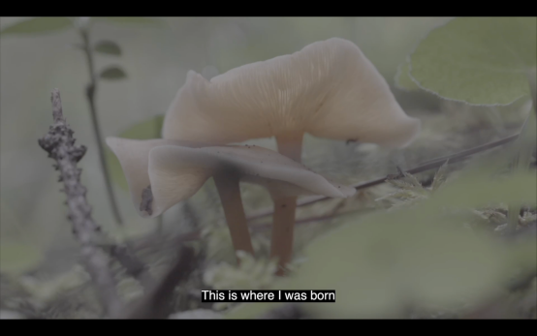  LOONG Pan  The Spore Monologue, 2025  Single channel video with sound  12’17’’  Edition of 5 | 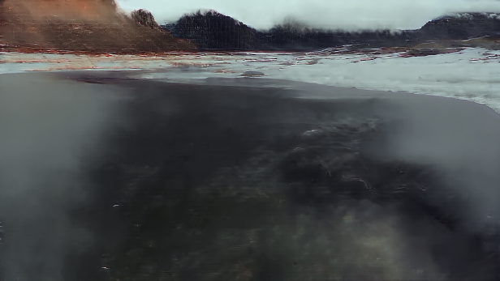  QIU Sheng  Still Water Still, 2026  AI-generated single-channel video, color, sound  7’42’’

4. Installation view
*The high-resolution images can be downloaded via the Google Drive link provided on the first page.

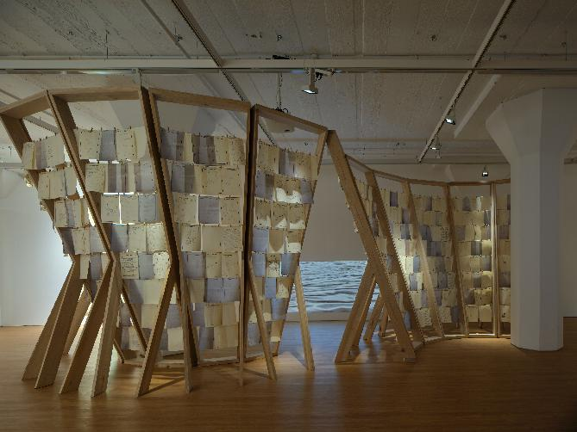 | 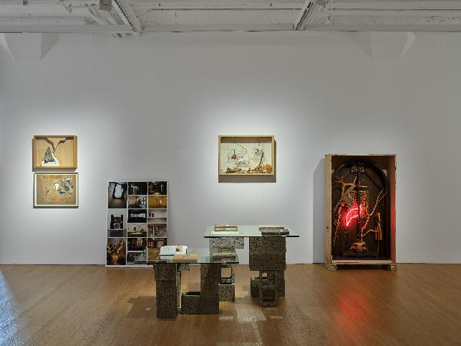
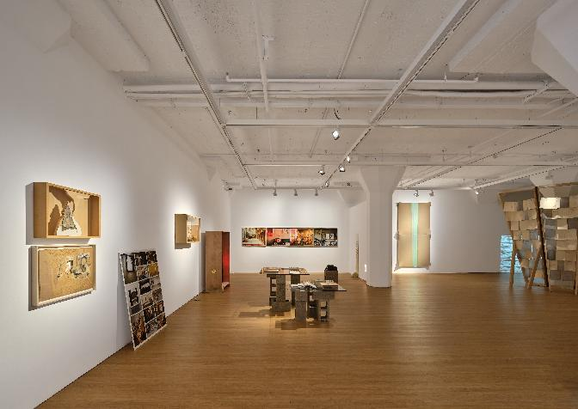 | 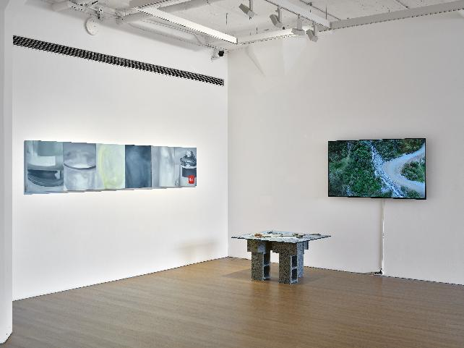
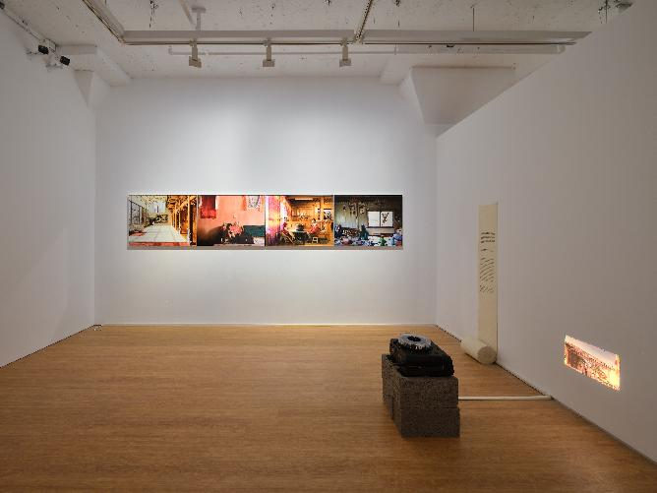 | 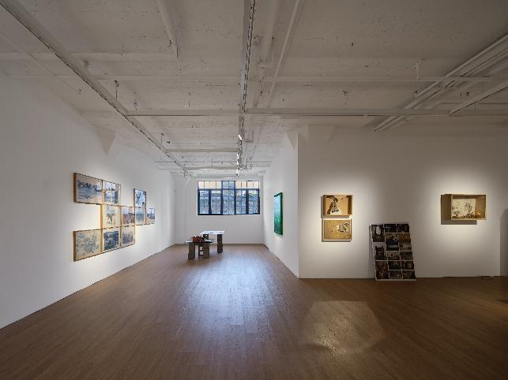
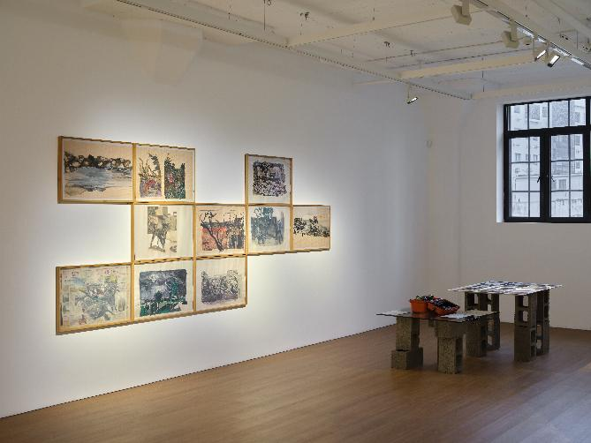 | 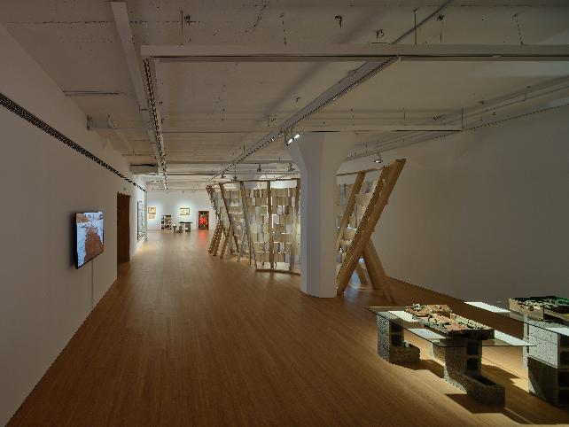
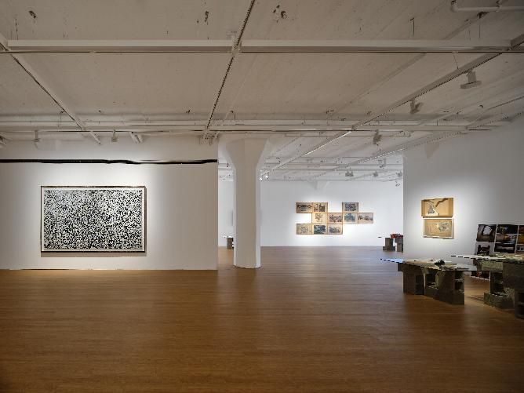 | 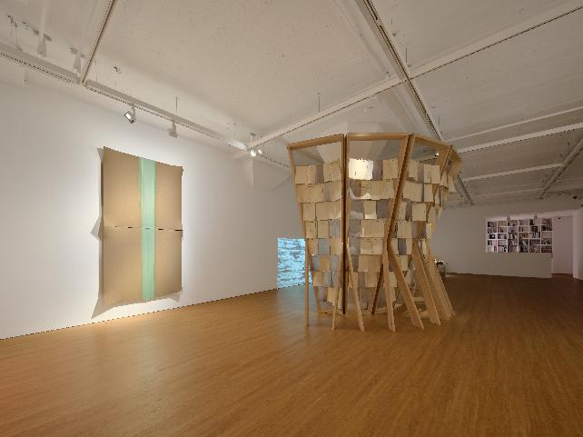
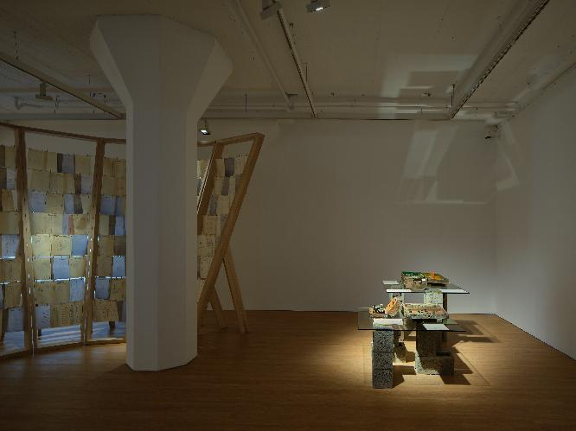 | 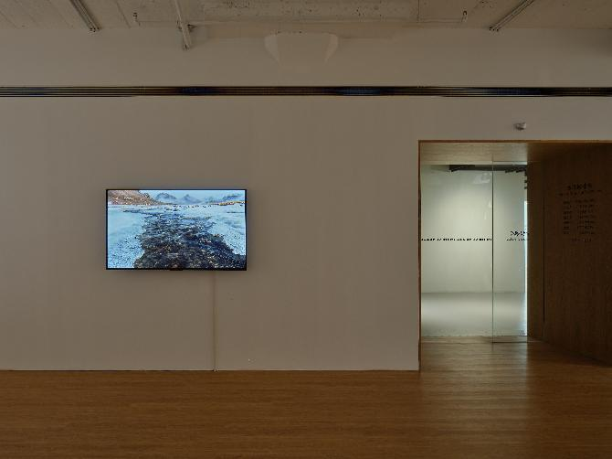
Installation view of Where Does the Water Go at ARARIO GALLERY SHANGHAI, Shanghai, China, 2026.

5. Artists Introduction

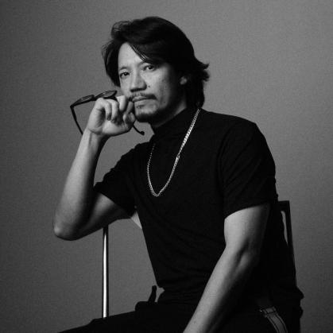 | CHEN Yujun (b. 1976, Fujian, China) graduated from the Integrated Art Department at China Academy of Art in 1999. From 1999 to 2014, he has taught at the Integrated Art and the Oil Painting Departments at China Academy of Art. He is currently living and working in Shanghai. As a representative artist born in the late 1970s, CHEN Yujun has grown up during the historical stage when Chinese society underwent a multitude of radical transformations. Through meticulous reflection and exploration, the relationship between individual genes/characteristics of life and the natural and cultural environment has increasingly become the driving force of CHEN’s creations. Themed from the Mulan River in his hometown to the Mother River that nurtures Asia and the whole world, his imagination and brushstrokes implicitly follow the footsteps of overseas Chinese who left their hometowns in the early days. CHEN intends to ask for the way out of self-redemption and the direction of human nomadism towards a further future.  CHEN Yujun (b. 1976, Fujian, China) graduated from the Integrated Art Department at China Academy of Art in 1999. From 1999 to 2014, he has taught at the Integrated Art and the Oil Painting Departments at China Academy of Art. He is currently living and working in Shanghai. As a representative artist born in the late 1970s, CHEN Yujun has grown up during the historical stage when Chinese society underwent a multitude of radical transformations. Through meticulous reflection and exploration, the relationship between individual genes/characteristics of life and the natural and cultural environment has increasingly become the driving force of CHEN’s creations. Themed from the Mulan River in his hometown to the Mother River that nurtures Asia and the whole world, his imagination and brushstrokes implicitly follow the footsteps of overseas Chinese who left their hometowns in the early days. CHEN intends to ask for the way out of self-redemption and the direction of human nomadism towards a further future.
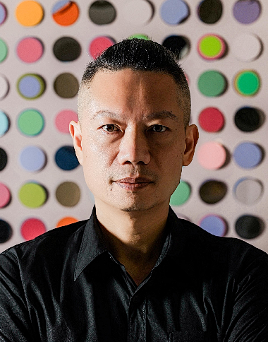 | CHEN Yufan (b. 1973, Fujian, China) graduated from the Department of Integrated Arts, China Academy of Art. He currently lives and works in Shanghai.For many years, Chen Yufan has persistently depicted an inner-landscape lodged deep within his mind in a modest and introspective manner. His landscapes blend memory and reality, ambiguous impressions and sensations. It is precisely this ambiguity that brings him close to the essence of abstract painting: extracting from concrete, everyday imagery to retain and express only the most fundamental spirit. His practice is imbued with personal experience and meditation on the individual, existence, repetitive labour and social order. The fluid quality in his works stems not only from his memories of his hometown Mulan River, but also from years of migratory experience, as well as his reflections and perceptions on the transformation of traditions.  He has held solo exhibitions at numerous renowned art institutions, including AYE Gallery (Beijing, 2010; 2012; 2018; 2024), Tang Contemporary Art (Bangkok, Thailand, 2020), Arario Museum (Jeju, South Korea, 2017), Pearl Lam Galleries (Hong Kong, 2023), Ink Studio (Shanghai, 2025; 2023; 2016), Yibo Gallery (Shanghai, 2020), among others. His works are collected by major institutions such as White Rabbit Gallery (Australia), UBS Foundation (Switzerland), the Sigg Collection Foundation, Long Museum (Shanghai), Arario Museum (South Korea), and Blue Mountain Foundation (Israel).
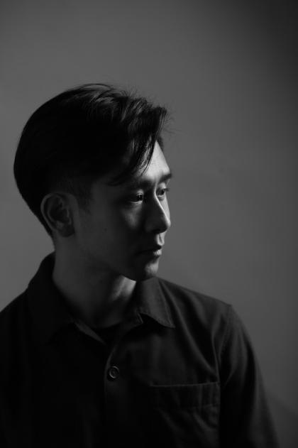 | CHEN Shiyang (b. 1991, Chongqing, China) received his Bachelor’s degree from the University of California, Berkeley, and a Master of Architecture from the Harvard Graduate School of Design. He is the founder of DoDesign and partner of Halfday Gallery, as well as a practice-based tutor at the School of Design, Shanghai Jiao Tong University.His interdisciplinary practice revolves around the dialogue between space, nature and time. Responding to the inherent energy of sites through restrained intervention, he makes construction a medium for perceiving nature. From the Nanchuan Stone House, “a chamber stacked of stones”, to the Nanhai Reclining-Buddha Hall inspired by the Buddhist notion “abiding nowhere, the mind arises”, he introduces impermanence into spatial experience through shifting light-shadow and weathering materials, pursuing a poetic yet restrained balance between human beings and the cosmos.  His works have won the French Créateurs Design Award, German ICONIC Award, Platinum MUSE Design Award (USA), Gold UN Design Award (USA), Silver IDA Design Award (USA), and Architizer A+ Award. He has been featured in Dezeen’s Top 10 Best Chinese Architecture Projects 2025, AD100 YOUNG, and Gooood’s 20 Young Rising Studios. His projects have been widely covered by publications including VOGUE, Dezeen and AD.
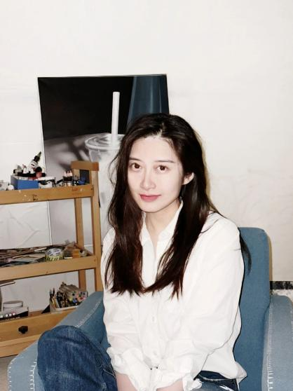 | GU Wenjing (b. 1999, Shandong, China) is a young contemporary artist based in Beijing. She is a Ph.D. candidate at the Central Academy of Fine Arts and received her master's degree from the Academy of Arts & Design, Tsinghua University. Her work spans painting, photography, and moving-image media. Through the continuous production of memorable imagery, she engages in visual expression across both still and moving images, reflecting on the role of personal memory within history. Her honors include the Outstanding Work Award at the 6th Jinan International Photography Biennale and the Yihe Support Fund Honorary Outstanding Exhibition Work award at the Lishui Photography Festival, among others.  She has held a solo exhibition at Author Gallery (Beijing, 2025). She has also participated in group exhibitions at Song Art Center (Beijing, 2025), Dong (Shanghai, 2025), Liu Haisu Art Museum (Shanghai, 2025), Bao’an 1990 Art Museum (Shenzhen, 2025), Suns Living Gallery (Beijing, 2024), Click Ten Gallery (Beijing, 2024), Liyuan Space (Beijing, 2024), Redtop Contemporary Art Center (Xiamen, 2024), Chengdu Contemporary Image Museum (Chengdu, 2023), Guardian Art Center (Beijing, 2023), Xieli Space (Beijing, 2021), Lishui Photography Museum (Lishui, 2021), Zero Art Center (Beijing, 2020), among other institutions.
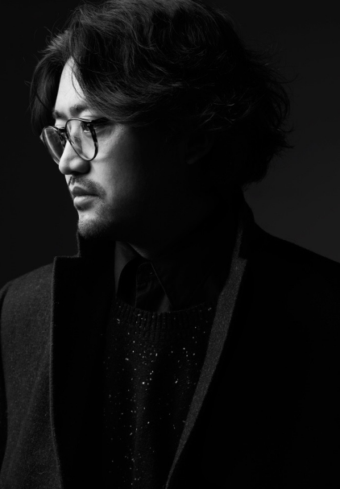 | LI Xiaoliang (b. 1984, Qinghai, China) is a photographer and visual artist. His work has long engaged with cultural mobility, identity reconstruction, and the deconstruction of "home" in the context of globalization. Through a gaze that is both cool and warm, he reveals the dialogues, conflicts, and symbioses between tradition and modernity, East and West, and the individual and the system within everyday living spaces. In 2016, his art project “Lonely Planet” received the Photography Sample Book Award (juried by Martin Parr) at the Lianzhou International Photo Festival. His work “Beijing Apartments”, which examines the living conditions of foreign models in China, received the Fine Art Photography Awards.  He has held solo exhibitions at numerous renowned art institutions, including Fosun Art Center (Chengdu, 2025), Sea World Culture and Arts Center (Shenzhen, 2024; 2023), How Art Museum (Shanghai, 2024; Wenzhou, 2019), Today Art Museum (Beijing, 2024), Three Shadows Photography Art Centre (Xiamen, 2022), Xie Zilong Photography Museum (Changsha, 2022), UCCA Lab (Beijing, 2021), TAG Art Museum (Qingdao, 2020), Design Society (Shenzhen, 2019), Pingshan Art Museum (Shenzhen, 2018), chi K11 Art Museum (Shanghai, 2017), among others.
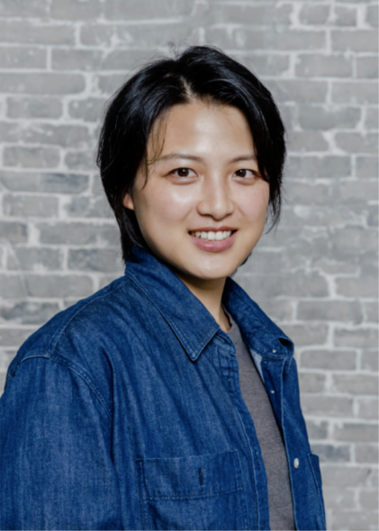 | LOONG Pan (b. 1991, Jiangxi, China) is an artist whose practice combines field research and laboratory experimentation. Through the lens of nonhuman organisms—particularly fungi and plants—she seeks to explore and present the "secret correspondences" of the web of life in which humans are situated. Adopting a mycelium-like methodology, LOONG Pan moves across e-waste towns, oil-spill-damaged coastlines, and mining zones, employing phytometallurgy, fungal degradation, and plant-ash glazing to make tangible the toxins, vibrations, subterranean networks, and biological resistance that shape these environments.Her recent practice examines how mineral cycles reconfigure relationships between human and nonhuman, local and global, historical and future worlds.  Her works have been exhibited at numerous key art museums and institutions at home and abroad, including Guangdong Museum of Art (Guangdong, 2026), Tsinghua University Art Museum (Beijing, 2025), Biyun Art Museum (Shanghai, 2025), CAFA Art Museum (Beijing, 2025), Song Art Museum (Beijing, 2024), Chronus Art Center (Shanghai, 2023), Pearl Art Museum (Shanghai, 2023), Beijing Biennale (Beijing, 2022), MAM Art Center (Beijing, 2022), Kunming Center for Contemporary Art (Yunnan, 2022), Shanghai Duolun Museum of Modern Art (Shanghai, 2022), Tianfu Art Museum (Chengdu, 2021), Power Station of Art (Shanghai, 2021), OCT Contemporary Art Terminal (Shenzhen, 2020), Hanazono Art Center (Nunagawa, Japan, 2020), among others.
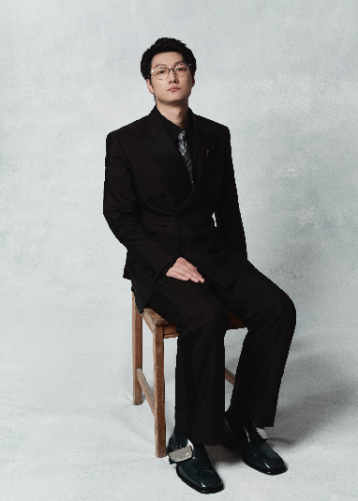 | QIU Sheng （b. 1989, Hangzhou, China）is a film director. He earned his bachelor’s degree from Tsinghua University and a Master of Fine Arts in Filmmaking from Hong Kong Baptist University. His creative practice spans narrative cinema, experimental moving-image works and AIGC-driven media experiments. Employing fluid cinematography, he persistently interrogates the interplay between individual memory, local humanity and contemporary societal conditions.  His debut feature film Suburban Birds won the Best Feature Award at the FIRST Youth Film Festival and was selected for the Locarno Film Festival, among others. His short film Double Helix received the Best Short Film Award at the Shanghai International Film Festival and Best International Short Film at the Gentel Film Festival. His second feature My Father’s Son was honoured with the Artistic Contribution Award at the Shanghai International Film Festival Golden Goblet Awards. His inaugural AI-generated work A Dollar Story took home the Best Action Short Award at the World AI Film Festival.

- Artist CV

CHEN Yujun
b. 1976, Fujian, China
Live and works in Shanghai, China

Education
1999 B.A., Department of Comprehensive Art, China Academy of Art
2007 M.A., Department of Comprehensive Art, China Academy of Art

Selected Solo Exhibitions
2025 I, we, Chen Yujun Solo Exhibition, Long Museum West Bund, Shanghai, China
2024 Growing as Painting, Chen Yujun, Art Yangyun, Shanghai
2023 Vilaging like the Vines, Chen Yujun's studio & West Bund Art & Design Fair, Shanghai, China
Locality as Universality-Chen Yujun Solo Exhibition, Shixiang Space, Beijing, China
2022 THE EARTH WATERS-Chen Yujun Solo Exhibition, Shixiang Space, West Bund Art & Design Fair, Shanghai, China
ARTHOUSER-Chen Yujun Solo Exhibition, Long Museum Chongqing, Chongqing, China
2021 The Endogenous Scenery, ZiWU Beijing, Beijing, China
Continuity and Variation, Guangdong Museum of Art, Guangzhou, China
Sheng Zhang-Chen Yujun Solo Exhibition, Long Museum West Bund, Shanghai, China
2020 Each Single Self, Arario Gallery, Seoul, South Korea
2019 Chen Yujun, Tang Contemporary Art, Beijing, China
Caravan of Wanderer, Worshiper, Lover of Living, Rén Space, Shanghai, China
2018 Reflection from the Golden Dome, Rén Space, Shanghai, China
2015 The Second Door, James Cohen Gallery, Shanghai, China
2012 Transitional Room, Boers-Li Gallery, Beijing, China
2010 The Empty Room, Boers-Li Gallery, Beijing, China

CHEN Yufan
B. 1973 Fujian, China
Currently lives and works in Shanghai

Education
1997 Graduated from the College of Art, Fujian Normal University
2007 Postgraduate Program, Department of Comprehensive Art, China Academy of Art

Solo Exhibitions
2025 Ultimate Repetition, Ginkgo Space, Shenzhen, China
2024 Chen Yufan, AYE Gallery, Beijing, China
2023 New Works, Ginkgo Space, Shanghai, China
2023 Investigation of Things to Attain Knowledge, Pearl Lam Galleries, Hong Kong, China
2023 Chen Yufan, MUUM Art Center, Hangzhou, China
2021 Temporal Representation, WS GALLERY, Shanghai, China
2020 Chen Yufan, Tang Contemporary Art, Bangkok, Thailand
2020 Chen Yufan, Yibo Gallery, Shanghai, China
2018 Ideal Place — New Works by Chen Yufan, AYE Gallery, Beijing, China
2016 Chen Yufan, Ginkgo Space, Beijing, China
2015 Chen Yufan, Asia Art Center, Taipei, China
2015 Above White, Below Black — Solo Exhibition by Chen Yufan, Trust & Harmony·Zhimei Space, Shanghai, China
2012 Folded Time — New Works by Chen Yufan 2012, AYE Gallery, Beijing, China
2010 Transformation into Unity, AYE Gallery, Beijing, China

GU Wenjing
B. 1999 Shandong, China
Currently lives and works in Beijing

Education
2022 B.A., Academy of Art & Design, Tsinghua University, Beijing, China
2025 M.A., Academy of Art & Design, Tsinghua University, Beijing, China
2025- Doctoral Candidate, Central Academy of Fine Arts, Beijing, China

Solo Exhibition
2025 Cache, Author Gallery, Beijing, China

Selected Group Exhibitions
2025 Prose of the World, Song Art Center, Beijing, China
2025 Artist’s Dinner Party – Contemporary Art Week "Rolling" Group Exhibition, Dong Space,
Shanghai, China
2025 Mechanism·Intelligence Shanghai Youth Art Exhibition, Liu Haisu Art Museum, Shanghai, China
2025 Stepping Left on Right Foot: Experience of Ascension,
Songli Art Technology and Cultural & Creative Zone, Beijing, China
2025 Archipelago Effect: From the Disappearance of Proximity to Ecological Reconstruction,
BSQ Beijing Bonded Art Zone, Beijing, China
2025 B-side: Hidden Track, BIE Box, Beijing, China
2025 Narration of Pedestrians, Bao’an 1990 Art Museum, Shenzhen, China
2024 Beijing Contemporary Art Expo, Beijing, China
2024 Manuscripts of Life·Accidental Imagination, Suns Living Gallery, Beijing, China
2024 Youth Power, Click Ten Gallery, Beijing, China
2024 The Age of Human Intelligence – The 3rd Jinan International Art Biennale, Jinan, China
2024 Naming, As Baptism Comes, Liyuan Space, Beijing, China
2024 Sweet Orient – The 10th Anniversary Exhibition of Author Gallery, Beijing, China
2024 Diversity Youth Artists Group Exhibition, Su Gallery, Beijing, China
2024 Film & Poetry Three-Unit Project, Red Top Contemporary Art Center, Xiamen, China
2023 Material Thinking – The 2nd International Contemporary Material Art Biennale, Karamay, China
2023 Bashu Youth Photography Season: Gathering of Young Friends,
Chengdu Contemporary Image Museum, Chengdu, China
2023 Jingphoto Beijing Image Art Expo, Beijing, China
2023 Art Beijing, Beijing, China
2023 Youth Art 100 Annual Exhibition, Guardian Art Center, Beijing, China
2021 The House in Daytime, Xieli Space, Beijing, China
2021 Lishui Photography Festival, Lishui Photography Museum, Lishui, China
2020 Universal Creation – Art Exhibition of Academy of Art & Design, Tsinghua University,
Zero Art Center, Beijing, China
2020 The 1st Jinan International Art Biennale, Jinan, China
2020 The 8th Jinan International Photography Biennale, Jinan, China

LI Xiaoliang
B. 1984 Qinghai, China
Currently lives and works in Beijing

Education
2010 Graduated from Beijing Jiaotong University

Selected Solo Exhibitions
2025 Li Xiaoliang: At That Time, This Moment, Fosun Foundation, Chengdu, China
2024 Li Xiaoliang: At That Time, This Moment, Sea World Culture and Arts Center, Shenzhen, China
2024 The Light of Safaring, How Art Museum, Shanghai, China
2024 Journey to Nowhere, Today Art Museum, Beijing, China
2023 Alexvi: 1/3 Solo Exhibition, Sea World Culture and Arts Center, Shenzhen, China
2022 Alexvi: Three Distances, Three Shadows Photography Art Centre, Xiamen, China
2022 Alexvi: Three Distances, Xie Zilong Photography Museum, Changsha, China
2021 Alexvi: Three Distances, UCCA Lab, Beijing, China
2020 Beijing Apartment, TAG·West Coast Art Museum, Qingdao, China
2019 Beijing Apartment, Design Society, Shenzhen, China
2019 Beijing Apartment, How Art Museum, Wenzhou, China
2018 Beijing Apartment, Pingshan Art Museum, Shenzhen, China
2017 Back to Black, chi K11 Art Museum, Shanghai, China

LOONG Pan
B. 1991 Jiangxi, China
Currently lives and works in Jiangxi

Education
2013 B.A., School of Animation, China Academy of Art, Hangzhou, China
2019 M.A., School of Animation, China Academy of Art, Hangzhou, China

Exhibitions
2026 Spring River Initiative ·Sprout — Long Pan, Shanghai Jiuguang Department Store, Shanghai, China
Sensory Ecology: Guangzhou Image Triennial 2025, Guangdong Museum of Art, Guangdong, China
2025 Another Perception, Tsinghua University Art Museum, Beijing, China
Weathering the Space — Orbital Spaces, Being Art Museum, Shanghai, China
Liquid Nostalgia: An Ecological Narrative Interwoven with Matter, Sensation, Technology and Imagination,
CAFA Art Museum, Beijing, China
Her / Their Eyes: Artists’ Perspectives, Langfeng Art, Shanghai, China
2024 Unidentified Objects, Song Art Museum, Beijing, China
2023 Flux in Dust, Chronus Art Center, Shanghai, China
Return to Nature, Mingzhu Art Museum, Shanghai, China
2022 Heat Flow of the Earth: Visitors Returning to Solar Time / Beijing Biennale, Beijing, China
Who Owns Nature·Clouds of Multi-species, M Long Art Center, Beijing, China
The Language of Mushrooms · The Network of All Things Interconnected,
Kunming Contemporary Art Museum, Yunnan, China
Remake the Future — The 8th Shanghai Duolun Youth Art Exhibition,
Shanghai Duolun Museum of Modern Art, Shanghai, China
2021 Chengdu Biennale, Tianfu Art Museum, Chengdu, China
No Power Cut, Ming Contemporary Art Museum, Shanghai, China
Stone from Another Mountain · PSA Young Curators Project, Power Station of Art, Shanghai, China
2020 Wavering Threads, DIAN Contemporary Art Center, Suzhou, China
Youth Gathering, OCT Contemporary Art Terminal, Shenzhen, China
Echigo-Tsumari Autumn Art Festival, Huayuan Art Center, Nunokawa, Japan

